QTEST TUTORIAL

These programs are developed with support by the National Science Foundation grant SES # 08-20009 (PI: Michel Regenwetter).

Tutorial Version of January 2014 (Zwilling & Regenwetter)

QTEST: Quantitative Testing of Theories of Binary Choice (henceforth ‘the paper’ or ‘this paper’) presents a general quantitative diagnostic framework for testing theories of binary choice. However, the paper does not provide the prospective user of QTEST with the knowledge and tools for using the software. This QTEST Tutorial (henceforth ‘the tutorial’) is a companion document to the paper and will allow one to recreate all of the figures and replicate the tables of results in the paper. Ideally, after completing the tutorial, a prospective user of QTEST will know how to use QTEST for their research. The paper also has a supplement posted online, Online Supplement to QTEST and references to this document will be henceforth made as ‘online supplement’.

If you need to reference this tutorial, please cite the paper (QTEST: Quantitative Testing of Theories of Binary Choice). While every attempt has been made to ensure the accuracy of the QTEST software program, we cannot guarantee that a user QTEST of will not find an error.

This tutorial will teach a prospective user of the QTEST software interface all the functions by way of recreating the figures and tables of the paper. The tutorial contains 5 parts:
Part I: Downloads
Part II: Generating the figures of the paper
Part III: Data Analysis
Part IV: Online Supplement
Part V: QTEST Options

Part I: Downloads
This provides instructions for downloading and installing the QTEST software.

Part II: Generating the figures of the paper
This provides detailed instructions and screenshots to recreate the Figures of the paper.

Part III: Data Analysis
This provides instructions for analyzing data and using QTEST to generate the results of the Tables of the paper.

Part IV: Online Supplement

Part V: QTEST Options

Parts II, III and IV are further subdivided by sections, denoted by capital letters (e.g. A or C). Part II encompasses section A through section F, Part III encompasses section G through section K while Part IV includes section L through section O. Almost all sections have subsections, denoted by a number following the section letter (e.g. section A.1 or section C.3). These section headers organize the tutorial, clarify internal tutorial references and enable a reader of the tutorial to navigate the document.

The Microsoft Word format of this tutorial was designed with the Navigation Pane and the Adobe Acrobat format allows a user to use Bookmarks to easily navigate the entire document. Please visit the following link for more guidance on using the Navigation Pane in Word or Bookmarks in Adobe, if you are not already familiar with these tools: http://labs.psychology.illinois.edu/DecisionMakingLab/qtest/Tutorial/ .

PART I: Downloads

The main QTEST website is located at:
http://internal.psychology.illinois.edu/labs/DecisionMakingLab/qtest/

From this website, you can download the QTEST software, tutorial files and the tutorial.

QTEST software
Download the QTEST software from: http://internal.psychology.illinois.edu/labs/DecisionMakingLab/qtest/Software

QTEST is written in Matlab code; but Matlab does not need to be installed on a computer to run QTEST. When visiting the website to download QTEST, you will need to download both a version of QTEST and an MCR installer. For computers with Windows operating systems, the bit size of both the QTEST software and the Matlab MCR installer need to match the bit-size of your computer (e.g. Windows 32-bit or Windows 64-bit).

QTEST tutorial files
Download the data, QTEST input files, and QTEST output files referenced in the tutorial from: http://internal.psychology.illinois.edu/labs/DecisionMakingLab/qtest/Files
This webpage contains a zipped file with all of the files needed for the entire tutorial. (Alternatively one may download these zip files one section at a time.)

QTEST tutorial
Finally, a Microsoft Word and Adobe Acrobat PDF version of this tutorial can be found at: http://internal.psychology.illinois.edu/labs/DecisionMakingLab/qtest/Tutorial/

PART II: GENERATING THE FIGURES OF THE PAPER
Part II of the tutorial provides step-by-step instructions for creating the figures in QTEST: Quantitative Testing of Theories of Binary Choice. It is designed in such a way so that each of the sections below labeled Section A through Section F, leads to a different figure in the paper. All files referenced in Part II of this tutorial are in the folder “SectionsA-F_Figures”, which can be downloaded by following the instructions in Part I of the tutorial (above).

Because we have figures in the paper and figures that result from QTEST, we use a different notation to refer to each of these figure types. Figures referenced in the paper follow the format: Figure # of the paper. The “F” of Figure is capitalized, the “#” represents a particular figure number of the paper (e.g. “2”) and “of the paper” means, specifically, that Figure # of the paper QTEST: Quantitative Testing of Theories of Binary Choice.

The QTEST software interface also generates figures. But these are always denoted as figures, with a lower case “f” and never referenced by figure numbers. QTEST automatically produces a figure number in the upper left hand corner of each window each time it generates a new figure. This figure number is determined by the number of existing figure windows open. If only the QTEST interface is open, and a figure is generated, the resulting figure will be labeled “Figure 1” by QTEST. If one figure window is already open, and a new figure is generated, QTEST labels this as “Figure 2”. We NEVER refer to a figure label generated by QTEST in this tutorial. Any correspondence between figure labels from QTEST output and Figure numbers of the paper are coincidental.

The figures in Part II and Part IV of this tutorial can be generated three different ways. These methods are now described in more detail.

Method 1 for generating figures of the paper
The first method is designed to allow a user to simply follow the instructions within the tutorial, section by section, to generate all figures of the paper. The advantage to this method is that one can see step by step screen shots for creating the figures. Continue reading this tutorial to take advantage of this method.

Method 2 for generating figures of the paper
If you are only interested in looking at the figures themselves, you may load the file corresponding with the Figure number of the paper directly into QTEST. These files are found within the QTEST tutorial files on the website. (See Part 1: Downloads, above, on the location of these files.) These files have the format “Figure#.png”, where “#” denotes a Figure number of the paper.

Method 3 for generating figures of the paper
The third method is basically a shortcut of Method 1. Instead of reading Parts II and IV of the tutorial, one can load a file in QTEST that already has the options specified and contains the necessary input files. In the folder ‘SectionA-F_Figures’, for instance, one will find files of the type “Figure#.mat”, where “#” denotes a Figure number of the paper. With the QTEST GUI open, one selects ‘Load’ (instructions below) and navigates to the .mat file of interest. In this same folder, one will also find files of the type “Figure#Note.txt”, which has a very truncated version of the instructions needed to successfully generate the figure, once you have loaded the .mat file. The notes in these text files are a highly compressed set of instructions that are spelled out in more detail in the tutorial for each figure.

QTEST allows a user to save their work at any point in time, load it and resume where they left off. Another approach some users of this tutorial may adopt is to work through each of the sections independently, where, after completing one section, the user does not save their work, closes QTEST and begins a new section with a new session of QTEST at a later time. The tutorial can accommodate both of these strategies.

When you first open QTEST it looks like the following screenshot.
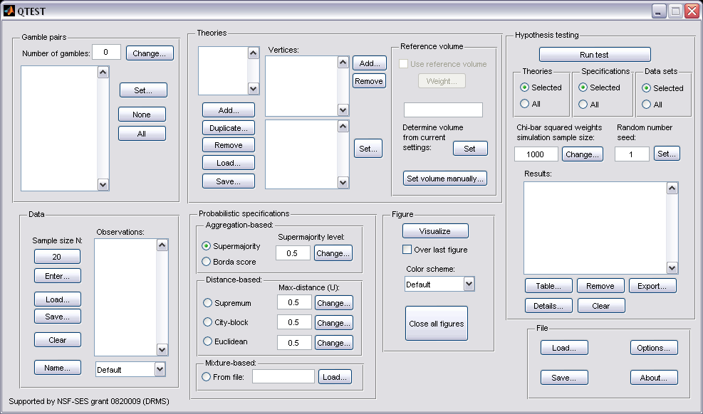

The QTEST interface has 7 spatially distinct areas, which contain a set of related functions. From left to right, and top to bottom, these are: “Gamble Pairs”, “Theories”, “Hypothesis Testing”, “Data”, “Probabilistic specifications”, “Figure” and “File”. These 7 names are circled in the screenshot below:

We now illustrate how to save and load a file. Suppose you have completed a section of this tutorial and wish to save your work. In the QTEST interface, under “File”, select “Save…”. Then navigate to a location on your computer to save the QTEST session, which will have a “*.mat” format, where the asterisk represents the file name and the “.mat” extensions stands for a Matlab file.

And then, when you are ready to resume, under “File” select “Load…” and navigate to the location of your saved “*.mat” file. Once again, the asterisk represents your file name and the .mat is a Matlab file extension.

This demonstration of saving and loading a file illustrates notation carried throughout the tutorial. First, the tutorial will begin instructions by indicating the location referenced, like “File” was just used. Then the functions within that location are demonstrated. We just how to use “Save…” and “Load…”. And usually these are illustrated by screenshots. So whenever you see words in double quotation marks, “ ”, these refer to an explicit representation on the QTEST interface. These are words that currently exist on the interface or user input to be entered (or user input entered previously). Black arrows on top of screenshots point to an input selection the user needs to make with their cursor. Black open ovals on top of the QTEST interface screenshots draw the users’ attention to something that has been updated as a result of an action taken by the user.

We now turn to the first section of the tutorial, A, where we recreate Figure 2 of the paper.

A. Theory ABC (Figure 2 of the paper)
Upon completion of section A of the tutorial, a version of Figure 2 of the paper will be created. In order to create this figure, we will learn how to use QTEST to create gamble pairs, define a decision theory, specify the theory’s prediction and finally create (and visualize in 3-dimensional space) the 0.50-majority/modal choice specification of this theory.

A.1 Create the gamble pairs
The basic entity on which QTEST builds every analysis is a set of gamble pairs. We start with the gambles in Figure 2 of the paper, labeled A, B, and C. In the QTEST interface, under “Gamble pairs”, select “Change”.

In the “Gambles” dialogue box that pops up, type “3”. Then select “OK”.
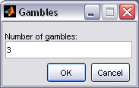

Notice the “Number of gambles” under “Gamble pairs” in the QTEST interface is “3”. Next, select “All” under “Gamble pairs”. This will create all possible pairs of gambles from 3 gambles.
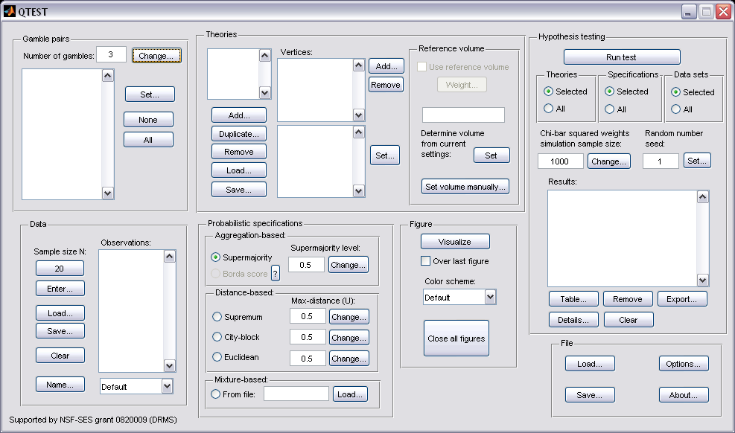

Under “Gamble pairs”, the list of gambles has updated to include “(A,B)”, “(A,C)” and “(B,C)”, which are all of the possible pairs of gambles.
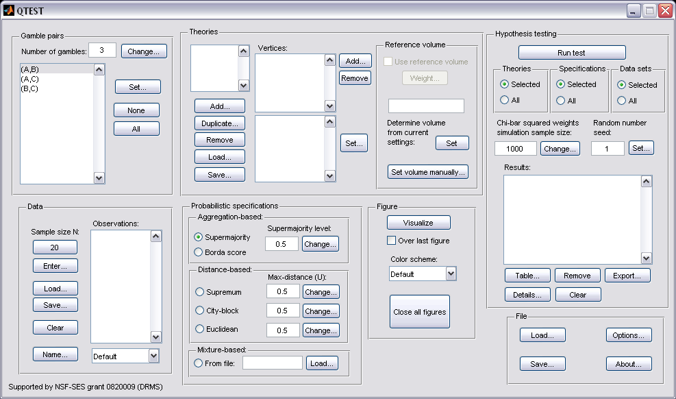

A.2 Define one decision theory, ABC
Having created the gamble pairs, we now define a decision theory. In the QTEST interface, under “Theories”, select “Add…”.

In the “Theory” dialogue box that pops up, enter “ABC”. Select “OK”.
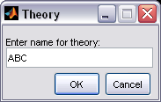

Notice “ABC” listed under “Theories”.
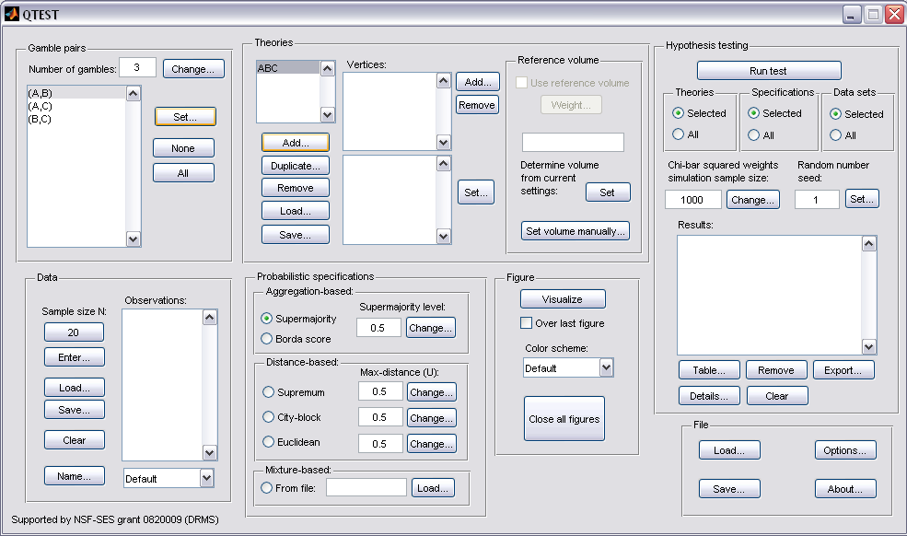

A.3 Specify the prediction of decision theory ABC
We can now specify the prediction of theory ABC. Under “Theories”, select “Add…”, just right of “Vertices:”.
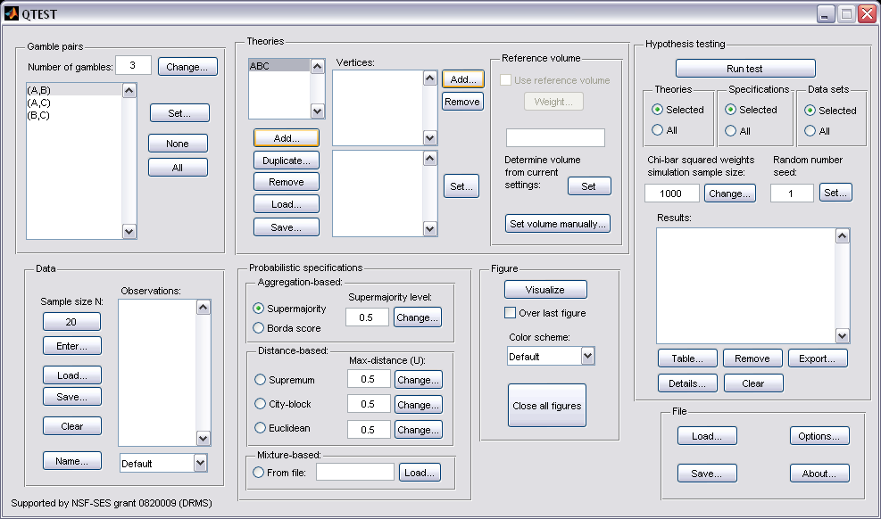

Enter “ABC”, as a name for the ranking ABC, in the “Vertex” dialogue box that pops up. Then select “OK.”
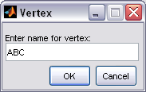

In Figure 2 of the paper, the vertex ABC is represented geometrically by a corner of the 3-D cube. Specify the coordinates of this vertex by selecting “Set…”.
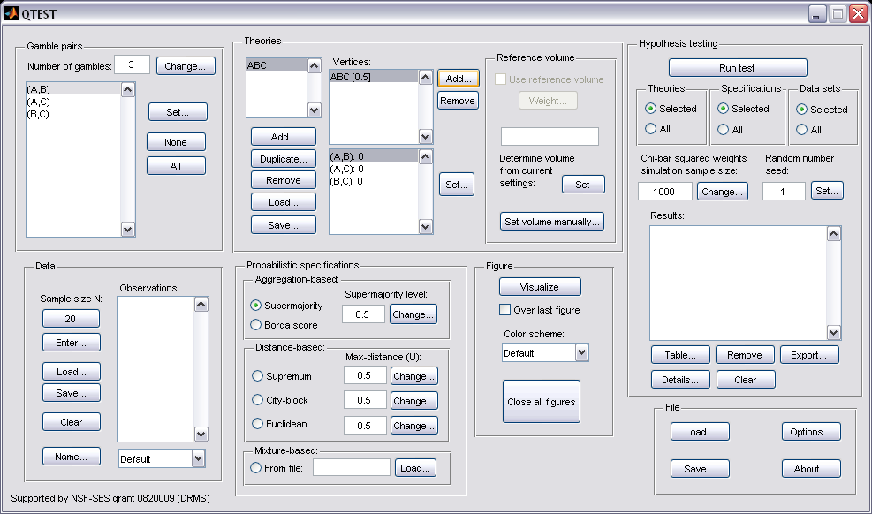

The “Set Vertex (Preference)” window pops up. For each gamble pair, select the gamble preferred under the ranking ABC. Since A is preferred to B in pair (A,B), select “A”. Likewise, A is preferred to C in pair (A,C), so select “A”. Finally, B is preferred to C in pair (B,C) so select “B”.
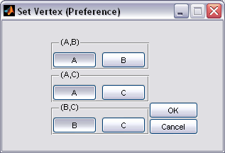

And then select “OK”.

The QTEST interface now shows theory “ABC” with the vertex representation corresponding to the ranking ABC that has coordinates (1,1,1). These coordinates are listed in the bottom half of “Vertices:”. Note that the Vertex label “ABC” is only a name and QTEST does not know what it stands for, so the user must specify the coordinates of the vertex.
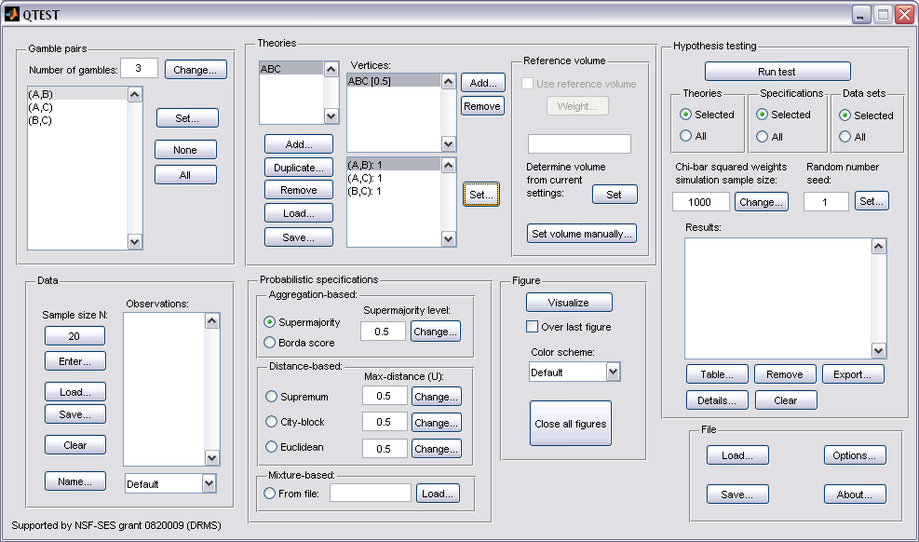

A.4 The 0.50-Majority/modal choice specification of theory ABC
Now we use QTEST to create a 0.50-majority/modal choice specification for vertex ABC. Select “ABC” under “Theories”. It will be highlighted in gray if selected.

Under “Probabilistic specifications”, the radio button left of “Supermajority” should be selected, and the “Supermajority level” should be set to “0.5”.

To create a rudimentary version of Figure 2 of the paper, press “Visualize”, under “Figure”.

A new figure window will pop up, like the one on the left, below. This figure can be rotated, printed, saved, etc., as indicated with the menu buttons in the top of the window. For instance, press once on the circle with an arrow icon inside, and then drag the cursor into the 3-D figure. Press the button on the mouse and then rotate the figure, to get the figure on the right.

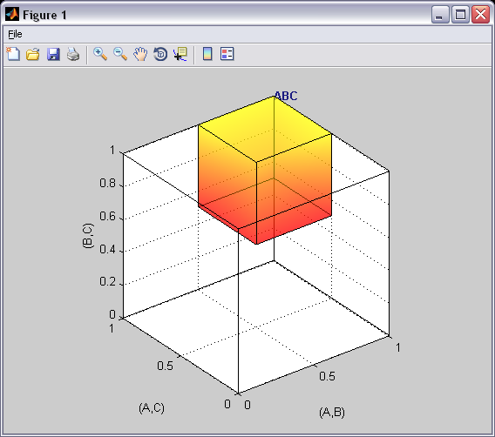
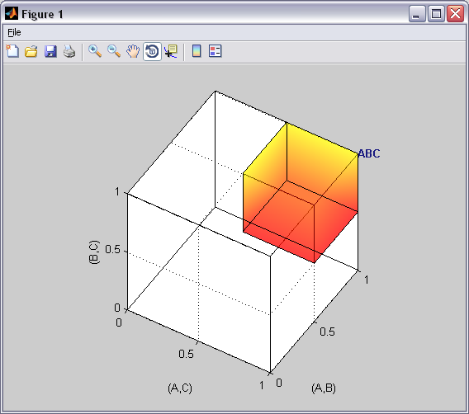

This completes the 0.50-majority specification of vertex ABC for Theory ABC. Notice that Figure 2 of the paper shows additional information, namely seven other preference patterns. These are BAC, ABCA, BCA, ACBA, CBA, CAB and ACB. We do not discuss here how those were added, since they were added only for explanatory purposes in the paper.

B. KT-V4 (Figures 3-5 of the paper)
After finishing Section B of the tutorial, we will have created Figures 3, 4 and 5 of the paper. There are two important differences between the figures created in Section A and those created now in Section B. First, we use a different theory and different vertex. Second, Figures 3, 4 and 5 of the paper are based on the gambles A, B, C, D and E in Table 1 of the paper. And of those 5 gambles we only consider gambles A,C, and D for the present section.

B.1 Create the gamble pairs
In the QTEST interface, under “Gamble pairs”, select “Change”.

This will bring up the “Gambles” dialogue box. Enter “5” and press “OK.”
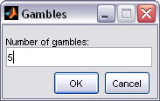

Under “Gamble pairs” notice the “Number of gambles:” has updated to “5”. Also notice that the rest of the interface has been cleared. This will always happen when the gamble pairs are changed.
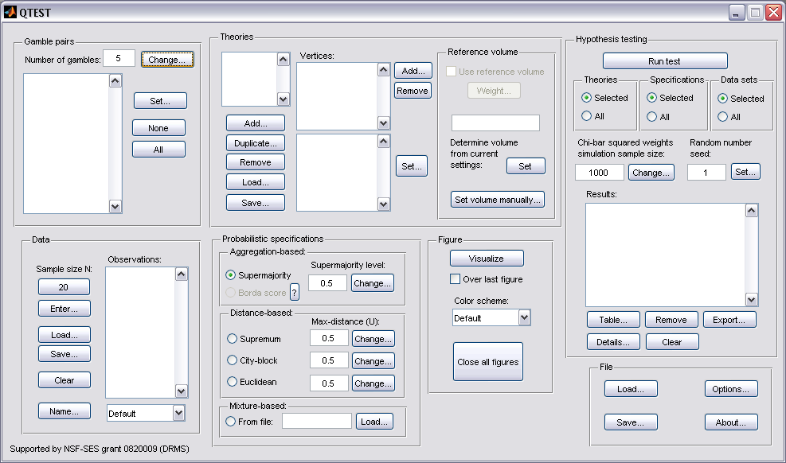

In Section A.1, with the 3 gambles A, B and C, we selected “All” in the “Gamble Pairs” section to create all 3 pairs of gambles. If we selected “All” for the 5 gambles A, B, C, D and E, this would result in the construction of 10 gamble pairs. However, in Figure 3 of the paper, in order to stay in 3-D space, we focus only on 3 of these possible 10 pairs: AC, AD and CD. So we now show how to create this subset of 3 gamble pairs from the 10 pairs that are possible. Under “Gamble pairs” select “Set”.

In the “Choose gamble pairs” dialogue box that pops up, select the boxes next to gamble pairs “(A,C)”, “(A,D)” and “(C,D)” and then select “OK”.
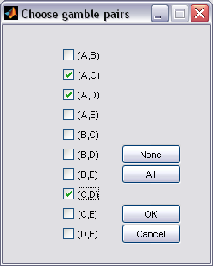

Under “Gamble pairs”, only the 3 gamble pairs selected are listed.
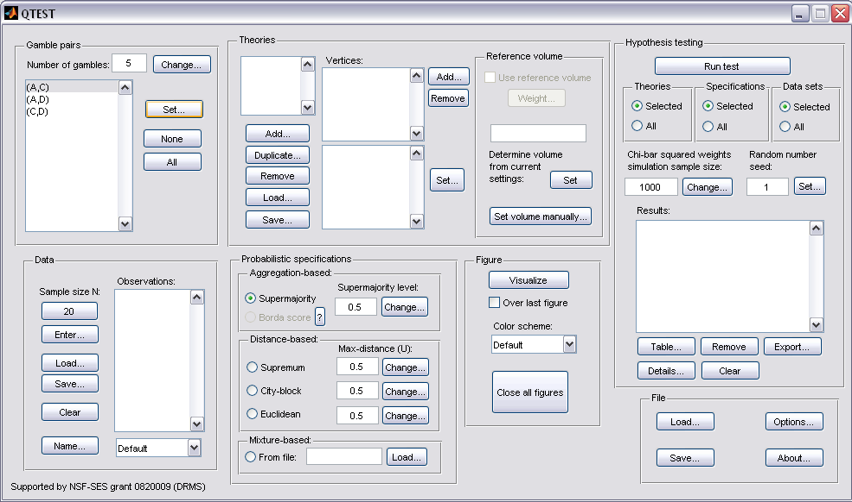

This is how to create a subset of gamble pairs if all gamble pairs are not needed. We now define our next decision theory.

B.2 Define one decision theory, CPT-KT
This time we will use the decision theory specified in Figure 3 of the paper: CPT-KT, or Cumulative Prospect Theory with a “Kahneman-Tversky” weighting function. Under “Theories” select “Add”. In the “Theory” dialogue box that pops up, enter “CPT-KT”. Then select “OK”.
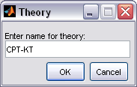

Under “Theories”, “CPT-KT” is listed.
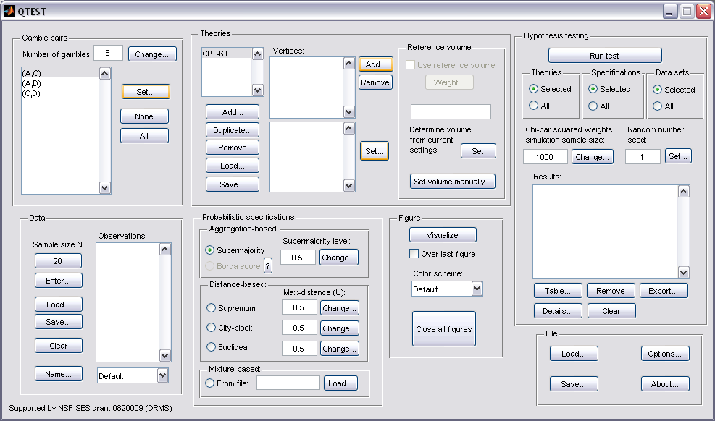

B.3 Specify a prediction of decision theory CPT-KT
Having defined CPT-KT, we now specify a prediction of the theory. Under “Theories”, just right of “Vertices:”, select “Add…”.

The “Vertex” dialogue box that pops up will prompt you for a label name of the vertex associated with theory CPT-KT. Figure 3 of the paper labels this vertex KT-V4. Enter “KT-V4”. Select “OK.”
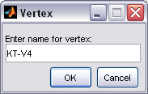

Next, specify the coordinates of this vertex. Under “Vertices:” select “Set…”.
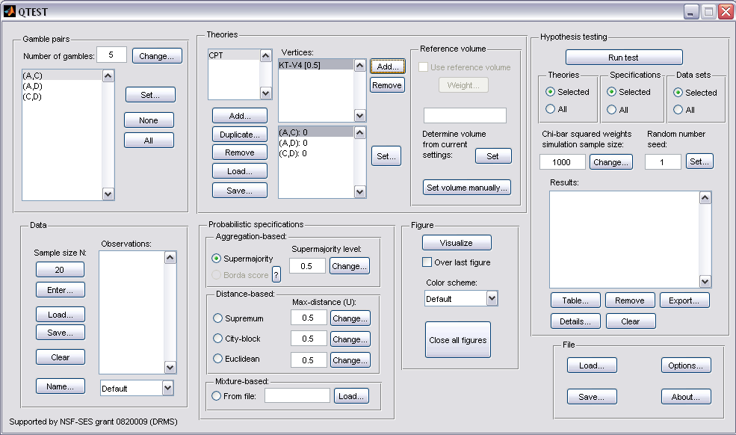

The “Set Vertex (Preference)” window pops up. For each gamble pair, select the button associated with the preferred gamble according to the ranking DAC. A is preferred to C in pair (A,C) so select “A”. D is preferred to both A and C so select “D” from pairs (A,D) and (C,D), respectively.
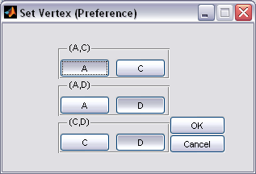

Then select “OK”.

Under “Theories” the QTEST interface shows theory “CPT-KT”. Under “Vertices”, the top half lists vertex, “KT-V4 [0.5]” and the bottom half lists the coordinates (1,0,0).
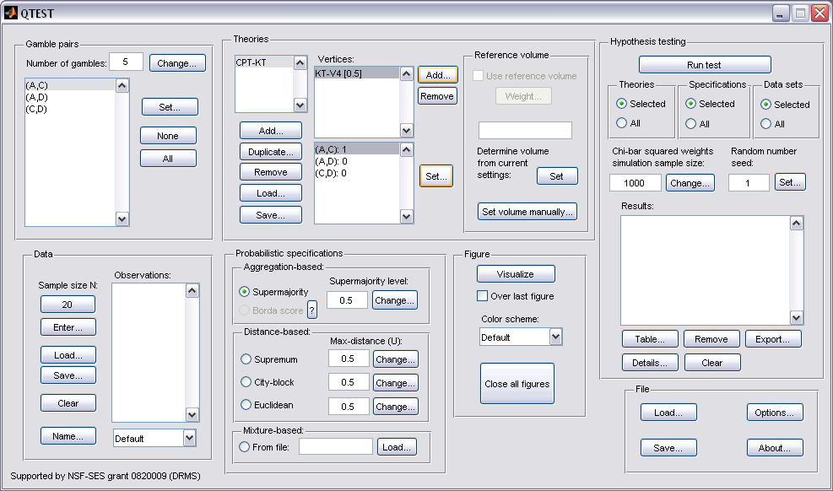

B.4 The 0.50-Majority/modal choice specification of KT-V4 for theory CPT-KT
We now use QTEST to construct the 0.50-majority/modal choice specification for KT-V4. First, under “Theories”, select “CPT-KT” and “KT-V4”. They will be highlighted in gray once selected.

Under “Probabilistic specifications”, verify the radio button left of “Supermajority” is checked and that the “Supermajority level:” is set to “0.5”.
To create a version of Figure 3 of the paper, under “Figure”, select “Visualize”.

A figure, like the one below, pops up in a separate window. This figure is the leftmost panel in Figure 3 of the paper (without the data points).
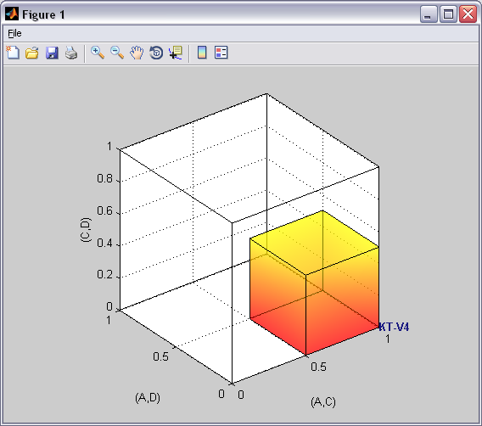

This completes the 0.50-majority specification of KT-V4 for theory CPT-KT. QTEST can create more than just a 0.50-majority/modal choice specification. Figure 4 of the paper, for instance, depicts the 0.75-supermajority specification of KT-V4 for theory CPT-KT. We now show how to create this probabilistic specification in QTEST.

B.5 The 0.75-Supermajority specification of KT-V4 for theory CPT-KT
We will now create the 0.75-supermajority probabilistic specification for KT-V4 in Figure 4 of the paper. Under “Theories”, select “CPT-KT” and “KT-V4” so they are gray highlighted.

Under “Probabilistic specifications”, under “Aggregation-based:”, verify the radio button left of “Supermajority” is selected. Adjust the “Supermajority level:” by selecting “Change”.
The dialogue box that pops up asks the user to specify the “Supermajority Level (Lambda):”. Enter “.75” into the box. Select “OK”.
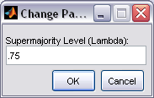

Notice two changes to the QTEST interface. First, under “Theories”, under “Vertices”, the vertex “KT-V4 [0.75]” now has the 0.75-supermajority specification contained in square brackets. Second, the “Supermajority level” under “Probabilistic specifications” has been updated to “0.75”.
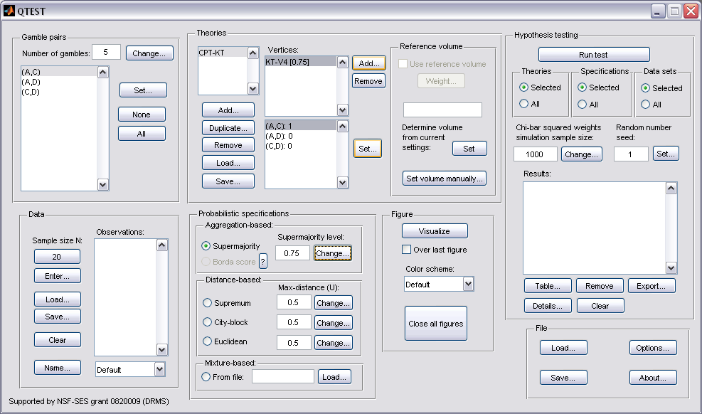

To create a version of Figure 4 of the paper, press “Visualize” under “Figure”.

A new figure will pop up in a separate window. In this case the resulting figure is the left panel in Figure 4 of the paper (without the data points).
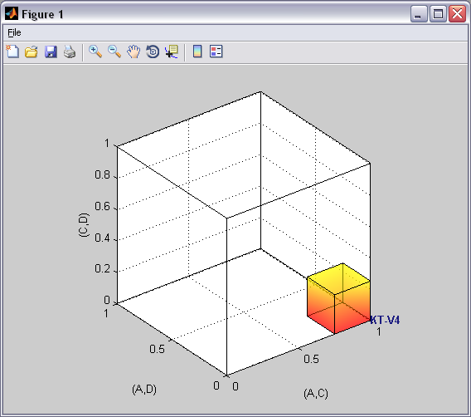

This completes the 0.75-supermajority specification of KT-V4 for theory CPT-KT. QTEST can also create distance-based specifications, such as supremum, city-block and Euclidean. Figure 5 of the paper depicts the 0.5-city-block specification of KT-V4 for theory CPT-KT. We now show how to create this probabilistic specification in QTEST. (For a formal derivation and fuller treatment of aggregation- and distance-based specifications, we refer the interested reader to Appendix B of the paper: Probabilistic Specification.)

B.6 The 0.50-city-block specification of KT-V4 for theory CPT-KT
We now create the 0.50-city-block distance-based probabilistic specification for KT-V4 in Figure 5. First, make sure “CPT-KT” and “KT-V4” are gray highlighted under “Theories”.
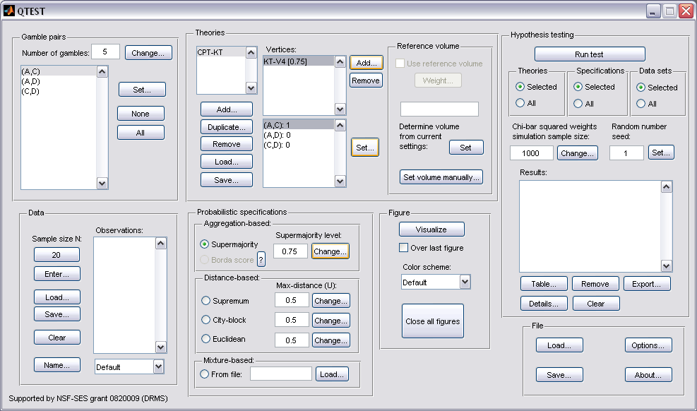

Under “Probabilistic specifications”, under “Distance-based:”, the radio button left of “City-block” should be selected. Leave the “Max-distance (U):” set to 0.5, as shown below.
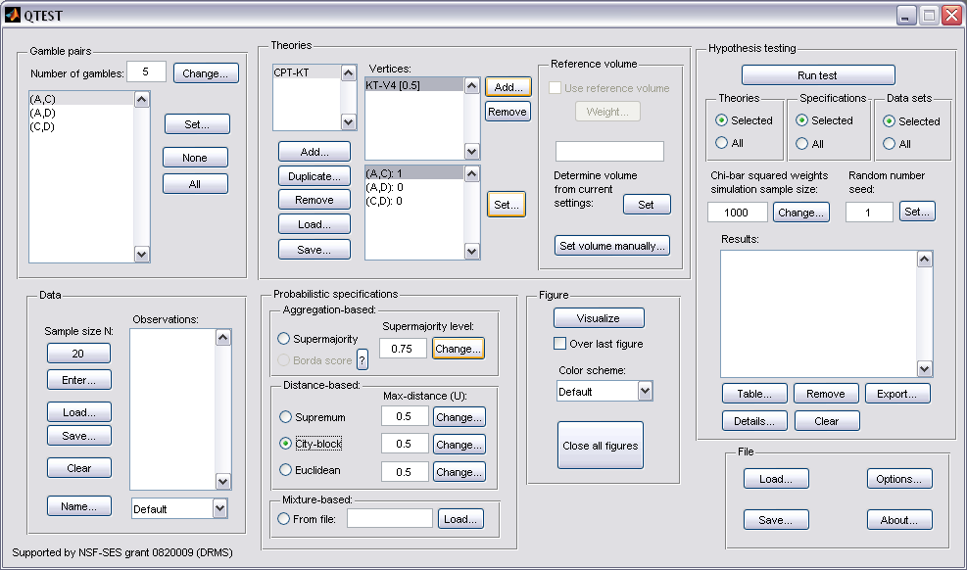

To create a version of Figure 5 of the paper, press “Visualize” under “Figure”.

A figure will pop up in a separate window. In this case it is the left panel in Figure 5 of the paper (without the data points). Please note that distance-based specifications with values greater than 0.50 will lead to a warning message, indicating that the regions are overlapping. In this case the user needs to think carefully about how to proceed.
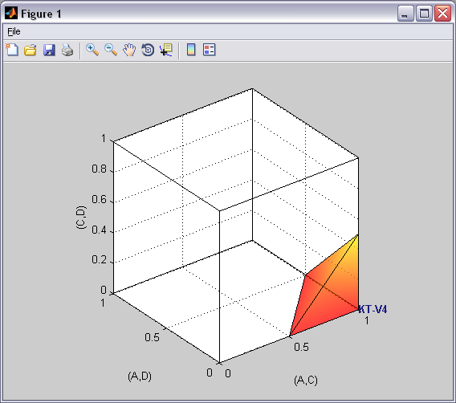

C. KT-V4 vs. LH (Figure 6 of the paper)
We build on Section B by introducing a second theory and demonstrate how the theories compare in the same 3-D geometric space. In Section B.4 we created the 0.50-majority/modal choice specification for CPT-KT for the vertex KT-V4 for the 3 gambles A, C and D. We use the same 0.50-majority/modal choice specification from B.4. But we also create a specification for the lexicographic heuristic, or LH, in Figure 6 of the paper.

C.1 Create the gamble pairs
If you are continuing from Section B.6 (or starting from a saved session of B.6), your QTEST interface needs to match the following screenshot under “Gamble pairs”. Specifically, set the “Number of gambles” to “5”. Then verify the 3 gamble pairs “(A,C)”, “(A,D)” and “(C,D)” are listed under “Gamble pairs”.
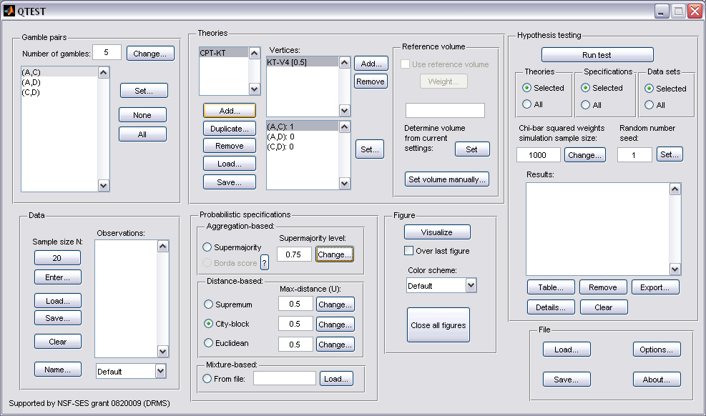

C.2 Define two decision theories, CPT-KT and LH
Figure 6 of the paper compares two theories: CPT-KT and LH. We already introduced CPT-KT in Section B.2. If you are starting a new session of QTEST (or do not have a saved session), please return to Section B.2 and define CPT-KT before proceeding. The correct QTEST interface will look like the following. Notice “CPT-KT” is defined under “Theories”.

Next add the LH. Under “Theories” select “Add…”.

Enter “LH” in the “Theory” dialogue box that pops up. Then select “OK”.
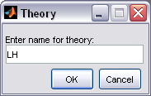

Notice that the updated “Theories” list now contains both “CPT-KT” and “LH”.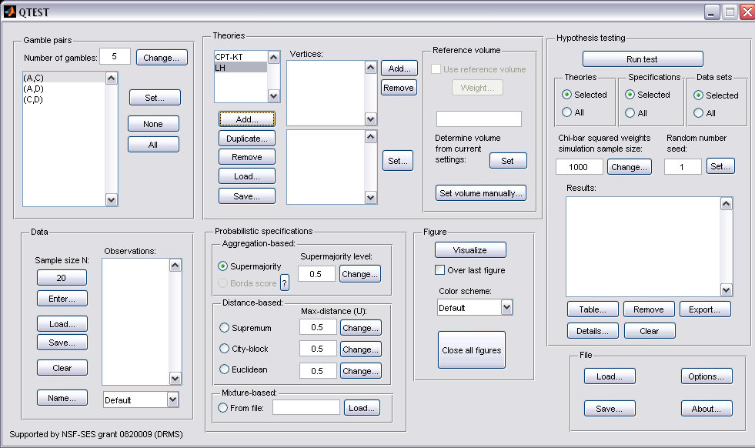

Now we have defined 2 theories in one QTEST session.

C.3 Specify predictions of decision theories LH and CPT-KT
Having defined the theory LH, we now specify its one prediction. Under “Theories”, select “LH” (it will be highlighted in gray) and then select “Add…”.

In the “Vertex” dialogue box that pops up, enter the vertex “LH”. Select “OK”.
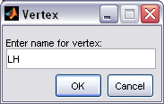

All gamble pairs are set to “0“ by default under “Vertices”. Press “Set” to specify the predictions.
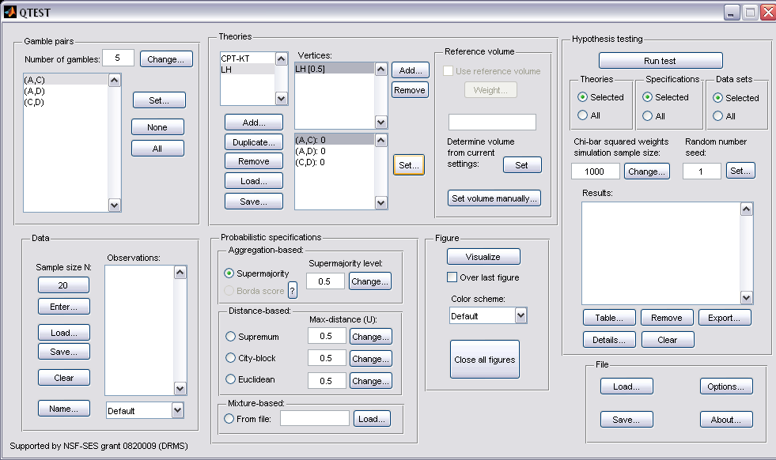

In the “Set Vertex (Preference)” dialogue box that pops up, select “A” from the pair “(A,C)”, “D” from the pair “(A,D)” and “C” from the pair “(C,D)”. Then select “OK”.
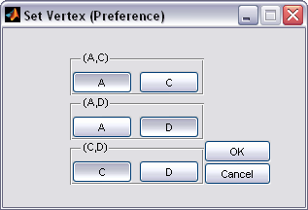

Notice the gambles are updated under “Vertices” for “LH”.
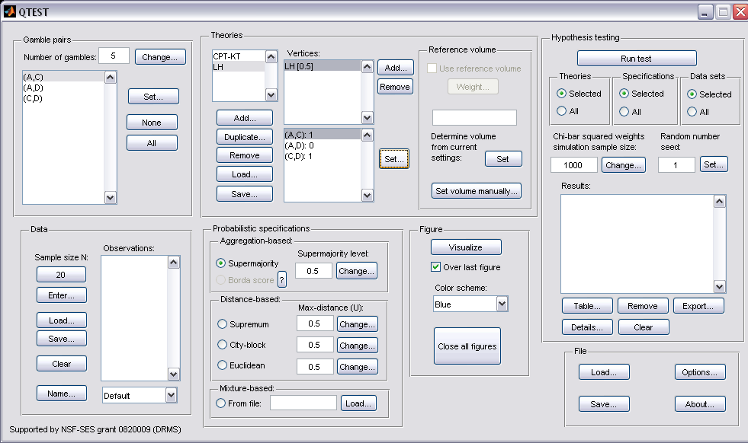

The prediction for LH is now specified. The prediction for CPT-KT should already be set. Check this by clicking once on “CPT-KT” under “Theories”. “CPT-KT” will now be highlighted in gray, “KT-V4” is highlighted in gray under “Vertices” and the gambles are defined as in the following screenshot.
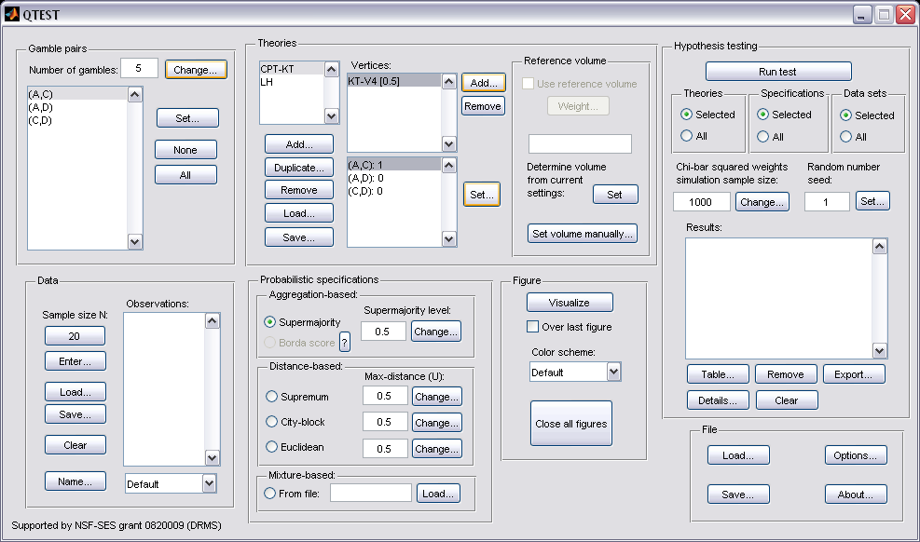

If your session of QTEST does not have the prediction for KT-V4, please see Section B.3.

C.4 The 0.50-Majority specification of KT-V4 (theory CPT-KT ) and LH (theory LH)
We are now ready to create the 0.50-majority/modal choice specification for both KT-V4 of CPT-KT and LH. We will specify KT-V4 first. Under “Theories” in the QTEST interface click on “CPT-KT” and “KT-V4” so they are both highlighted in gray. Under “Probabilistic specifications”, the radio button left of “Supermajority” should be selected and the “Supermajority level:” should be “0.5”.
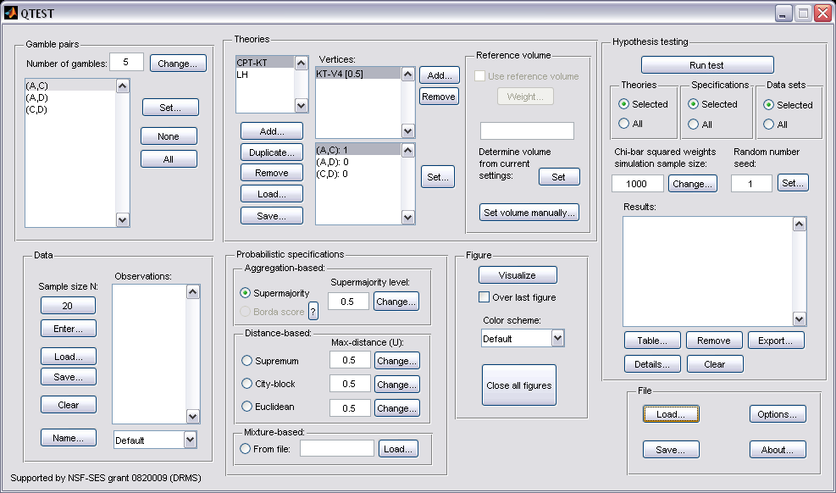

To see this 0.50-majority/modal choice specification in 3-D space, press “Visualize” under “Figure”.

The resulting figure (below) is similar to Figure 3 of the paper which is also the figure we created in the previous section. Do not close this figure window yet. Downsize or move it to the side, as we will add a second figure to this same window.
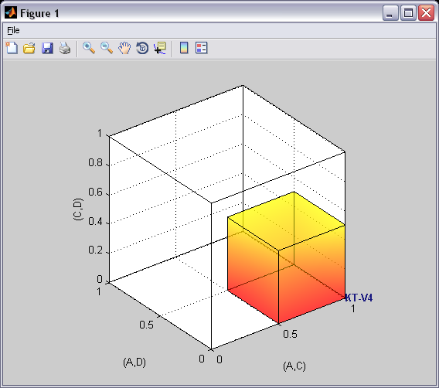

We are now ready to create the 0.50-majority/modal choice specification for LH. Under “Theories” in the QTEST interface click on “LH” and under “Vertices”, make sure “LH[0.5]” is selected. Both of these should be highlighted in gray. In the “Probabilistic specifications” section, the radio button left of “Supermajority” should be selected and the “Supermajority level:” should be “0.5”.
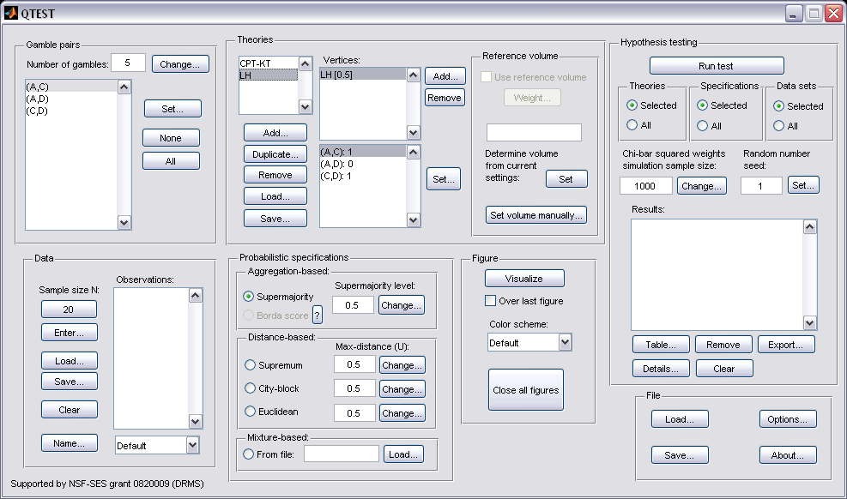

We want to visualize this figure also. But the procedure is a little different this time. First, in the QTEST interface, under “Figure”, and under “Visualize”, check the box next to “Over last figure”. Second, directly beneath “Over last figure”, from the “Color scheme:” dropdown menu choose “Blue”.

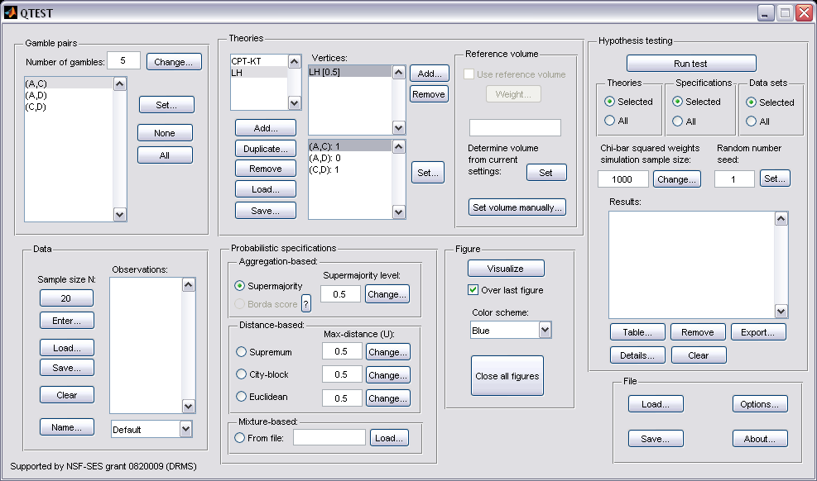
Now click “Visualize” to get the following figure.
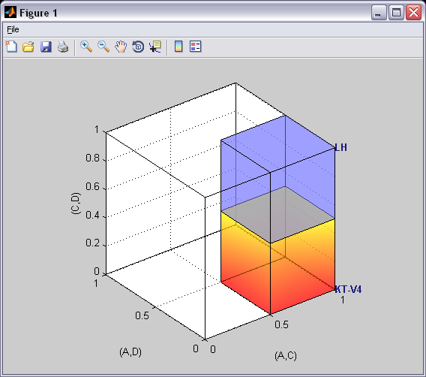

The 0.50-majority/modal choice specification for LH is created as a blue cube in the same figure window as the figure that QTEST used for the 0.50-majority/modal choice specification of KT-V4 for CPT-KT, which is the orange cube.

D. Linear Orders (Figure 7 of the paper)
Section B.1 through Section B.4 defined 3 gamble pairs out of a possible 10 gamble pairs, defined one vertex (KT-V4) for CPT-KT and constructed a single 0.50-majority/modal choice specification for those 3 gamble pairs. In this section, instead of constructing a single 0.50-majority/modal choice specification, we will construct a 0.50-majority/modal choice specification for each of the six linear orders on A, C, D, in a single 3-D figure. Once completed, we will have the left panel of Figure 7 of the paper.

D.1 Create the gamble pairs
We continue our QTEST session from Section C.4. Your session should match the information under “Gamble pairs” in the following screenshot. (If it does not, either load a saved session from C.4 or return to Section B.1 to create the 3 gamble pairs “(A,C)”, “(A,D)” and “(C,D)”.)

D.2 Define a decision theory, Linear Orders
Now add another theory under “Theories” by selecting “Add…” In the “Theory” dialogue box that pops up, enter “Linear Orders” and then press “OK”. If this is done correctly, your QTEST interface will match the screenshot below. 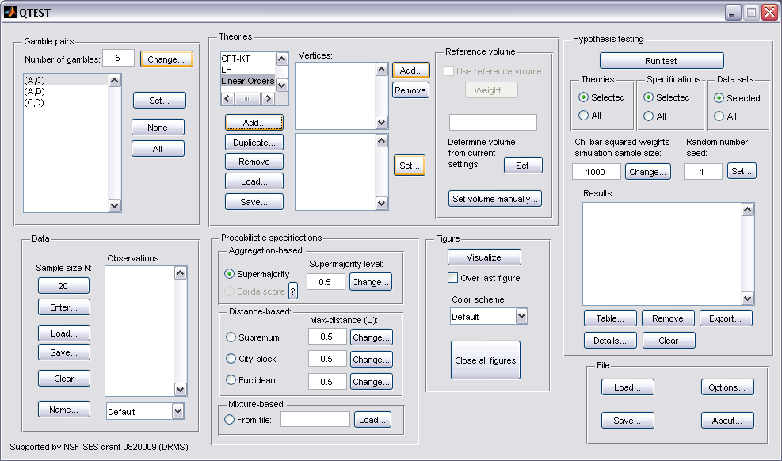

D.3 Specify the predictions of decision theory Linear Orders
We will first specify the prediction DAC, with 3-D coordinates (1,0,0). In the QTEST interface, under “Theories”, select “Add…”, just right of “Vertices”.

In the “Vertex” dialogue box that pops up, type “DAC” and press “OK”.
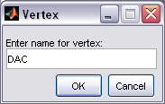

Now “DAC [0.5]” appears in the list of “Vertices” under “Theories” in the QTEST interface. Notice that the 3 gamble pairs, (A,C), (A,D) and (C,D) are all followed by a “0” under “Theories”. This is the default. To specify the prediction for DAC, press “Set” under “Vertices:”.
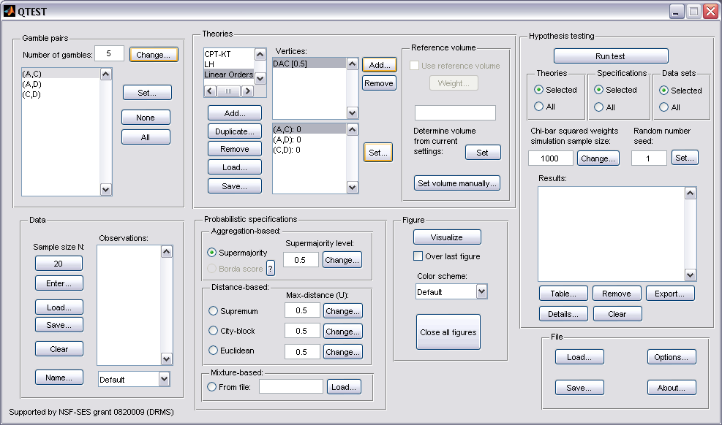

In the “Set Vertex (Preference)” dialogue box that pops up, select A from the gamble pair (A,C), D from the gamble pair (A,D) and D from the gamble pair (C,D). Then press “OK”.
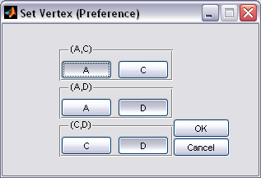

The QTEST interface should match the following screenshot. Note that there is now a “1” following the gamble pair “(A,C)” while “(A,D)” and “(C,D)” are both followed by a “0” under “Vertices:”.
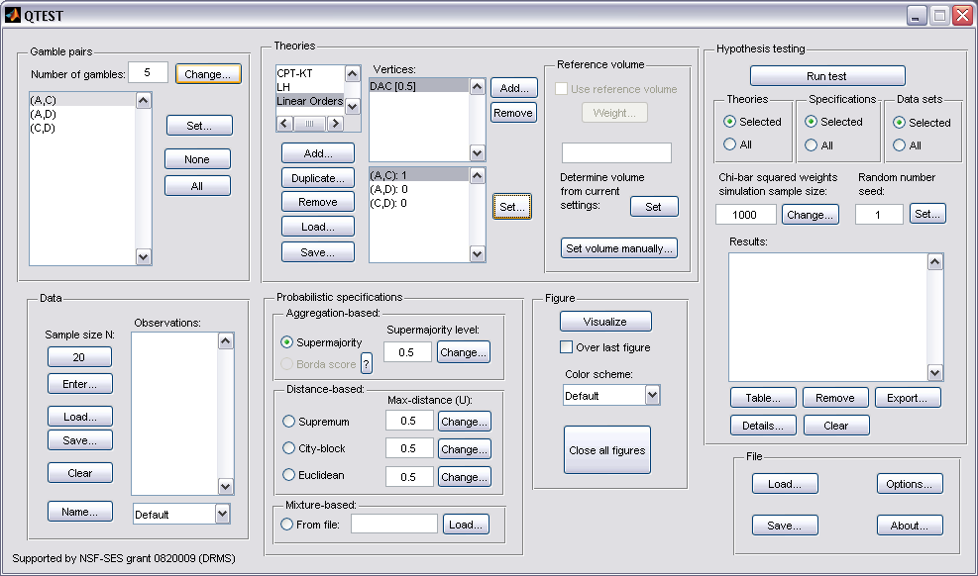

This completes the first prediction. Creating the remaining 5 rankings follows the same procedures as the first. We only provide a verbal description of the rankings, leaving it to the reader to make the changes in QTEST.

Select “Add” just right of “Vertices” in QTEST. In the “Vertex” dialogue box that pops up enter “DCA” and then press “OK”. Make sure “DCA” is highlighted in gray under “Vertices” in the QTEST interface and then press “Set”. In the “Set Vertex (Preference)” dialogue box that pops up, make sure “C” from gamble pair “(A,C)” is selected, “D” from gamble pair “(A,D)” is selected and “D” from gamble pair “(C,D)” is selected. Then select “OK”.

Select “Add” just right of “Vertices” in QTEST. In the “Vertex” dialogue box that pops up enter “CDA” and then press “OK”. Make sure “CDA” is highlighted in gray under “Vertices” in the QTEST interface and then press “Set”. In the “Set Vertex (Preference)” dialogue box that pops up, make sure “C” from gamble pair “(A,C)” is selected, “D” from gamble pair “(A,D)” is selected and “C” from gamble pair “(C,D)” is selected. Then select “OK”.

Select “Add” just right of “Vertices” in QTEST. In the “Vertex” dialogue box that pops up enter “CAD” and then press “OK”. Make sure “CAD” is highlighted in gray under “Vertices” in the QTEST interface and then press “Set”. In the “Set Vertex (Preference)” dialogue box select “C” from gamble pair “(A,C)”, “A” from gamble pair “(A,D)” and “C” from gamble pair “(C,D)”. Then select “OK”.

Select “Add” just right of “Vertices” in QTEST. In the “Vertex” dialogue box that pops up enter “ADC” and then press “OK”. Make sure “ADC” is highlighted in gray under “Vertices” in the QTEST interface and then press “Set”. In the “Set Vertex (Preference)” dialogue box, select “A” from gamble pair “(A,C)”, “A” from gamble pair “(A,D)” and “D” from gamble pair “(C,D)”.

Select “Add” just right of “Vertices” in QTEST. In the “Vertex” dialogue box that pops up enter “ACD” and then press “OK”. Make sure “ACD” is highlighted in gray under “Vertices” in the QTEST interface and then press “Set”. In the “Set Vertex (Preference)” dialogue box select “A” from gamble pair “(A,C)”, “A” from gamble pair “(A,D)” and “C” from gamble pair “(C,D)”.

The QTEST interface should now match the following screenshot. Note the list of “Vertices” contains “DAC [0.5]”, “DCA [0.5]”, “CDA [0.5]”, “CAD [0.5]”, “ADC [0.5]” and “ACD [0.5]”. By selecting one of these vertices (it will be gray highlighted) the gambles specified by that vertex are shown in the box directly beneath the list of “Vertices:”.
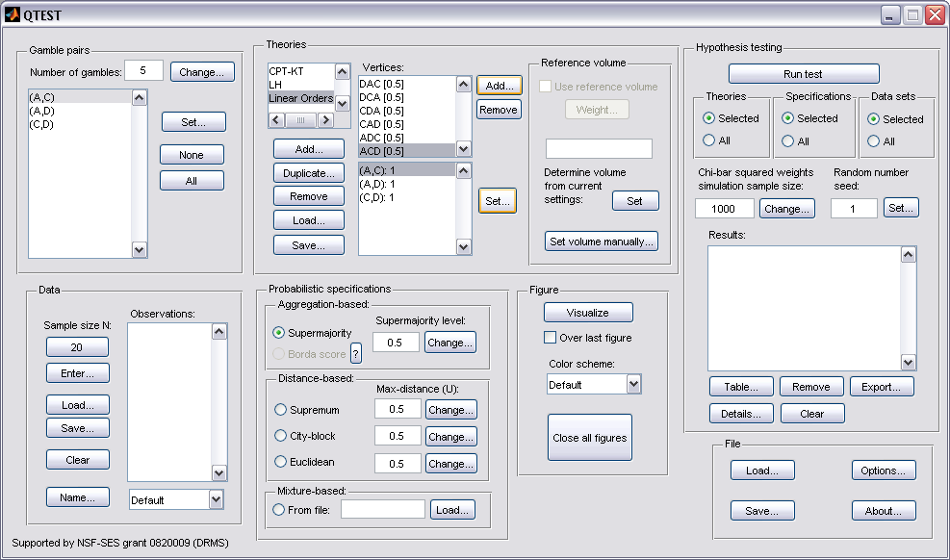

Now that the 6 predictions, or vertices, of Figure 7 of the paper have been defined, we can create the 0.50-majority/modal choice specification for each of these 6 predictions.

D.4 The 0.50-Majority specification of 6 predictions for theory Linear Orders
Under “Theories” make sure “Linear Orders” is selected--it will be highlighted in gray.

Under “Probabilistic specifications”, verify that the “Supermajority” radio button is selected and that the “Supermajority level:” is set to “0.5”.
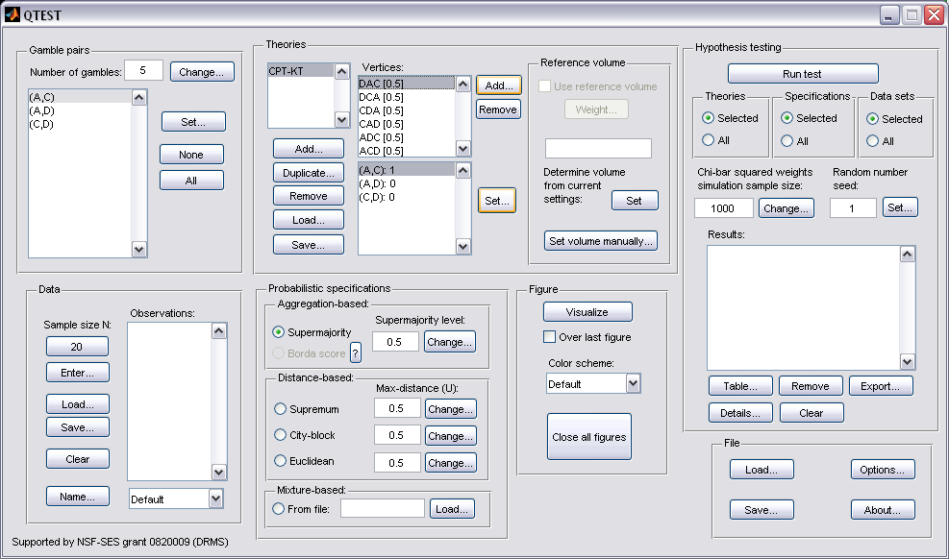

Now, under “Figure” in the QTEST interface, press “Visualize” once. The resulting figure is a version of the left-hand side of Figure 7 of the paper.
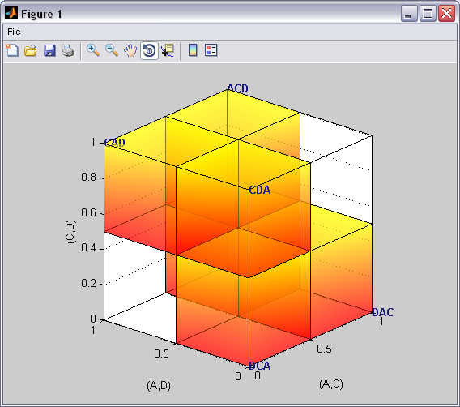

How can we create the right-hand side of Figure 7 of the paper? The gamble pairs, theories and vertices are identical for the two figures. The only difference between the left- and right-hand sides of Figure 7 of the paper is the supermajority specification. In the left-hand side the supermajority specification is 0.5 whereas in the right-hand side the supermajority specification is 0.90. We can create this specification by making one change in the QTEST interface.

D.5 The 0.90-Supermajority specification of 6 predictions for Linear Orders
In the QTEST interface, select “Change” under “Probabilistic specifications”. In the dialogue box that pops up, enter “0.9” for the “Supermajority Level (Lambda)”. Then press “OK”. The interface will then look like the following screenshot.
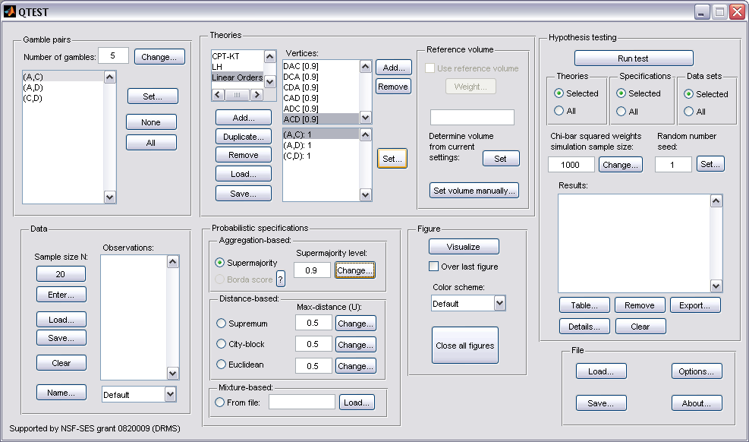

Press “Visualize” once under “Figure” in the QTEST to get the following figure, which is a version of the right-hand side of Figure 7 of the paper.
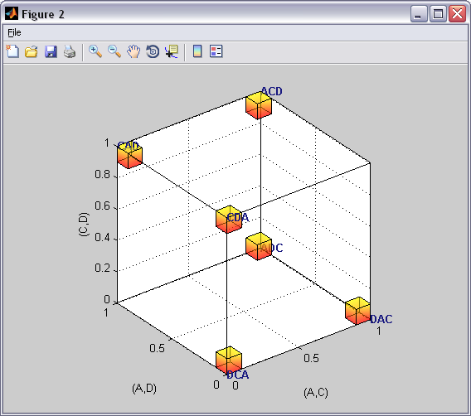

This completes the section for defining one theory, Linear Orders, with multiple predictions and with a separate probabilistic specification for each prediction.

E. CPT-KT vs. LH (Figure 8 of the paper)
In this section, we will build on our knowledge from Sections D.1 through D.4 that compared one prediction for CPT-KT and one prediction for LH. Here, we compare these theories again. But this time we consider all predictions for CPT-KT rather than just one. Once we complete this section, we will have replicated a version of Figure 8 of the paper.

E.1 Create the gamble pairs
If you are continuing from Section D.5, or loading Section D.5 from a saved session, your QTEST session, under “Gamble pairs” should match the screenshot below. (If you need to create these gamble pairs, please go to Section D.1 above.)

E.2 Define two decision theories, CPT-KT and LH
Under “Theories”, “CPT-KT”, “LH” and “Linear Orders” are listed. If you do not see “CPT-KT” and “LH” listed, return to Section C.2 to define these theories in QTEST.

Under “Theories”, select “CPT-KT” so it is gray highlighted and then select “Remove”.
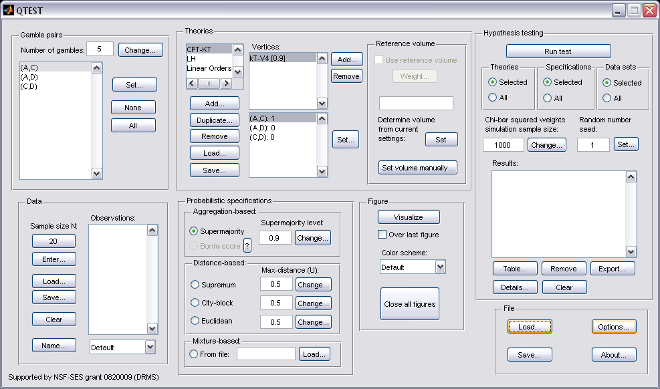

Only two theories remain, “LH” and “Linear Orders”. Select “Linear Orders” so it is gray highlighted. Then select “Duplicate…”.
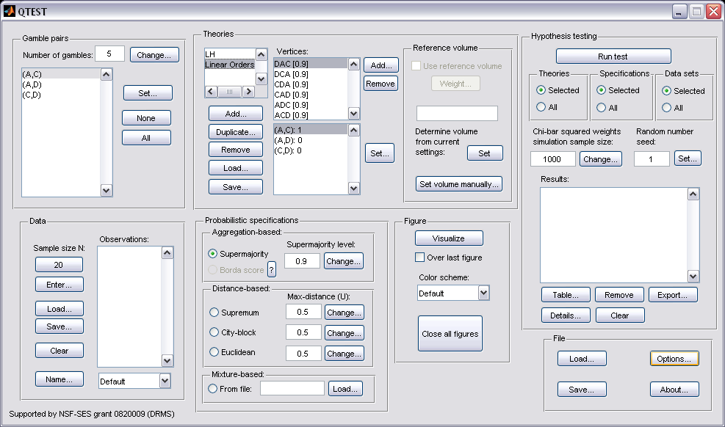

In the “Duplicate…” dialogue box, enter “CPT-KT”. Select “OK”.
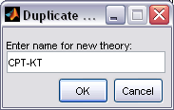

“CPT-KT” is listed under “Theories” but now it has identical “Vertices:” as the “Linear Orders” theory. But we will change the predictions of “CPT-KT” next.
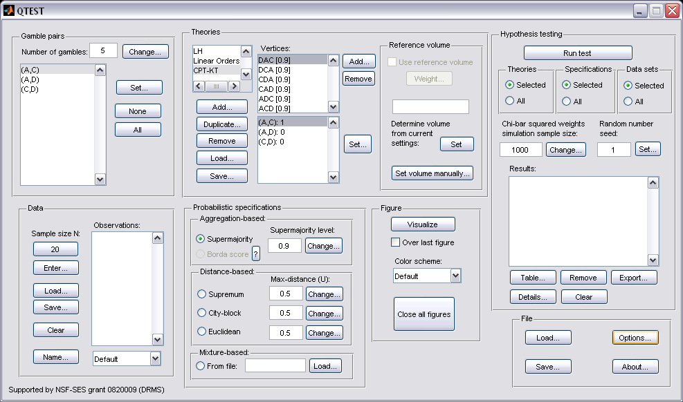

E.3 Specify the predictions of decision theories LH and CPT-KT
Select “CPT-KT” so it is gray highlighted.

Under “Vertices:”, select “CAD[0.5]” so it is gray highlighted. Then select “Remove”.
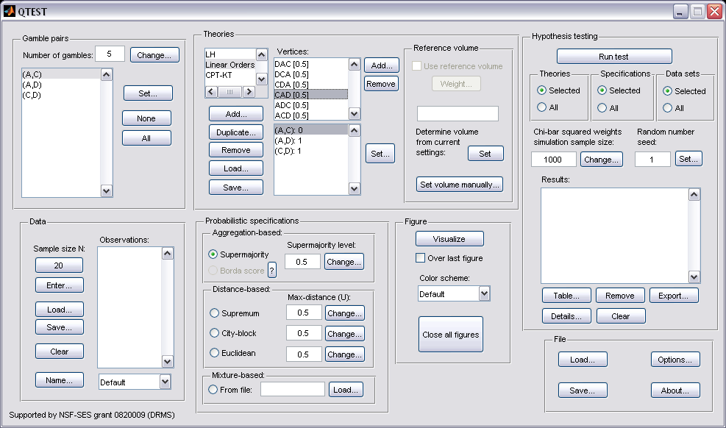

“CAD” is removed from the “Vertices” list and now only five predictions remain.
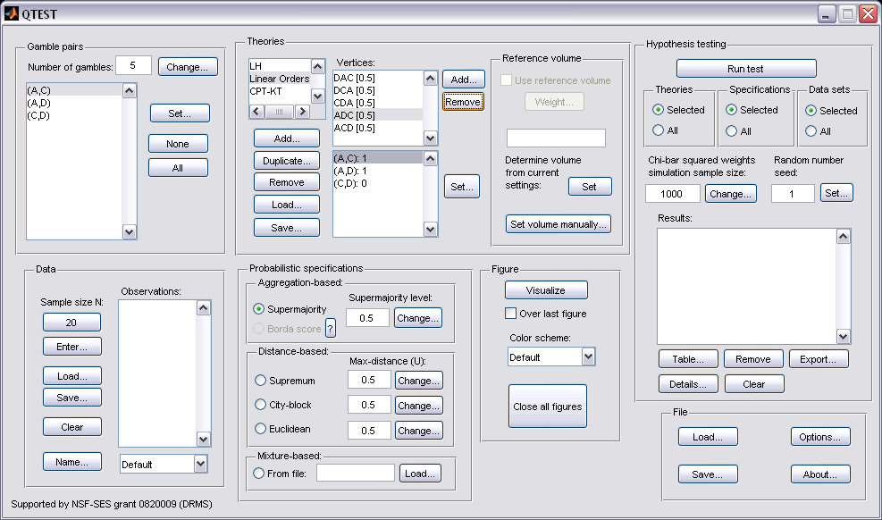

Select “CDA[0.5]” under “Vertices:”. Again select “Remove”.
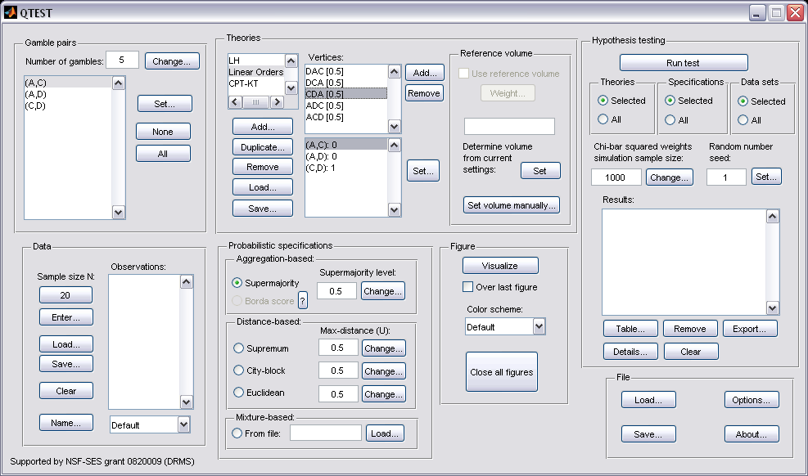

The QTEST interface will now match the following screenshot. The list of “Vertices:” only contains the four predictions “DAC [0.5]”, “DCA [0.5]”, “ADC [0.5]” and “ACD [0.5]”. 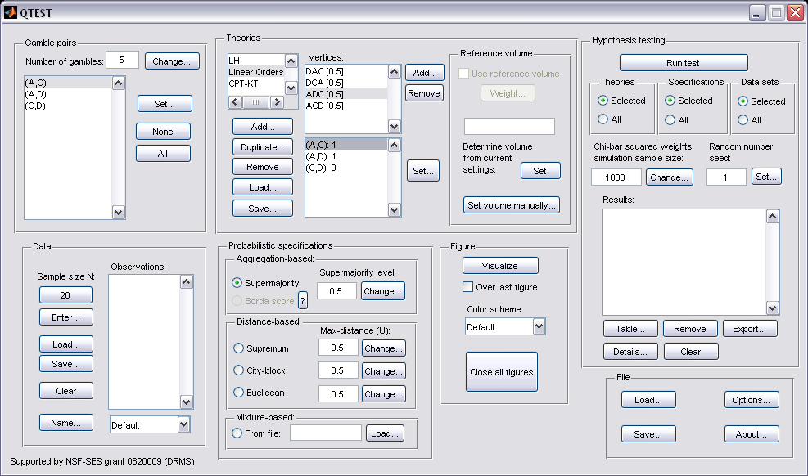

Select “LH” so it is gray highlighted. After highlighting “LH”, under “Vertices”, “LH” is listed in the top half and the coordinates for its vertex are listed in the bottom half. Verify your session of QTEST matches this screenshot.
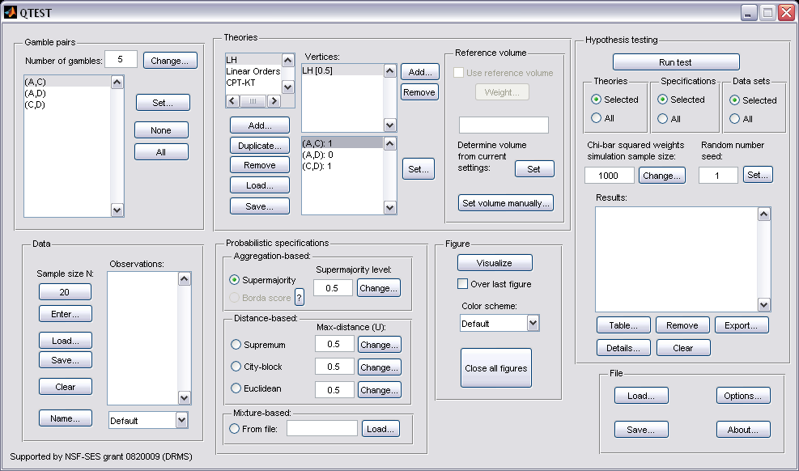

E.4 The 0.50-Majority specification of CPT-KT and LH
We are now ready to create the 0.50-majority/modal choice specification for both CPT-KT and LH. Under “Theories” in the QTEST interface click on “CPT-KT” so it is highlighted in gray. Under “Probabilistic specifications”, the radio button left of “Supermajority” should be selected and the “Supermajority level:” should be changed or set to “0.5”. Under “Theories, select “CPT-KT” and under “Figure” change “Color scheme” to “Default” and uncheck “Over last Figure” (if it is not already unchecked). Then select “Visualize”.
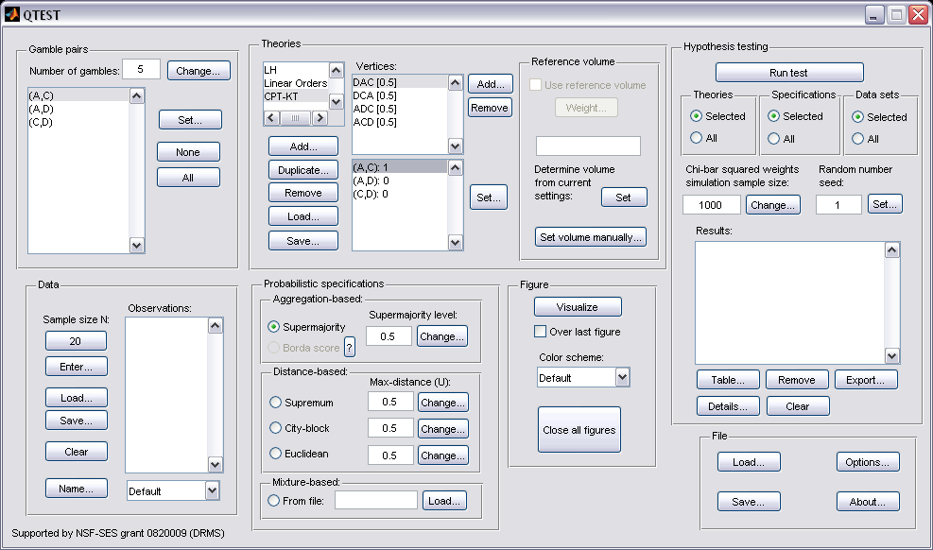

Once this figure has been created, do not close it. Instead, select “LH” under “Theories”. Then check “Over last figure” under “Figure”. Change “Color scheme” to “Blue”. Then select “Visualize”, which should give the following figure, which is a version of the left-hand side of Figure 8 of the paper.
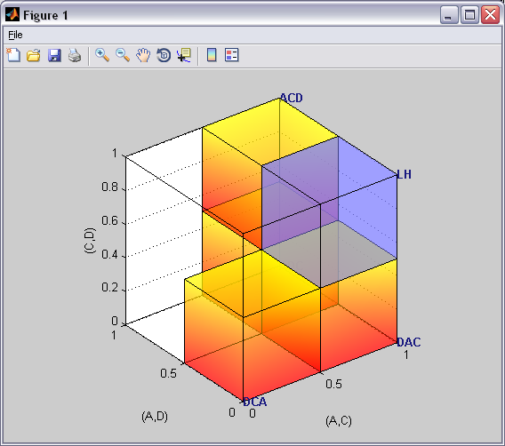

E.5 The 0.90-supermajority specification of KT-V4 (theory CPT-KT ) and LH (theory LH)
We repeat the same procedure as E.4 but now create a 0.90-supermajority specification. Under “Probabilistic specifications”, the radio button left of “Supermajority” should be selected and the “Supermajority level:” should be set to “0.9”.
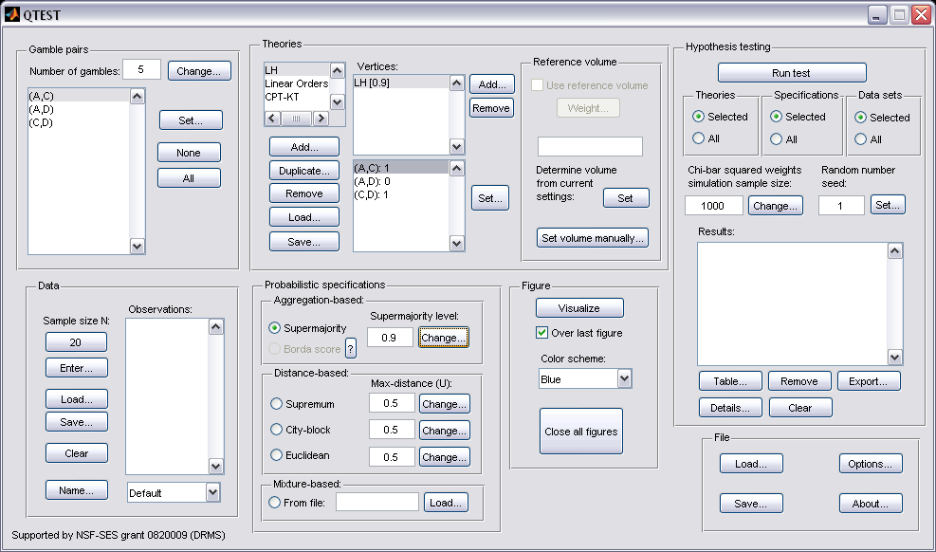

Under “Theories, select “CPT-KT” and under “Figure” change “Color scheme” to “Default” and, if it is checked, uncheck “Over last Figure”. Then, under “Figure” select “Visualize”. Once this figure has been created, do not close it. Instead, select “LH” under “Theories”. Then check “Over last figure” under “Figure”. Change “Color scheme” to “Blue”. Then select “Visualize”, which should give the following figure, which is a version of the right-hand side of Figure 8 of the paper.

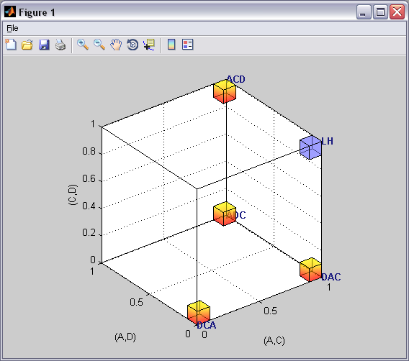

F. Mixture Models (Figure 9 of the paper and Figure 2 of the Online Supplement)
Figure 9 of the paper creates a fundamentally different type of probabilistic specification. The method for specifying these mixture models is different than the one used for the distance-based probabilistic specifications, which comprise all previous sections of the tutorial (Sections A-E). In particular, due to the mathematical aspects involved in specifying these models, the process is not nearly as automated in QTEST as are the models we have considered so far.

F.1 Create the gamble pairs
We will use the same gamble pairs as in our QTEST session from Section E. If you are loading a saved session, loading the session from Section D will be most helpful. Your session should match the circled information, under “Gamble pairs”, in the following screenshot.
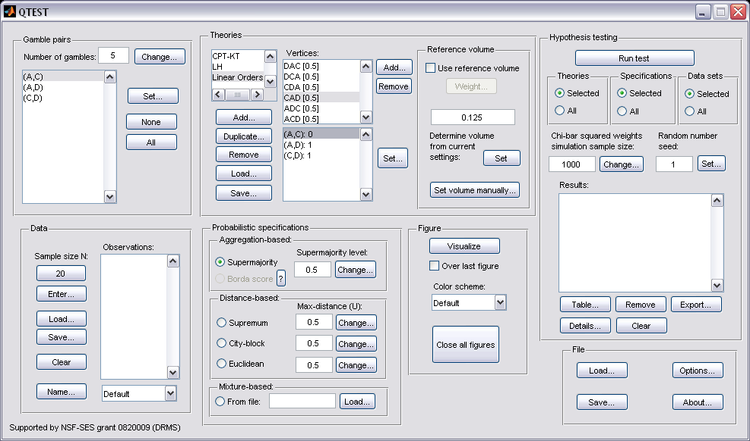

F.2 Define one decision theory, Random CPT-KT
For mixture models, QTEST does not require a decision theory defined under “Theories”. Instead, we rely on the “Mixture-based” panel for these models.
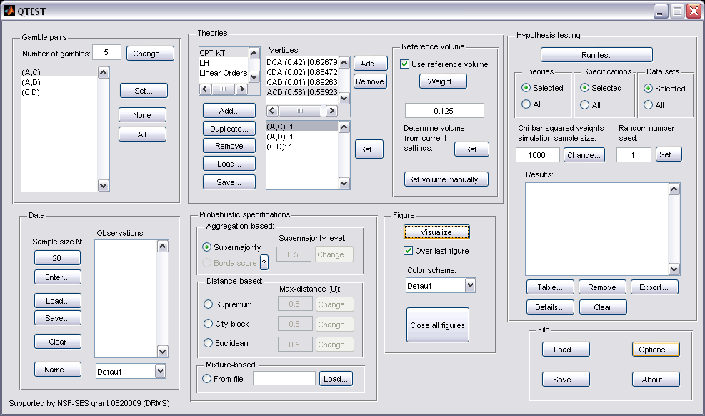

F.3 Mixture model specification of CPT-KT
The vertices for the mixture model are defined differently than for all previous sections of the tutorial. We need to create a special text file (with a .txt extension), which contains information that QTEST reads. We will now look at the specific requirements of this text file. Specifying and testing a mixture model is recommended for more advanced users, e.g., because it requires that the user first solves the relevant mathematics problems to determine the facet structure of the polytope that characterizes the mixture model.

We call our text file “Figure9_MixtureInput.txt”.
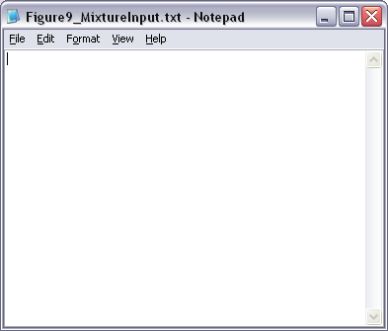

The first line of “Figure9_MixtureInput.txt” must contain two numbers, separated by a space. The first number represents the number of linear inequalities while the second number represents the number of gambles under consideration. To obtain the system of facet defining inequalities, one must use software like PORTA which is discussed in the paper under the section ‘Random Preference and Random Utility Models’ and in the Online Supplement to QTEST. After entering the vertices “ACD”, “ADC”, “DAC” and “DCA” (or the 3-D coordinates 111, 110, 100 and 000) into PORTA, one will obtain the following system of 4 linear inequalities:

$${0*P}_{AC}+ 0*P_{AD}- 1*P_{CD} ≤0$$
$$-1{*P}_{AC}+ 1*P_{AD}+ 0*P_{CD} ≤0$$
$${0*P}_{AC}+ -1*P_{AD}+ 1*P_{CD} ≤0$$
$$1{*P}_{AC}+ 0*P_{AD}+ 0*P_{CD} ≤1$$

We now have 4 linear inequalities (where each row is 1 linear inequality). So the first number of the first row of the input file is 4, to denote the number of linear inequalities. The second number, determined by the number of gambles (recall we have 3 in Figure 9: A, D and C), is 3. The first line of “Figure9_MixtureInput.txt” looks like the following screenshot.

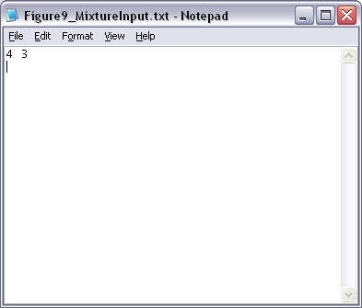

The next row is an optional blank row. The row after contains the coefficients of everything to the left of the inequality signs in the system of linear inequalities provided above, with each column separated by a tab (or a single space). The inequalities must be formulated precisely as above, with the ≤ sign and the constant on the right hand side of the inequality. Since there are 4 rows of inequalities, we have 4 rows of coefficients. Be sure to include any 0 coefficients. Adding these coefficients to the “Figure9_MixtureInput.txt” file yields the following.

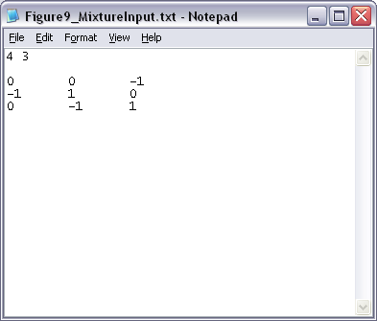

Again, the next row is an optional blank row. Then the constants of the system of linear inequalities (i.e. everything to the right of the ≤ operator in the system of inequalities above) are listed, one per row. (NOTE: The order of the constants must have the correct sign (positive or negative.) Since we have 4 rows of inequalities, we also have 4 rows of constants.
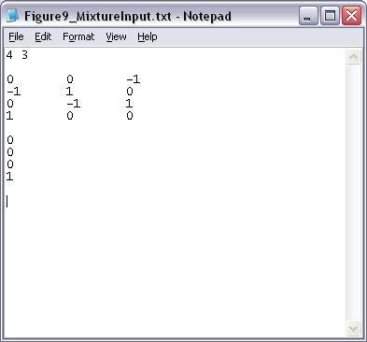

This file contains all the required information QTEST needs to analyze a mixture model. Alternatively, the file might look like the following, which does not have the optional spaces between rows.
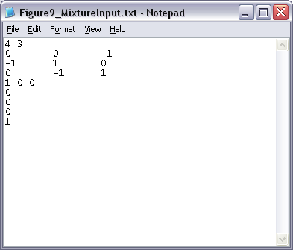

Or if one used spaces in between the coefficients of the linear inequalities (instead of tab), their file might look like one of the following two files.
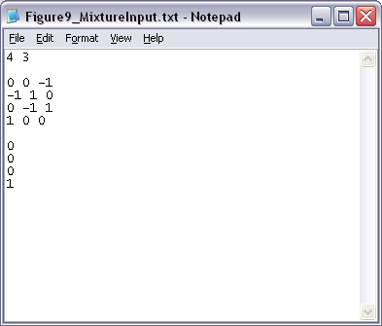

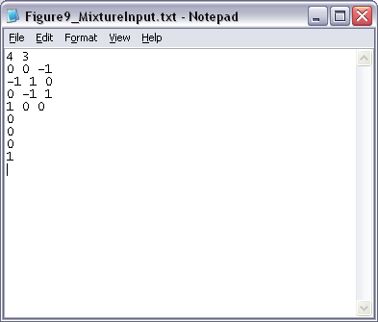

Finally, while not necessary for QTEST to do the analysis, it can be helpful to have more informative labels than the generic ones that QTEST will generate. After the last constant from the last inequality, (with an optional blank row), one can include the optional name “Vertices”, the coordinate and/or even the labels (in double quotes) for each vertex name. Once again, none of this information is required by QTEST—they are useful primarily for purposes of documentation and for 3-D visualizations.
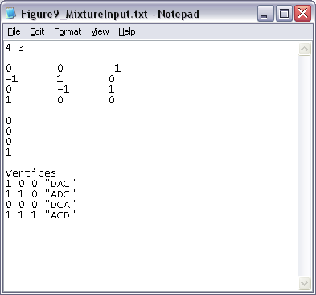
This is all of the information QTEST needs to analyze a mixture model. Save this “Figure9_MixtureInput.txt” file. In the following section we will use this file to complete the analysis of the mixture model in the QTEST interface.

F.4 Mixture model analysis of Random CPT-KT
In the QTEST interface, under “Probabilistic specifications”, under “Mixture-based”, select the radio button next to “From file:”. Then select “Load…”.
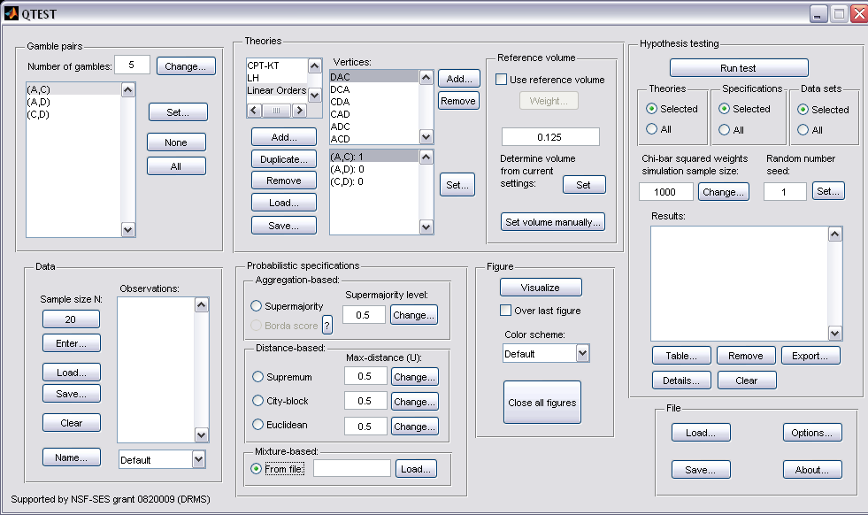

In the “Load Specification” dialogue box that pops up, change the “Files of type:” to “Text files (*.txt)” and then navigate to the location of the “Figure9_MixtureInput.txt” file. Then select “Open”.
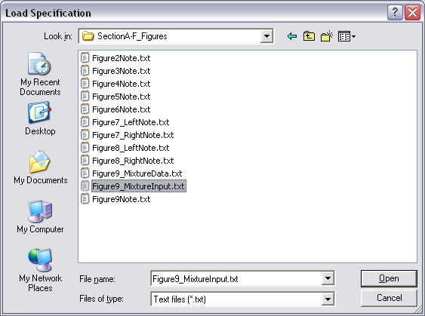

Now “Figure9_MixtureInput.txt” appears under “Mixture-based”. Under “Figure”, select “Visualize”.
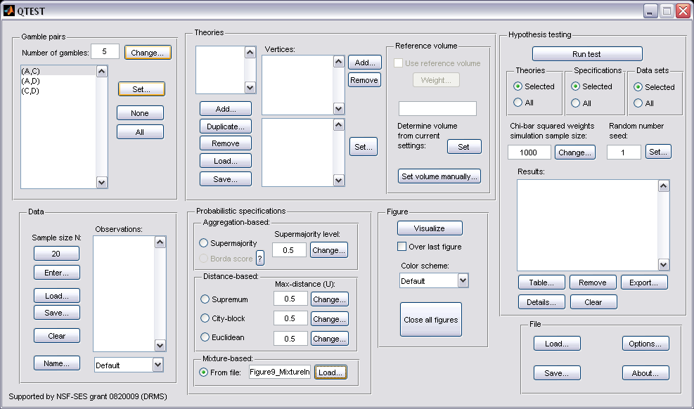

The figure that pops up is a version of Figure 9 of the paper.
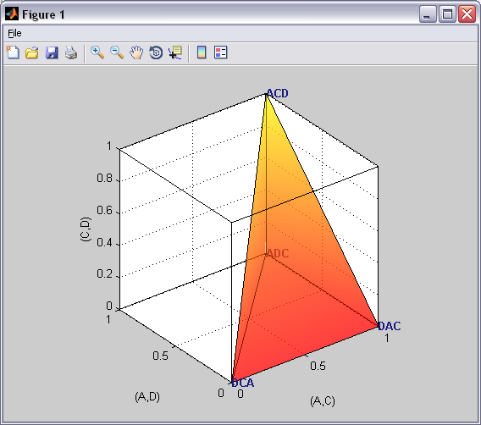

This completes the 3-D example for the mixture model specification for Figure 9 of the paper, and is the last figure of the paper.

PART III: Data Analysis
Part II of the tutorial exclusively dealt with 5 parts of the QTEST interface: “Gamble Pairs”, “Theories”, “Probabilistic Specifications”, “Figure” and “File”. In this last part of the tutorial, we build on this knowledge and also learn how to use the “Data” and “Hypothesis Testing” parts of the QTEST interface in order to test theories on data.

Part II of the tutorial analyzed part of the data set called Cash II to generate the Figures of the paper. Part III of the tutorial analyzes the entire datasets for both Cash I and Cash II.

The objective of this Data Analysis section is to allow a user of QTEST to recreate the results shown in Tables 5 and 6 of the paper QTEST: Quantitative Testing of Theories of Binary Choice made accessible. Just as Part II of the tutorial was organized around the creation of each Figure of the paper, so Part III is organized around the generation of each Table of the paper.

In Part II of the tutorial, it was reasonable to manually enter all of the information needed to generate the Figures of the paper because we only used 3 gamble pairs. In Part III, the data analysis requires 10 gamble pairs, necessarily increasing the amount of information QTEST needs in order to run analyses. While it is certainly possible to enter all of this information manually, that process becomes laborious and error-prone. To circumvent this problem, and approximate research settings (which often have lots of gamble pairs and large data sets), most of the analyses that follow require loading an appropriate input file provided with this tutorial. We will show how one can enter the required information into the QTEST interface manually and, thereafter, will show how to use the input files. Moreover, a set of corresponding output files is also provided so the user of this tutorial can match their work with these files.

Part III of the tutorial encompasses Sections G through K. Sections G and H present detailed examples of data analysis. Section I provides some general guidelines on file nomenclature and different ways to replicate the tables of the paper. Sections J and K allow a user of QTEST to reproduce Tables 5 and 6 of the paper.

G. Data analysis of one theory with one vertex
All files needed for Section G can be found within the folder “SectionG-H_DataAnalysis”, which is downloadable from the QTEST website. If one loads the file “LH_.5_Maj.mat” into QTEST then it will contain all the steps of Section G of this tutorial. We begin with the upper half of Table 5, which is the 0.50-majority/modal choice specification and we analyze LH first.

G.1 Gamble pairs
Starting with a clear (or new) QTEST interface, under “Gamble pairs”, “Change” the “Number of gambles:” to “5” and then select “All”. QTEST should look like the following screenshot.
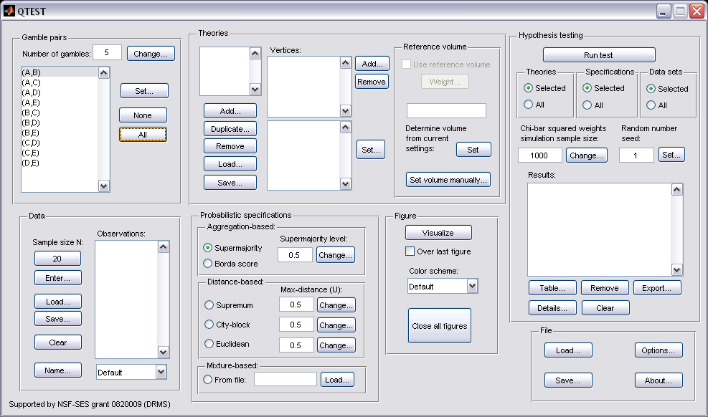

G.2 Theory and vertex
Now we need to define the vertices for LH. Under “Theories”, select “Add…”. In the “Theory” dialogue box that pops up, enter “LH”. Then select “OK”. Under “Vertices:”, select “Add…”. In the “Vertex” dialogue box that pops up, enter “LH” and then select “OK”. QTEST will now look like the following screenshot.
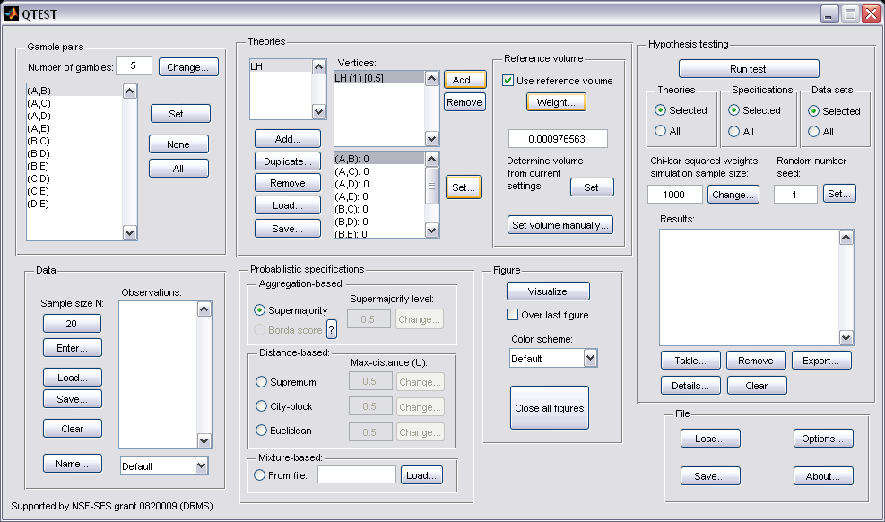

Next, specify the predictions of LH by selecting “Set…” under “Vertices:”.

From the paper, if a decision maker follows LH, they will prefer the first gamble in pairs (A,B), (B,C), (C,D) and (D,E). In the coding of 1’s and 0’s, the decision maker would have a 1 for these four pairs. The decision maker would prefer the second gamble in pairs (A,C), (A,D), (A,E), (B,D), (B,E) and (C,E), which would be coded as a 0 for these 6 pairs. We now translate this logic into QTEST. In the “Set Vertex (Preference)” dialogue box that popped up (after pressing “Set…” under “Vertices:”), select the following gambles from each pair in the window. You should only have to change 4 of the 10 gambles from their default selections:

“A” in pair “(A,B)”
“B” in pair “(A,C)” (default selection)
“D” in pair “(A,D)” (default selection)
“E” in pair “(A,E)” (default selection)
“B” in pair “(B,C)”
“D” in pair “(B,D)” (default selection)
“E” in pair “(B,E)” (default selection)
“C” in pair “(C,D)”
“E” in pair “(C,E)” (default selection)
“D” in pair “(D,E)”

If you have done this correctly, the pop up window should look like the following screenshot. (An arrow is only shown on the screenshot where it was necessary to change the default selection of each pair.) Then press “OK”.
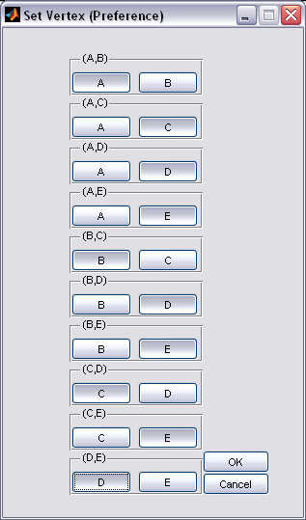

Under “Vertices:”, notice the predictions have been updated. 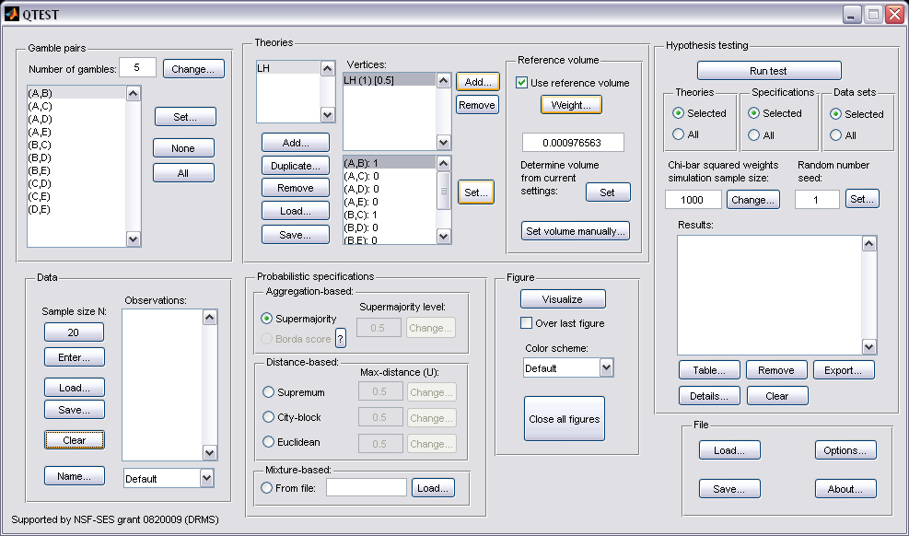

To check if these predictions are correctly defined, the number following each gamble pair in the bottom half of the “Vertices:” section should match the following vector of 1’s and 0’s:

(A,B): 1
(A,C): 0
(A,D): 0
(A,E): 0
(B,C): 1
(B,D): 0
(B,E): 0
(C,D): 1
(C,E): 0
(D,E): 1

G.3 Data
Now that we have defined the gamble pairs and the vertex for LH, we need to enter data, under “Data” in the QTEST interface. For this step, we will briefly overview how one would enter data manually into QTEST using the data from Decision Maker 1 (DM1) and Decision Maker 13 (DM13) of Table 2 of the paper. We will load the data from a file for our analysis of Table 5 of the paper, however, because, with 18 participants and 10 gamble pairs for both Cash I and Cash II data sets, individual data entry would take much time and lead to an increased chance of making an error.

At this point we recommend that at least 20 observations per gamble pair, per person be used in a QTEST analysis. This ensures the assumptions of the asymptotic distributions are reasonably met. Of course, one may use more than 20 observations. But with less than 20 observations the results may be compromised. However, there are exceptions--see the Online Supplement for more details.

Under “Data”, the first selection listed for a user of QTEST is “Sample size N:”.

This “Sample size N:” represents the number of decisions each participant made on each gamble pair in the entire experiment. The default sample size is “20”. To change the sample size, simply select “20” and in the dialogue box that pops up, enter the “Observations per pair:”. And then press “OK” when finished.
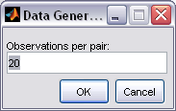

The next button, “Enter…” allows the user to specify the number of times the first gamble (i.e., the gamble “coded as Gamble 1” in Table 2 of the paper) in the gamble pair was selected.

In the “Enter Observations” dialogue box that pops up, there are two choices for entering the data. Option one requires entering the number of times the first gamble was chosen for each gamble pair. We start with DM1 of the paper. Use the 2nd to last column from Table 2 of the paper to get the following. Then press “OK”.
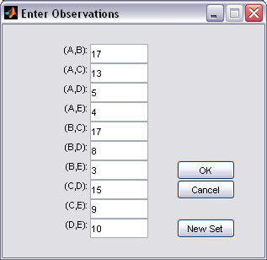

Option two for data entry is to enter the number of times the first gamble was chosen, enter a comma and then enter the number of times the second gamble (i.e., the gamble “coded as Gamble 0” in Table 1 of the paper) was chosen. Here is a different screenshot for the same data as the previous screenshot, but entered in this different format:
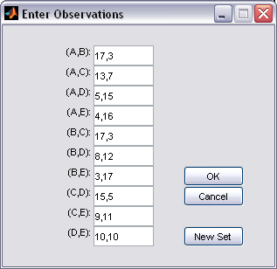

Under “Data”, under “Observations:”, notice that each pair of gambles is followed by two values separated by a comma. The first number (before the comma) represents the number of times the first gamble was selected (in this case 17 times out of 20) and the second number (after the comma) represents the number of times the second gamble was selected by the participant. Also notice that the “Name…” is set to “Default”. Select “Name…” and in the “Data Set” dialogue box that pops up, enter an appropriate name for this data set. Then press “OK”.
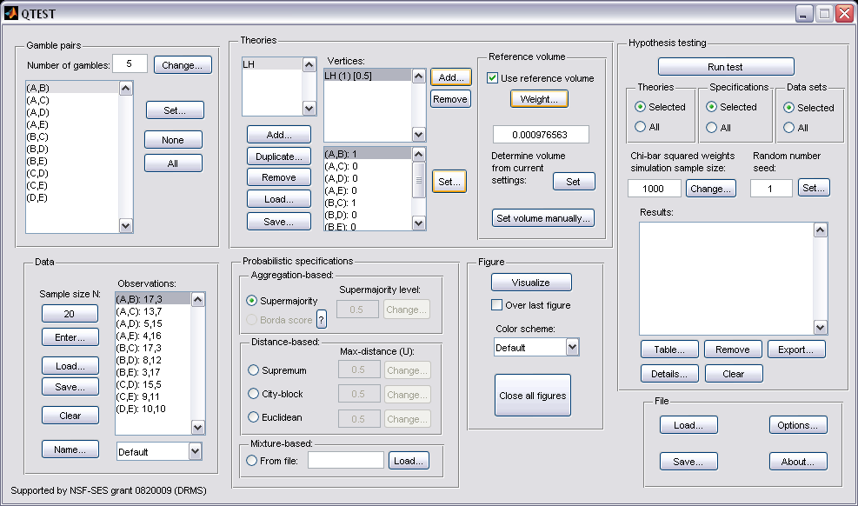

Now we enter the data for DM13 from Table 2 of the paper, which is the last column of that table. Select “Enter…” again.

In the “Enter Observations” dialogue box that pops up, you will see the data from the previous entry, DM1. Select “New Set”. (If the user selects “OK” in this dialogue box, it will overwrite the previously entered data set.)
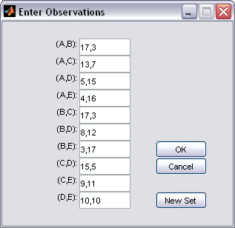

In the QTEST interface, under “Data”, notice in the dropdown menu that there are 2 identical data sets. Select “Set 2” so that it is highlighted. Then select “Enter…”.
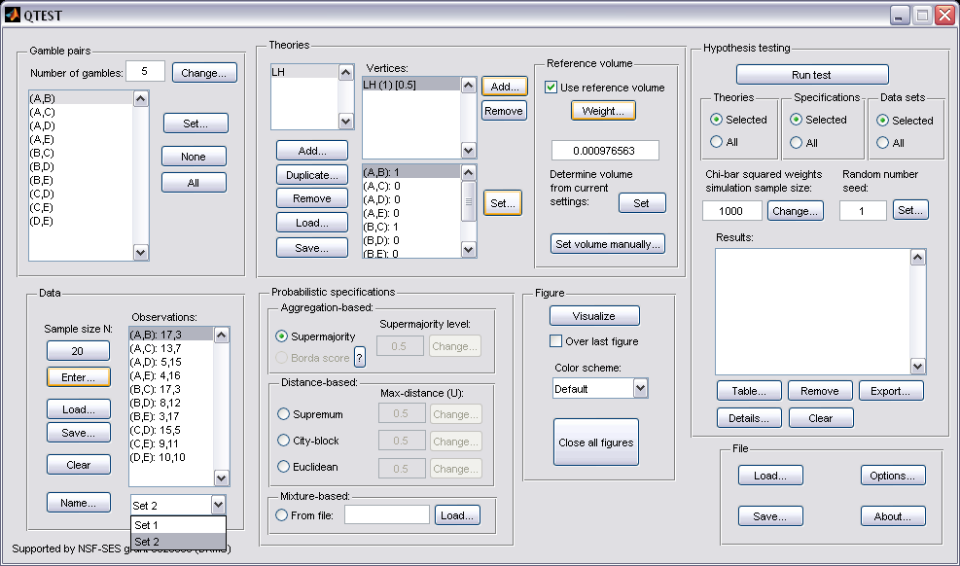

The “Enter Observations” dialogue box initially contains the gambles chosen by DM1 (labeled “Set 1” by default).
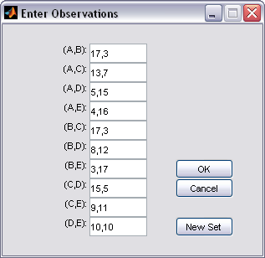

Replace all the entries of this dialogue box with the values for DM13, which can be found in the last column of Table 2 of the paper. When finished, it should look like the following screenshot. Then select “OK”.
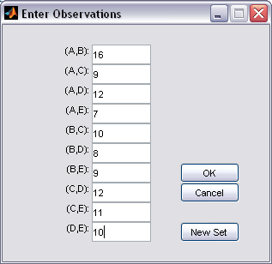

Under “Observations:”, “Set 2” lists the choices of DM13. Replace “Set 2” with “DM13” by selecting “Name…”.
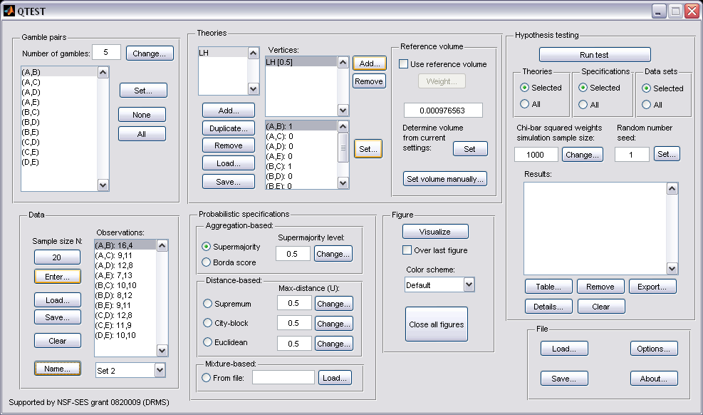

In the “Data Set” dialogue box, enter “DM13”. Then select “OK”.
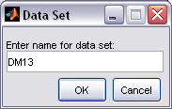

Rename “Set 2” by selecting it from the dropdown menu, select “Name…” and then entering “DM1” in the dialogue box.
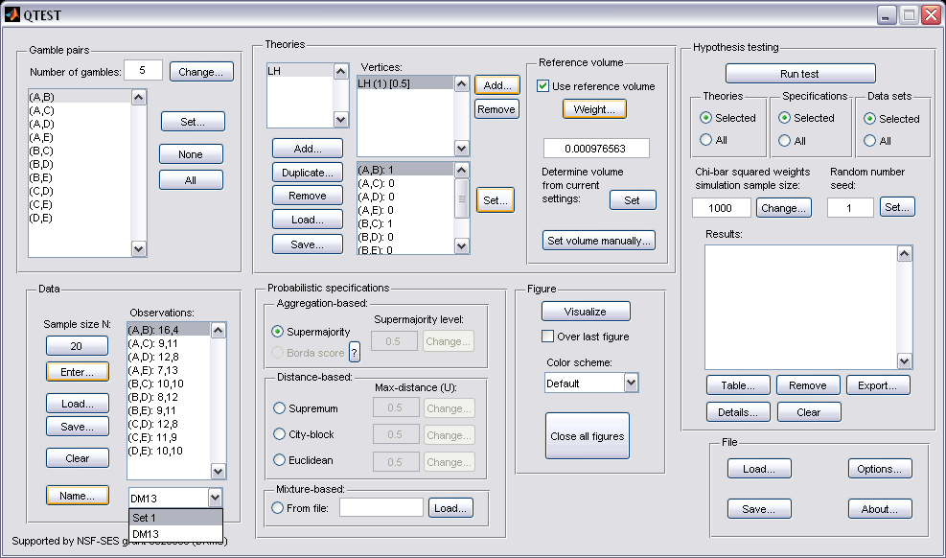

When finished renaming the 2 data sets, they will look like the following.
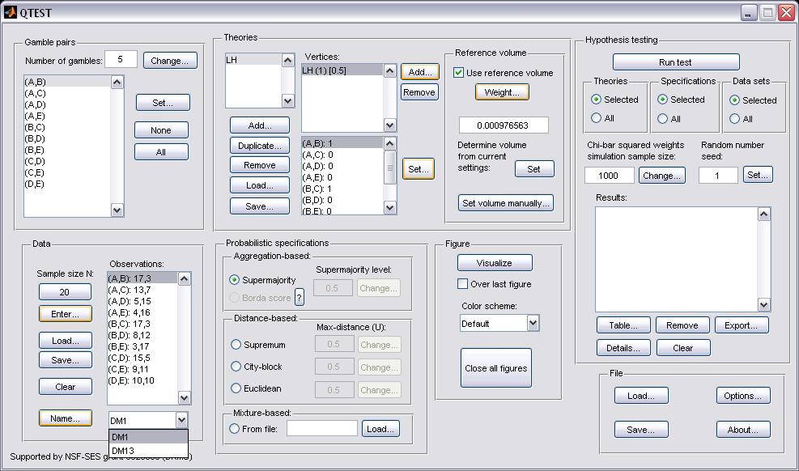

Data from DM1 and DM13 are 2 of the 18 decision makers that comprise the Cash I and Cash II data. We will analyze both Cash I and Cash II in the entirety, starting with Cash I. So we now want to load the Cash I data. Under “Data”, first select “Clear”.
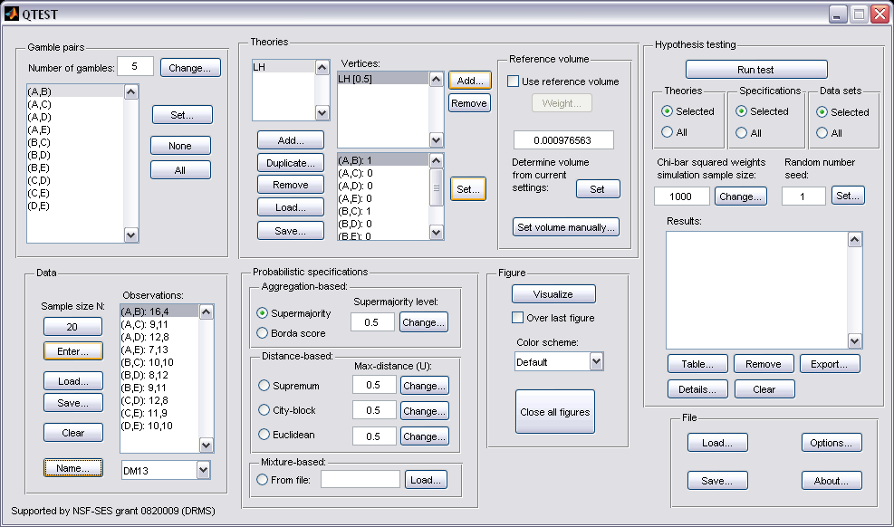

The QTEST interface should now look like the following:
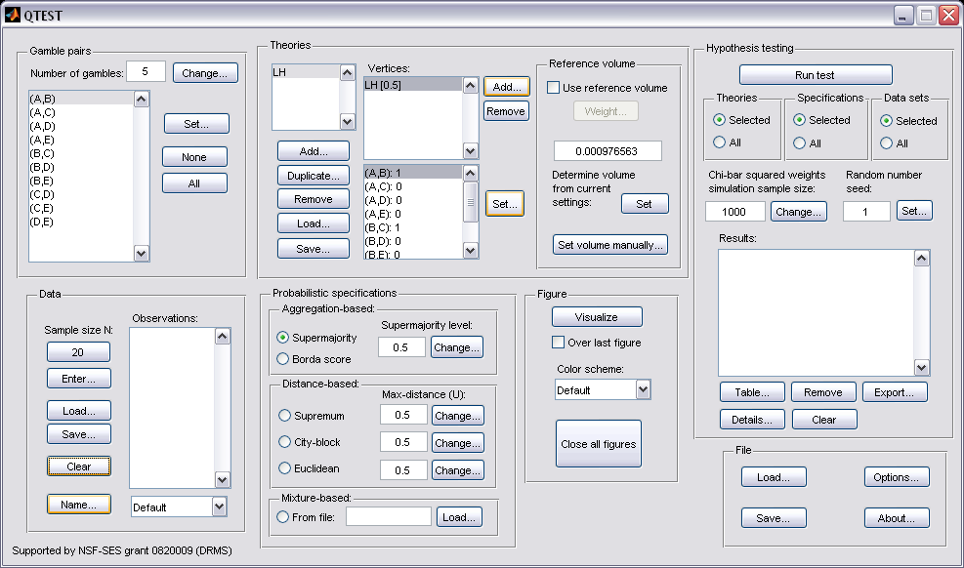

Now we are ready to enter the Cash I data. But before bringing these data into QTEST, we will first examine the specific requirements for this data file. Below is a screenshot of the data file “Cash1.txt”, which we will use to illustrate those requirements.
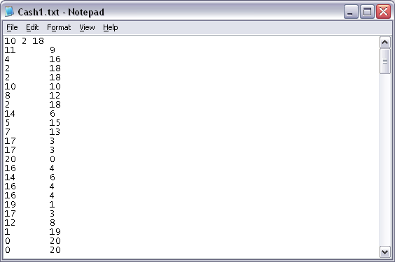
Participant 2 data (10 lines)
Participant 1 data (10 lines)
Tab delimited
1st line

The first line of the data input file must contain 3 values, with a single space between the 1st and 2nd, as well as between the 2nd and 3rd values. Here, the first number of the first line is “10”, which represents the number of gamble pairs. The second number of the first line is “2” which represents the 2-column format of the data that follow. The third number of the first line is “18”, denoting the number of participants.

The data for the 1st participant begin on the second line. The structure of these data must have the number of times the first gamble was chosen as the first entry (left column) and the number of times the second gamble was chosen as the second entry (right column). Here, these two entries are separated by a tab delimiter; but a single space delimiter will also work.

The data for participant 1 encompass lines 2 through 11, for a total of 10 lines. This is because the participant made decisions on all 10 gamble pairs among the five gambles. The data for the Participant 2 begin immediately on the next line after the end of the data for Participant 1. Participant 2 has their data in lines 12 through 21. And, while not shown in this screenshot, the remaining 16 participants in this Cash I data set are also included in the “Cash1.txt file”. (NOTE: optionally, one may separate data sets for each participant with a single blank line, to possibly improve readability.) We now load this file into QTEST.

Under “Data” select “Load…”.

In the “Load Observations” dialogue box that pops up, navigate to the “Cash1.txt” data input file. Then select “Open”.
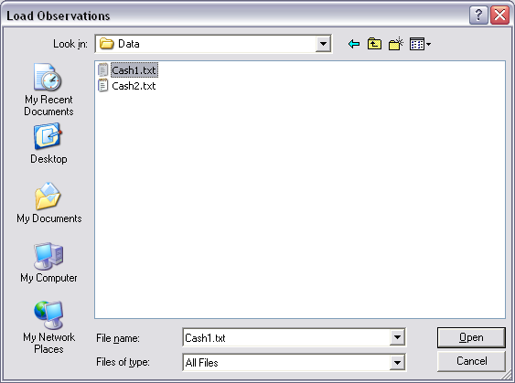

Under “Data” notice the “Observations:” list has now been populated:
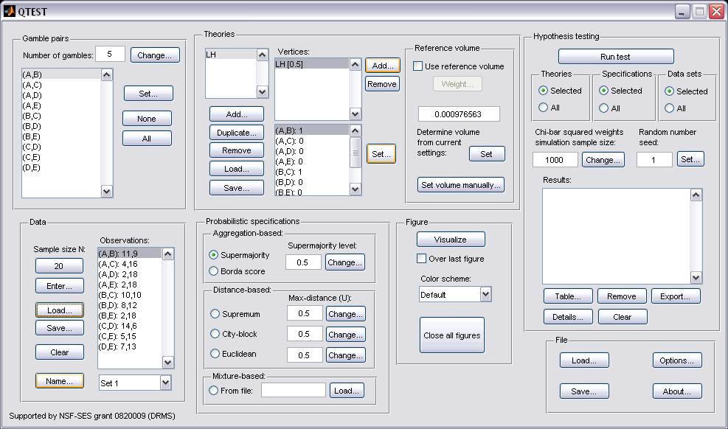

Under “Data”, select the dropdown menu next to “Name…” to see all 18 data sets that have been loaded into the QTEST interface.
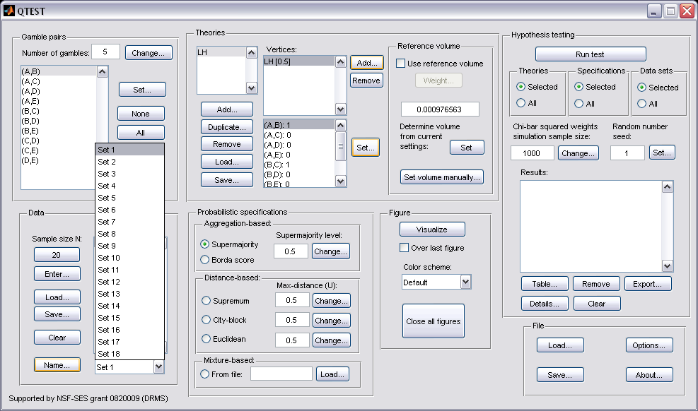

Select any set (it will be gray highlighted) to see the data for that participant. The following screenshot shows the data for “Set 18” (Participant 18).
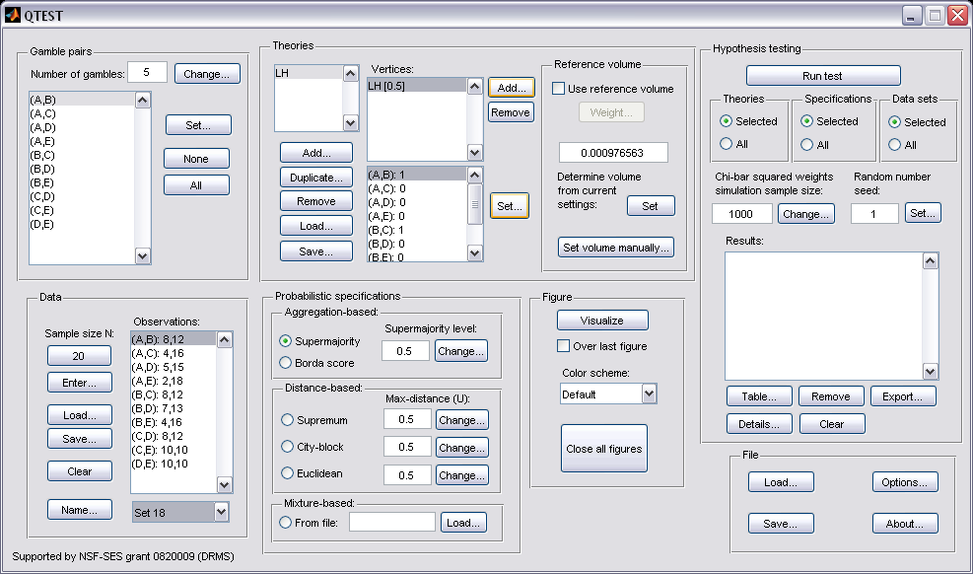

We now have the Cash I data loaded into QTEST. Next we create the probabilistic specification.

G.4 Probabilistic specification
The results of the top-half of Table 5 of the paper are based upon a 0.50-majority/modal choice specification. To set this specification, under “Probabilistic specifications”, make sure the radio button left of “Supermajority” is selected and that the “Supermajority level:” is set to “0.5”.

G.5 Hypothesis testing
We are now ready for the goodness-of-fit test of LH for the Cash I data. Before executing this test, we need to verify that the settings are correct. Under “Hypothesis testing”, under the “Run test” button, there are 3 columns: “Theories”, “Specifications” and “Data sets”. For each of these, the user must choose the radio button next to either “Selected” or “All”.

If the radio button for “Theories” under “Hypothesis testing” is set to “Selected”, then the analysis will only include the theory highlighted in gray in the “Theories” section. For LH, there is only one theory so this radio button is set to “Selected”. (If the radio button were set to “All”, then all theories under “Theories” would be analyzed.”)

If the radio button for “Specifications” under “Hypothesis testing” is set to “Selected”, then the analysis will only include the selected specification under “Probabilistic specifications” where the radio button is selected. In this case, we only want a 0.50-majority/modal choice specification so “Selected” under “Hypothesis testing” is chosen. (If a user wanted to do “All” the specifications, it would be necessary to first set the level of the specification for all “Aggregation-based” and “Distance-based” under “Probabilistic specifications”. Even though only one radio button at a time can be selected under “Probabilistic specifications”, once a change has been made for a particular specification it will continue to be set to that value and used in the analysis.)

Finally, under “Hypothesis testing”, we can analyze data sets individually or analyze the data all at one time. For instance, since we have 18 data sets, if we ran each of these 18 data sets individually, that would require selecting a data set under “Data” each time (from the dropdown menu next to “Name…”) and then “Run test” under “Hypothesis testing” 18 separate times, one for each data set. But if the radio button next to “All” is chosen under “Data sets” under “Hypothesis testing”, then 18 analyses are run all together. But it is important to note that, even when “All” is selected under “Data sets”, data are never aggregated. Each data set is always analyzed on its own and never combined, no matter which radio button is selected. In this case, since we want to analyze the data for all 18 participants, change the radio button selection to “All” under “Data sets”:

Under “Hypothesis testing” there are two more inputs the user may specify: “Chi-bar squared weights simulation sample size” and “Random number seed”. Only advanced users are likely to use these.

The appropriate “Chi-bar squared weights” in the underlying “order-constrained inference” engine that operates `under the hood’ of QTEST are determined based on certain numerical simulations. The simulations use a random sampling process. The larger the sample size, the more accurate the resulting weights, and therefore a more accurate p-value will be computed. Increased accuracy comes at the cost of more computation to reach a result.

If a hypothesis test is repeated on same data, QTEST produces the exact same chi-bar squared weights because the “random” samples are actually simulated, based on a seed. In order to produce another, independent, computation of a hypothesis test, choose a different “Random number seed” under “Hypothesis testing”.

For all results in Tables 4 and 5, the default values of both “Chi-bar squared weights” and “Random number seed” are used.

Now that all the settings under “Hypothesis testing” are correct, select “Run test”. The “Running Hypothesis Test” window will pop up. It starts with an empty, white, horizontal rectangle and fills with red as the analysis progresses.
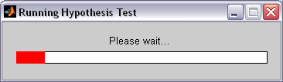

The time for the analysis to complete can vary widely. It depends on many factors: the computer running the analysis, the number of data sets, the type and number of probabilistic specifications, the number of theories, the number of vertices for each theory, the number of simulation sample weights and other factors. (It can be a good idea to just run the hypothesis test for a single data set the first time an analysis is executed so as to get an approximate baseline expectation of how long QTEST may need in order to complete the entire analyses for all data sets. Such a baseline computation may sometimes not be representative of other computations, however, if data or theories vary widely from one analysis to another.) Once the analysis is complete, QTEST will now look like the following screenshot. Under “Hypothesis testing”, under “Results:”, you will see a list of completed analyses.
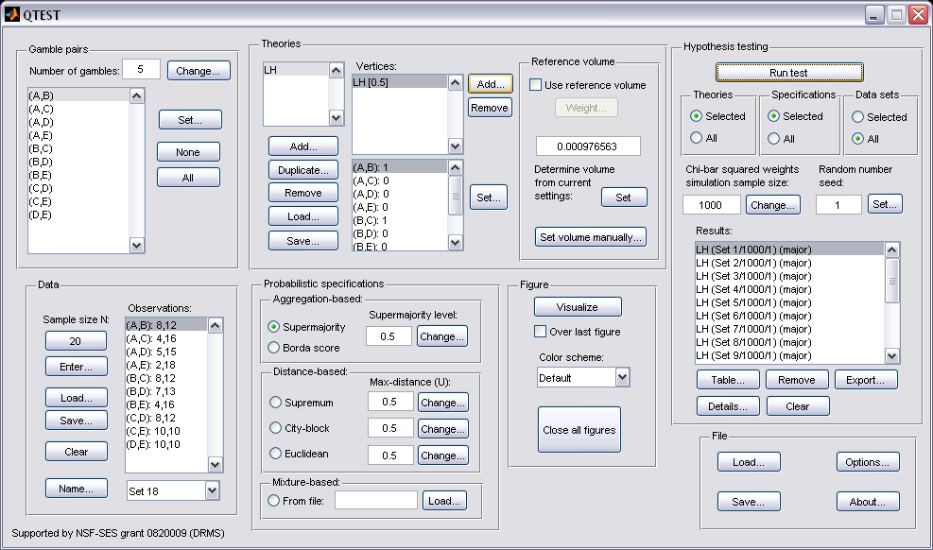

QTEST offers several tools for working with, and examining, the results when the hypothesis testing has completed. Under “Hypothesis testing”, under “Results:”, select “Table…”.

A “Results” window pops up that looks like the following screenshot.
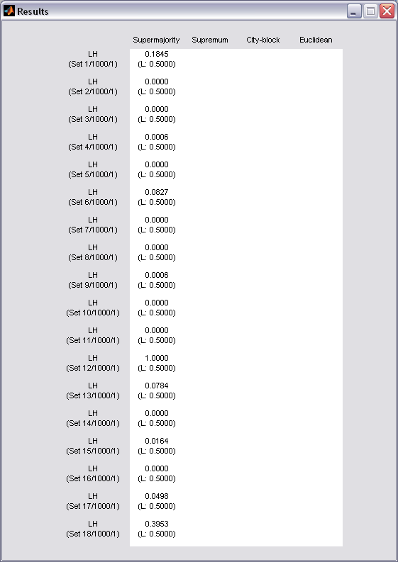

Column headers are the probabilistic specifications “Supermajority”, “Supremum”, “City-block” and “Euclidean”. Each row header contains two lines. The first line denotes the theory name, in this case “LH”. The second line “(Set 1/1000/1)” provides the data set (“Set 1”), the number of simulation samples (“1000”) and the random seed number (“1”). An entry within the table, at the intersection of each row and column header, will provide the p-value, which is the first line and for the circled entry in the screenshot above, that value is “0.1845”. The second line within the table provides the supermajority level. In this case we set it to 0.50 and that is why we see “(L: 0.5000)” in the first cell of the table. (The “L” stands for lambda.)

If the same session of QTEST is used for further analyses, these results will stay in this table. If further results include the same theory and data, but a different probabilistic specification, the appropriate column would be filled in. But if a new theory is used, then the results from this new theory would be appended to the current table.

If a user needs more information, they can select the result for which they wish to see more detail from the “Results:” list and then select “Details…”, as shown in the screenshot below.

A different “Results” window pops up.
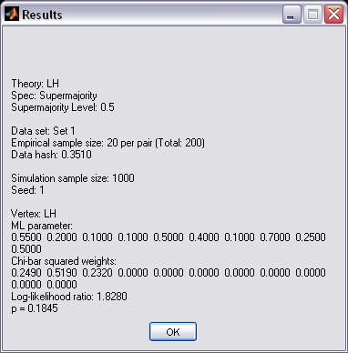

The “Results” window that pops up gives more of the results from the order-constrained inference algorithm developed in Davis-Stober (2009).

The first 4 lines of text, and the 7th and 8th lines of text, give equivalent information to that already discussed in the earlier table format.

The 5th line of text “Empirical sample size: 20 per pair (Total: 200)” simply provides the number of observations for each gamble pair, which was set in “Data”.

The 6th line of text, “Data hash: 0.3510”, is an identifier of the data used in this particular test. It helps identify different data sets in the results table (unless names have been assigned to individual data sets).

The 7th line of text, “Vertex: LH” specifies which vertex was analyzed. In this case, there was only one vertex. But in the event of multiple vertices, there will be a unique set of results for each vertex.

The line of text starting with “ML parameter” contains the maximum likelihood estimates. At least one of these values lies on one of the faces of the supermajority cube that represents the 0.50 supermajority specification. So, here, two best-fitting binary choice probabilities are 0.50. In situations like this, where the point estimates are on the boundary of the parameter space, the log-likelihood statistic does not have a Chi-squared distribution. Rather the statistic developed by Davis-Stober follows a Chi-bar squared distribution, which is a mixture of Chi-square distributions (2009). Here, QTEST has determined the weights of this mixture with the results in the line starting with “Chi-bar squared weights:”

The second to last line of text contains the log-Likelihood ratio: “1.8280”. In the appropriate Chi-bar squared distribution, which is the last line of the output, a log-likelihood ratio value of 1.8180 has a p-value of 0.1845. This represents a non-significant violation. Note that log-likelihood ratio values of different respondents are not directly comparable in a meaningful way because each case is typically modeled by a different Chi-bar squared distribution. Hence, a larger log-likelihood value need not translate into a poorer fit, when comparing two data sets.

Of course, it would be quite tedious to look at each individual result, for each data set, for each vertex for each theory, especially when the number of vertices or data sets, or both, are large. Therefore QTEST can export the results to a spreadsheet format. Under “Hypothesis testing”, under “Results:”, select “Export…”.

An “Export Results As” window pops up. Navigate to the location to save the file. Here we name the file “LH_Cash1_Majority” and save it as a .csv file. Select “Save”.
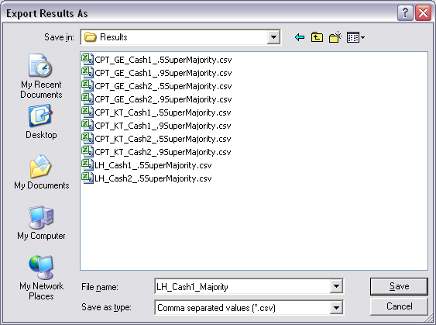

The following screenshot shows the “LH_Cash1_Majority.csv” file. In this case, each column is a different participant, labeled “Set 1” through “Set 18” in columns “B” through “S” of the spreadsheet. All of the information in this spreadsheet is identical to what one would see if they selected “Details…” for each participant. The layout is a little different, however.
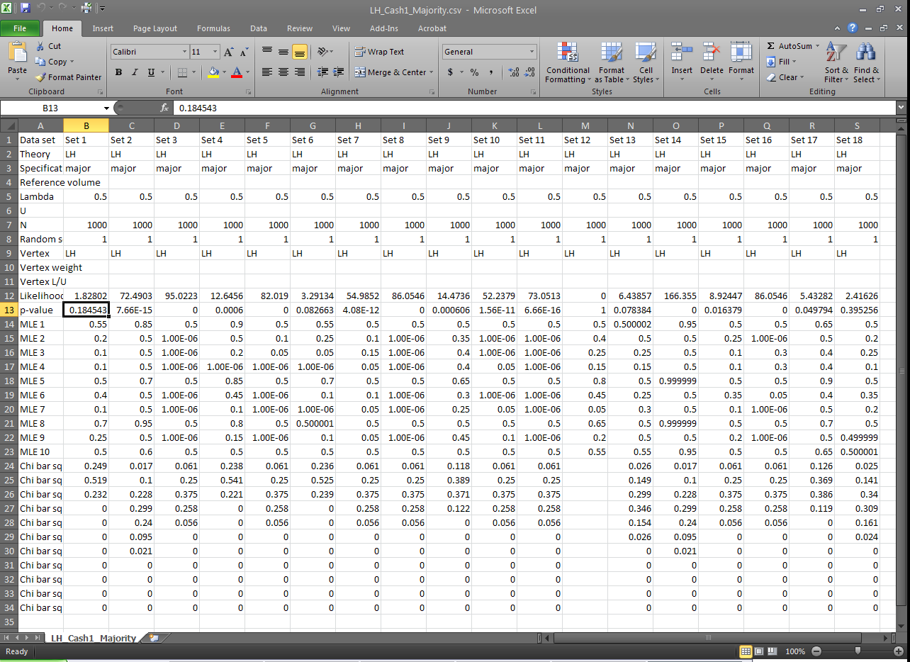

This completes the analysis for Cash I data for LH, which only has 1 vertex. We now consider CPT-GE for the Cash I data, which has 11 vertices.

H. Data analysis of one theory with multiple vertices
There are only two differences between Section G and H. In Section G, we showed how to enter the theory, vertices and data manually. In Section H we show how to load all of this from files, greatly expediting the analysis. The second difference concerns the output. In Section G there was a 1 vertex so there was only one set of results for each experimental data set. But in Section H we have 11 vertices. The structure of these results is different and we will explore those differences. All files needed for Section H can be found in the folder “SectionG_H_DataAnalysis”. Loading the file “Complete_CPT_GE_Cash1_.5M.mat” will give identical results as following all steps in Section H. In order to illustrate how to load files into QTEST and interpret results with multiple vertices, we will analyze the Cash I data for CPT-GE with a 0.50-majority/modal choice specification.

H.1 Gamble pairs
Even though QTEST is designed to store multiple theories, each with their own predictions, we will clear everything from QTEST except the “Gamble pairs” to keep the screenshots easier to follow. The following screenshot shows the 3 selections to clear the interface. Select “Clear” under “Data”; under “Hypothesis testing”, under “Results:”, select “Clear”; and under “Theories”, select “Remove” to remove “LH”. This will also automatically clear the associated vertex.
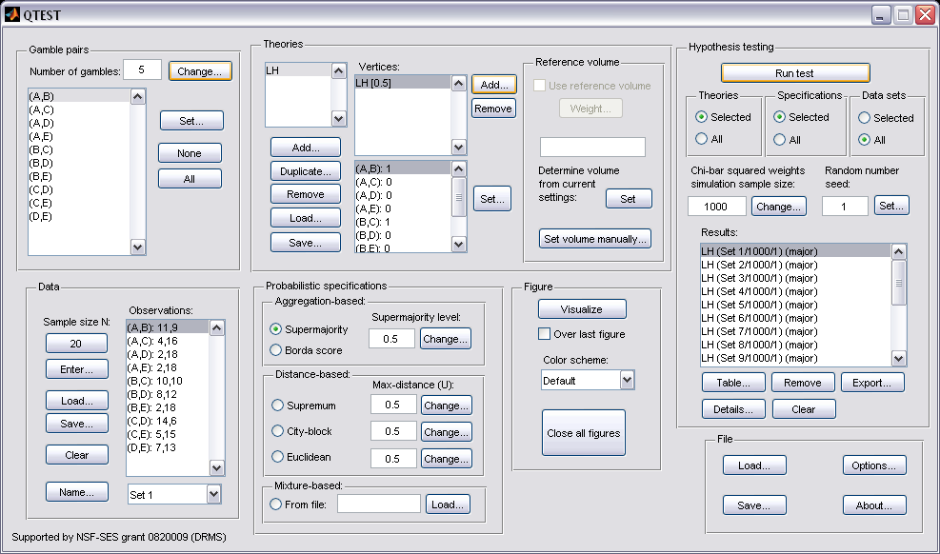

The QTEST interface looks like the following screenshot. We only retain the “Gamble pairs”. If you are starting a new session of QTEST, match the “Gamble pairs” to the screenshot below.
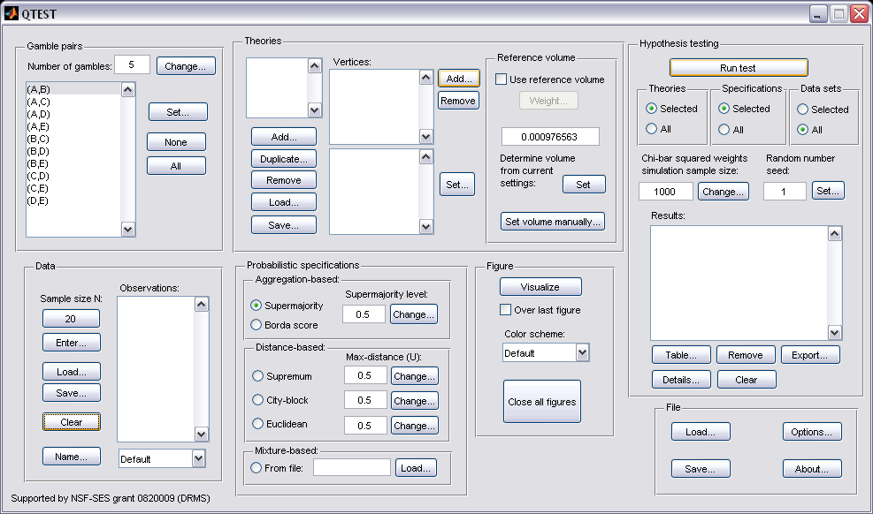

H.2 Theory and vertices
Under “Theories”, select “Load…”.

In the “Load Theory” dialogue window that opens, navigate to the file “Vertices_Cash1_CPT_GE.csv” and then select “Open”.
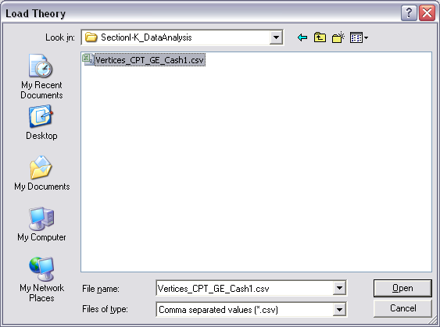

Then a “Theory” dialogue box pops up. Enter “CPT_GE_C1”, where “C1” stands for Cash I. Select “OK”.
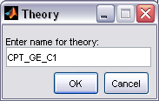

The “Theories” list now contains “CPT_GE_C1” and “Vertices:” lists the 11 predictions of Cash I for CPT-GE.
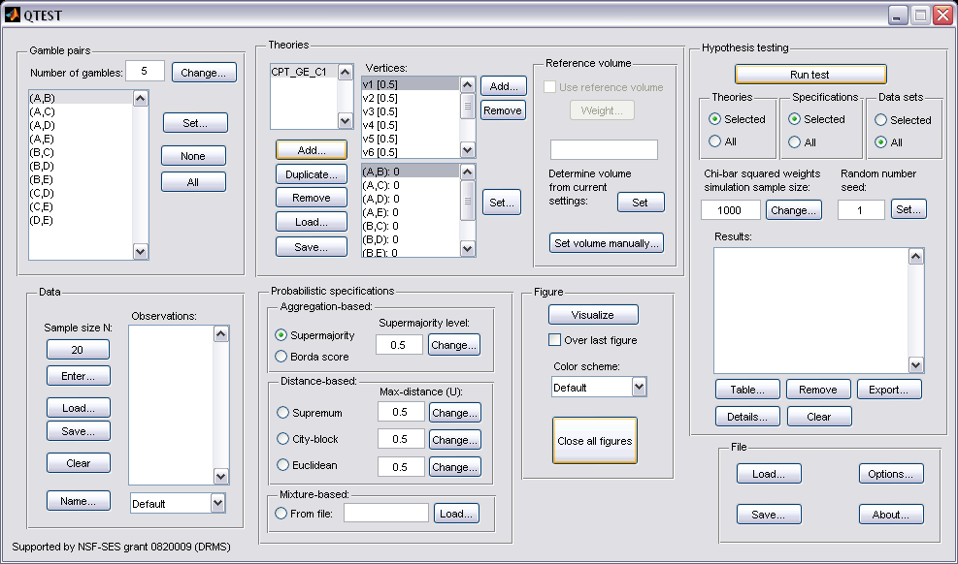

H.3 Data
Next we will enter the Cash I data. Under “Data” select “Load”.

In the “Load Observations” window that pops up, change “Files of type:” to “Text files” and then navigate to the data file “Cash1.txt”. Then select “Open”.
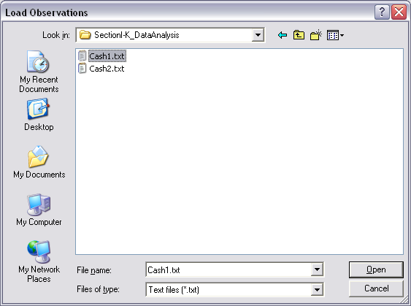

To verify all 18 Cash I data sets loaded properly, under “Data”, next to “Name…” select the dropdown menu. If they loaded, the dropdown menu will list “Set 1”-“Set 18”.
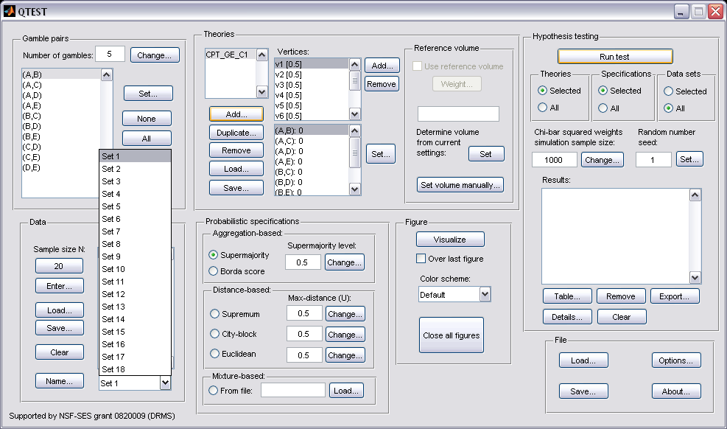

H.4 Probabilistic specification
Under “Probabilistic specifications”, verify that the radio button next to “Supermajority” is selected and that the “Supermajority level:” is set to “0.5”, as in the following screenshot.
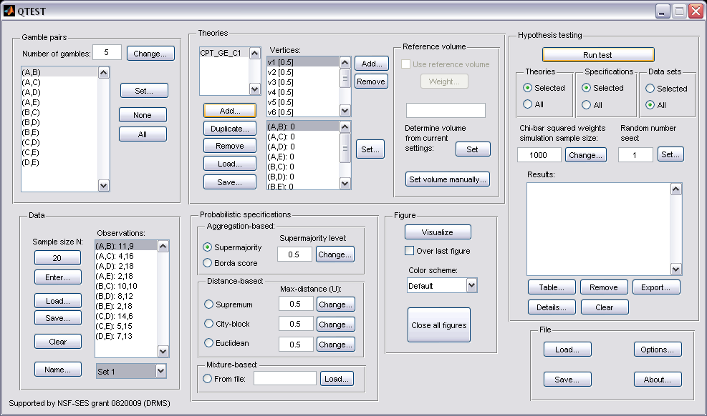

H.5 Hypothesis Testing
Under “Hypothesis testing” verify that the radio button next to “All” under “Data sets” is selected. Then select “Run test”.

Once the analyses completes, under “Results:” you will see the following. 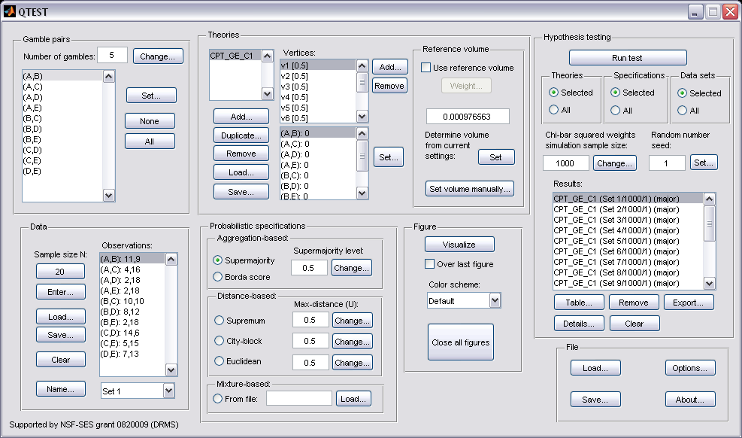

To save the results, under “Results:”, select “Export…”. An “Export Results As” window pops up. Save the file as “Results_CPT_GE_Cash1_.5M.csv”. Select “Save”.
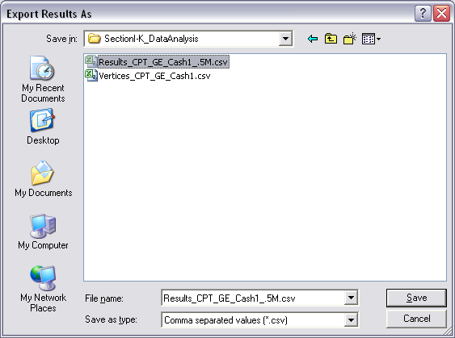

Now open the “Results_CPT_GE_Cash1_.5SM.csv” file we just saved. (Or open the file in the folder “SectionI-K_DataAnalysis” downloaded from the website.) A screenshot of part of the file is provided below. We have added all the highlighting here. The spreadsheet will not contain highlighted cells. First, notice that for Set 1, there are now 11 columns of results, one column for each vertex, as highlighted in yellow. Second, to identify the best fitting vertex for this decision-maker under a 0.50-majority/modal choice specification for the Cash I data, look at the p-values in row 13. Highlighted in green is the p-value of “0.127187”, which is the largest p-value for this participant. Third, each column contains the maximum likelihood estimates for the 10 gamble pairs for this decision maker for each vertex. In order-constrained inference, the best fitting vertex is the one with the largest p-value. The overall p-value of the model is that largest p-value, in the case of Set 1, it is vertex one which has a p-value of 0.127187 . 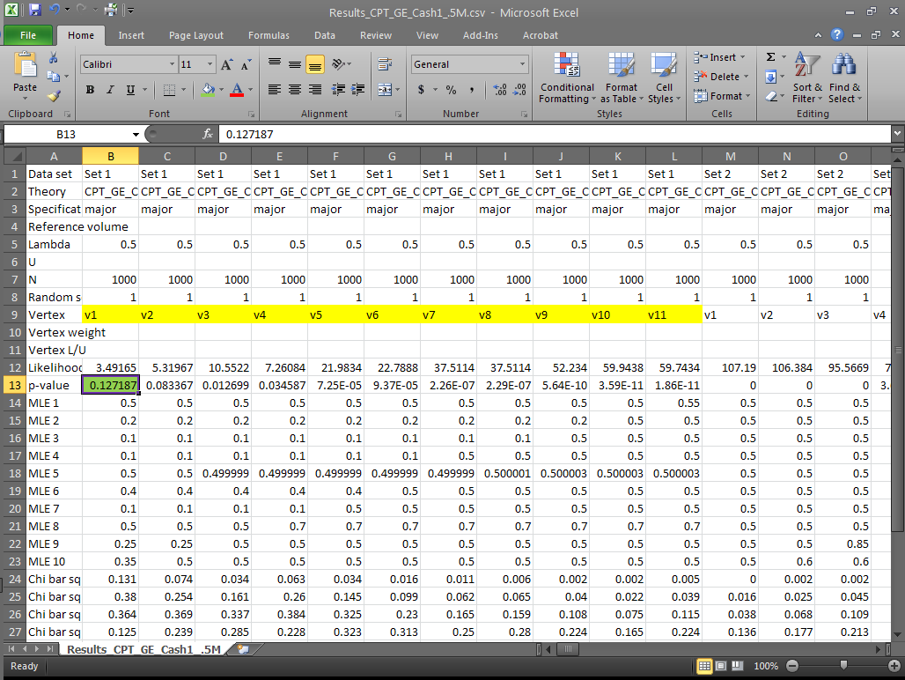

This completes the analysis for the Cash I data for CPT-GE with a 0.50-majority/modal choice specification. We learned how to load the theory, vertices and data file to analyze data in QTEST. And we also saw how to interpret results from a theory with more than one vertex. In Section K we learn how to set, and analyze, vertices with different weights for CPT-GE with a 0.50-majority/modal choice specification for Cash I data.

I. Guidelines for Replicating Tables 5 & 6
We first provide nomenclature guidelines for working with the folders and files for Tables 5 and 6 of the paper. There is a separate folder for each table. Table 5 code and results are contained in the folder “SectionJ_Table5” while Table 6 code and results are contained in the folder “SectionK_Table6”. Both of these folders are organized as follows.

Within each of the main Table folders, there are 5 sub-folders:
“DataSets”
“TheoriesVertices”
“QTEST_Session_Complete”
“QTEST_Session_NoResults”
“QTEST_Results”

The “DataSets” folder contains the raw Cash I and Cash II data sets, in a form ready for analysis by QTEST. Cash I is named “Cash1.txt” while Cash II is named “Cash2.txt”.

The “TheoriesVertices” folder contains the predictions for all of the vertices for the theories LH, CPT-KT and CPT-GE for both Cash I and Cash II predictions. To understand the naming structure of these files, consider the example “Vertices_CPT_GE_Cash1.csv”. “Vertices” means the file contains the vertices (or predictions). “CPT_GE” means these are the predictions for the theory CPT-GE. And “Cash1” means the predictions are based on the Cash I stimuli. QTEST requires the “.csv” extension format to read these files. (For Table 6, the folder is not called “TheoriesVertices” but instead “TheoriesFDI”. And in place of “Vertices” in each file name is “FDI”. Otherwise the nomenclature is identical.)

The folder “QTEST_Session_NoResults” has files that contain the setup of the data set, theory and probabilistic specification—but QTEST has not been run yet. Consider the example file “NR_CPT_GE_Cash1_.5M.mat”. The “NR” means this is a QTEST session that has No Results. “CPT_GE_Cash1” specifies the theory CPT-GE and that the predictions are based on Cash I gambles. “.5M” means 0.50-majority/modal choice specification. Finally, these files end in a “.mat” extension, which QTEST requires. One will also see “.9SM” for some files, instead of “.5M”, which denotes the 0.90-supermajority specification.

The “QTEST_Session_Complete” folder contains the complete QTEST interface setup for a given data set, theory, set of predictions and probabilistic specification as well as the output of the complete analysis. These file names begin with “Complete”, list the theory name next, the data set used, the supermajority specification and end with a .mat extension. Here is an example of this file type: “Complete_CPT_GE_Cash1_.5M.mat”. In this case “Complete” denotes this analysis has the complete setup and a completed analysis. “CPT_GE” means the theory analyzed. “Cash1” is the data set. And “.5M” means 0.50-majority/modal choice specification. One will also see “.9SM” for some files, instead of “.5M”, which denotes the 0.90-supermajority specification.

The folder “QTEST_Results” contains .csv spreadsheet files with the output from the analysis. For instance, “Results_CPT_GE_Cash1_.5M.csv”.

Using the files provided, a user can replicate the results of Table 5 and 6 of the paper using one of the following three methods.
- The first method is similar to how one might proceed if they have collected experimental data and are ready to do an analysis in QTEST.
- First, in the QTEST interface, set the “Number of gambles:” under “Gamble pairs”. For the tables of the paper 5 gambles (or 10 gamble pairs) are needed.
- Second, under “Data” in the QTEST interface, select “Load”. Navigate to one of the data files (either “Cash1.txt” or “Cash2.txt”) from the “DataSets” folder downloaded from the website.
- Third, under “Theories” in the QTEST interface, select “Load” and navigate to the “TheoriesVertices” folder and select one of the files. (If one is trying to replicate parts of Table 7, select “Load” from the “Mixture-based” specification instead of the “Theories” section.)
- Fourth, one will need to select the appropriate probabilistic specification in the QTEST interface. (Table 7 does not require this step.)
- Finally, under “Hypothesis testing” in the QTEST interface select all (or a subset) of the data and then select “Run test”.
- For the second method the gamble pairs are already defined, the data are automatically loaded, the theories and vertices are set and the probabilistic specification is defined. The only difference from the first method is that the analysis has not actually been run. This is useful, for instance, if one would like to set up their analysis to run, save it and wait until a computer is available to run the analysis. These files are in the folder “QTEST_Session_NoResults”. To use this method, simply select “Load…” under “File” and navigate to the appropriate file. And then select “Run test” under “Hypothesis testing”.
- The third method is similar to how one might proceed if one has already run an analysis in QTEST but would like to look again at that completed analyses. With this method all gamble pairs are defined, the data is automatically loaded, the theories and vertices are set and the probabilistic specification is automatically loaded. The “Results” are also completed and loaded. One can view those results in table format from the QTEST interface or export them to a .csv file. These files are in the “QTEST_Session_Complete”.

We will illustrate all three of the methods now, analyzing the Cash I data for LH with a 0.50-majority/modal choice specification. The files for each method are in the folder “SectionL_3Methods”.

Method 1
First, in the QTEST interface, set the “Number of gambles:” under “Gamble pairs” to 5. Then select “All” (also under “Gamble pairs”) so all 10 gamble pairs are now listed. Second, under “Data” in the QTEST interface, select “Load”. Navigate to “Cash1.txt” in the “SectionI_3Methods” folder, in the folder “Method1”, and then select “Open”. Third, under “Theories”, select “Load” and navigate to the file “Vertices_LH_Cash1.csv” and then select “Open”. In the “Theory” dialogue box that pops up enter “LH_C1” and then select “OK”. Finally, set the “Probabilistic specification” to “Supermajority” at the “0.5” level.

Once these changes have been completed, the QTEST interface should look like the following screenshot. If your session of QTEST matches the screenshot, you can now reproduce the results of Table 5 of the paper for LH for Cash I data with a 0.50-majority/modal choice specification. To reproduce those results, under “Hypothesis testing” in the QTEST interface, select “All” under “Data sets” and then select “Run test”. (Load the file “NR_LH_Cash1_.5M.mat” to replicate the following screenshot.)

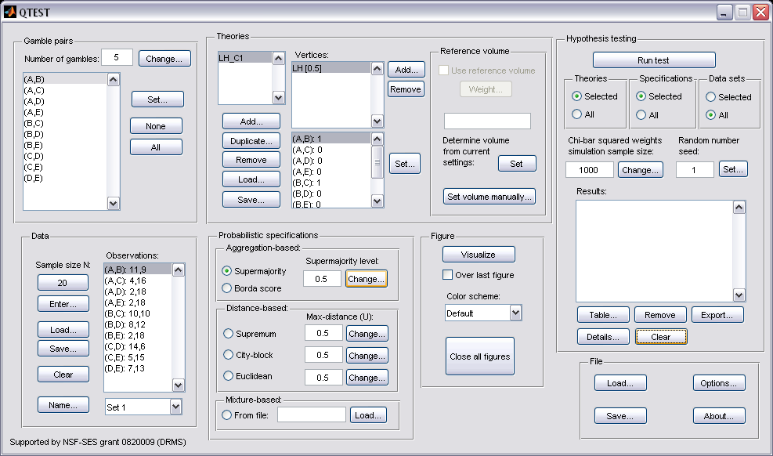

Method 2
Under “File” of the QTEST interface, select “Load…”.

Navigate to the file “NR_LH_Cash1_.5M.mat”. After completing this step the QTEST interface should look like the following screenshot. Especially notice that the “Results:” are NOT completed yet. At this point one would need to select “Run test” under “Hypothesis testing” if they wanted to complete this analysis.

Method 3
Under “File” of the QTEST interface, select “Load…”.

Navigate to the file “Complete_LH_Cash1_.5M.mat” and load it. After finishing this step the QTEST interface should look like the following screenshot. Especially notice that the “Results:” are automatically loaded.
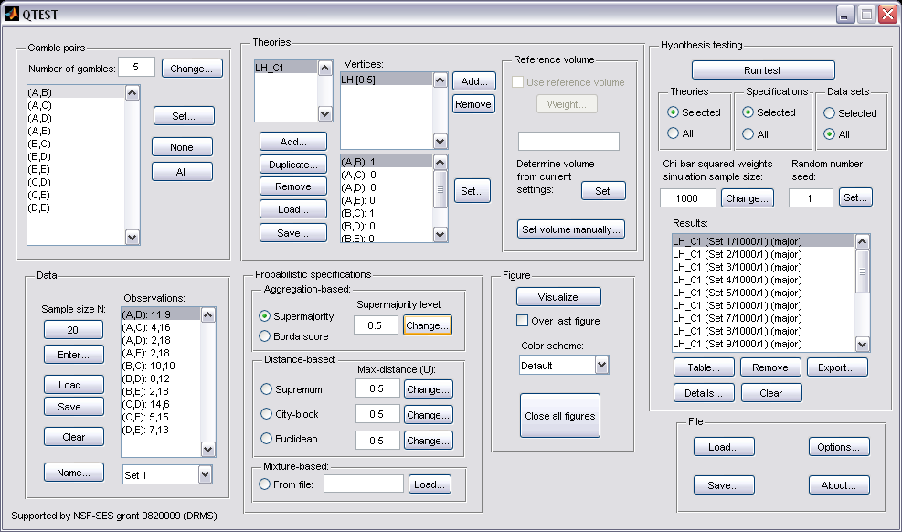

Results
No matter which of the 3 methods were used, if all of the steps were properly completed, the completed QTEST analysis should now look like the following screenshot.

At this point one can verify they have completed the analysis correctly by comparing these results to the appropriate column of Table 5 of the paper or by looking at the file “Results_LH_Cash1_.5M.csv”.

For Sections J and K only the file names and folders are provided for each of the 3 methods just described.

J. Table 5 of the paper
The following section will replicate all results of Table 5 of the paper. Each of the 10 subsections (J.1, J.2, …, J.9, J.10) replicate a different column of Table 5.

J.1 Cash I, LH, 0.50-Majority/modal choice
In this section we analyze the Cash I data for LH with a 0.50-majority/modal choice specification. All files are contained in the folder “SectionJ_Table5”
Method 1
- Set the “Number of gambles:” under “Gamble pairs” to 5. Then select “All” (also under “Gamble pairs”) so all 10 gamble pairs are now listed.
- Under “Data”, select “Load”. Navigate to “Cash1.txt” in the “DataSets” folder and then select “Open”.
- Under “Theories”, select “Load” and navigate to the folder “TheoriesVertices”. Select the file “Vertices_LH_Cash1.csv” and then select “Open”. In the “Theory” dialogue box that pops up enter “LH_C1” and then select “OK”.
- Set the “Probabilistic specification” to “Supermajority” at the “0.5” level.
- Under “Hypothesis testing”, select “All” under “Data sets” and then select “Run test”.
Method 2
- Under “File” of the QTEST interface, select “Load…”. Navigate to the “QTEST_Session_NoResults” folder and open the file “NR_LH_Cash1_.5M.mat”.
- Under “Hypothesis testing”, select “All” under “Data sets” and then select “Run test”.
Method 3
- Under “File” of the QTEST interface, select “Load…”. Navigate to the “QTEST_Session_Complete” folder and open the file “Complete_LH_Cash1_.5M.mat”.
Results
- The results for this section are in the folder “QTEST_Results” in the file “Results_LH_Cash1_.5M.csv”.

J.2 Cash II, LH, 0.50-Majority/modal choice
In this section we analyze the Cash II data for LH with a 0.50-majority/modal choice specification.
Method 1
- Set the “Number of gambles:” under “Gamble pairs” to 5. Then select “All” (also under “Gamble pairs”) so all 10 gamble pairs are now listed.
- Under “Data”, select “Load”. Navigate to “Cash2.txt” in the “DataSets” folder and then select “Open”.
- Under “Theories”, select “Load” and navigate to the folder “TheoriesVertices”. Select the file “Vertices_LH_Cash2.csv” and then select “Open”. In the “Theory” dialogue box that pops up enter “LH_C2” and then select “OK”.
- Set the “Probabilistic specification” to “Supermajority” at the “0.5” level.
- Under “Hypothesis testing”, select “All” under “Data sets” and then select “Run test”.
Method 2
- Under “File” of the QTEST interface, select “Load…”. Navigate to the “QTEST_Session_NoResults” folder and open the file “NR_LH_Cash2_.5M.mat”.
- Under “Hypothesis testing”, select “All” under “Data sets” and then select “Run test”.
Method 3
- Under “File” of the QTEST interface, select “Load…”. Navigate to the “QTEST_Session_Complete” folder and open the file “Complete_LH_Cash2_.5M.mat”.
Results
- The results for this section are in the folder “QTEST_Results” in the file “Results_LH_Cash2_.5M.csv”.
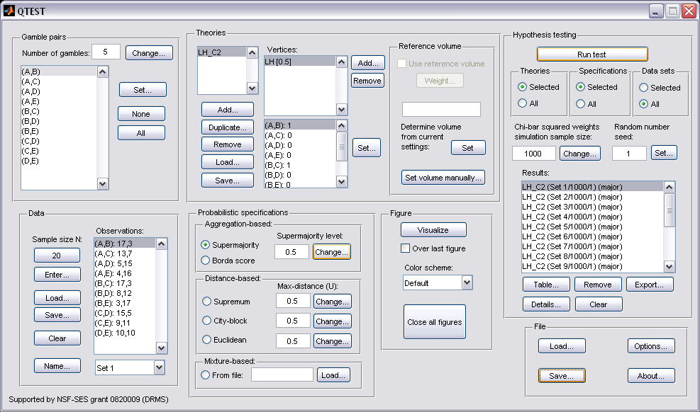

J.3 Cash I, CPT-KT, 0.50-Majority/modal choice
In this section we analyze the Cash I data for CPT-KT with a 0.50-majority/modal choice specification.
Method 1
- Set the “Number of gambles:” under “Gamble pairs” to 5. Then select “All” (also under “Gamble pairs”) so all 10 gamble pairs are now listed.
- Under “Data”, select “Load”. Navigate to “Cash1.txt” in the “DataSets” folder and then select “Open”.
- Under “Theories”, select “Load” and navigate to the folder “TheoriesVertices”. Select the file “Vertices_CPT_KT_Cash1.csv” and then select “Open”. In the “Theory” dialogue box that pops up enter “CPT_KT_C1” and then select “OK”.
- Set the “Probabilistic specification” to “Supermajority” at the “0.5” level.
- Under “Hypothesis testing”, select “All” under “Data sets” and then select “Run test”.
Method 2
- Under “File” of the QTEST interface, select “Load…”. Navigate to the “QTEST_Session_NoResults” folder and open the file “NR_CPT_KT_Cash1_.5M.mat”.
- Under “Hypothesis testing”, select “All” under “Data sets” and then select “Run test”.
Method 3
- Under “File” of the QTEST interface, select “Load…”. Navigate to the “QTEST_Session_Complete” folder and open the file “Complete_CPT_KT_Cash1_.5M.mat”.
Results
- The results for this section are in the folder “QTEST_Results” in the file “Results_CPT_KT_Cash1_.5M.csv”.
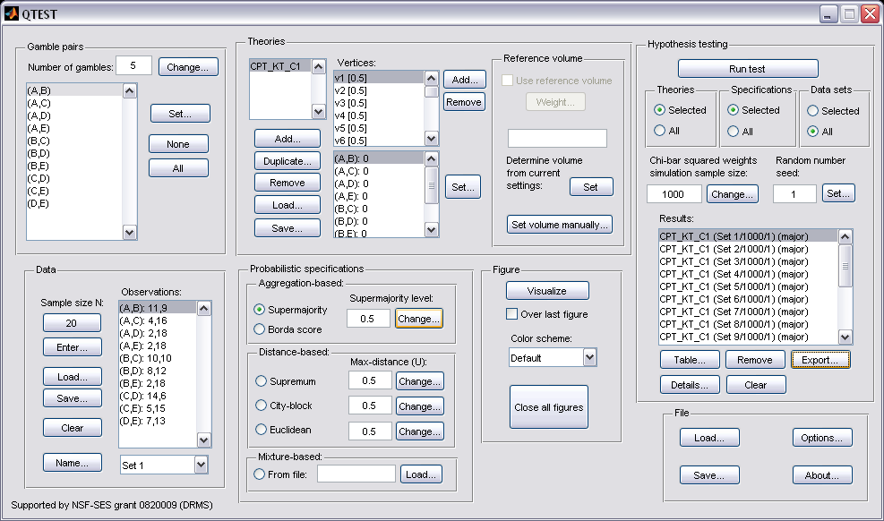

J.4 Cash I, CPT-KT, 0.90-Supermajority
In this section we analyze the Cash I data for CPT-KT with a 0.90-supermajority specification.
Method 1
- Set the “Number of gambles:” under “Gamble pairs” to 5. Then select “All” (also under “Gamble pairs”) so all 10 gamble pairs are now listed.
- Under “Data”, select “Load”. Navigate to “Cash1.txt” in the “DataSets” folder and then select “Open”.
- Under “Theories”, select “Load” and navigate to the folder “TheoriesVertices”. Select the file “Vertices_CPT_KT_Cash1.csv” and then select “Open”. In the “Theory” dialogue box that pops up enter “CPT_KT_C1” and then select “OK”.
- Set the “Probabilistic specification” to “Supermajority” at the “0.9” level.
- Under “Hypothesis testing”, select “All” under “Data sets” and then select “Run test”.
Method 2
- Under “File” of the QTEST interface, select “Load…”. Navigate to the “QTEST_Session_NoResults” folder and open the file “NR_CPT_KT_Cash1_.9SM.mat”.
- Under “Hypothesis testing”, select “All” under “Data sets” and then select “Run test”.
Method 3
- Under “File” of the QTEST interface, select “Load…”. Navigate to the “QTEST_Session_Complete” folder and open the file “Complete_CPT_KT_Cash1_.9SM.mat”.
Results
- The results for this section are in the folder “QTEST_Results” in the file “Results_CPT_KT_Cash1_.9SM.csv”.
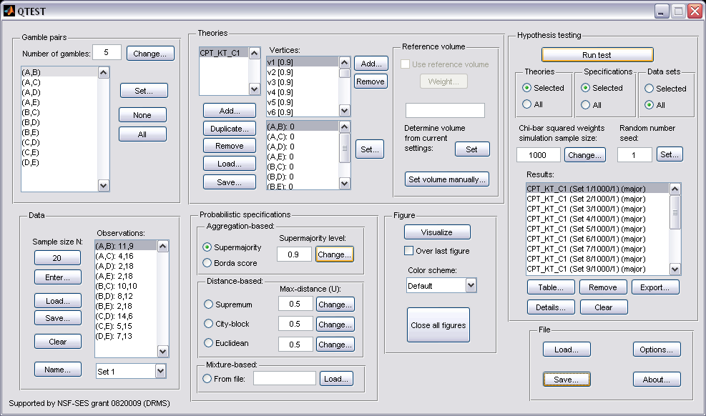

J.5 Cash I, CPT-GE, 0.50-Majority/modal choice
In this section we analyze the Cash I data for CPT-GE with a 0.50-majority/modal choice specification.
Method 1
- Set the “Number of gambles:” under “Gamble pairs” to 5. Then select “All” (also under “Gamble pairs”) so all 10 gamble pairs are now listed.
- Under “Data”, select “Load”. Navigate to “Cash1.txt” in the “DataSets” folder and then select “Open”.
- Under “Theories”, select “Load” and navigate to the folder “TheoriesVertices”. Select the file “Vertices_CPT_GE_Cash1.csv” and then select “Open”. In the “Theory” dialogue box that pops up enter “CPT_GE_C1” and then select “OK”.
- Set the “Probabilistic specification” to “Supermajority” at the “0.5” level.
- Under “Hypothesis testing”, select “All” under “Data sets” and then select “Run test”.
Method 2
- Under “File” of the QTEST interface, select “Load…”. Navigate to the “QTEST_Session_NoResults” folder and open the file “NR_CPT_GE_Cash1_.5M.mat”.
- Under “Hypothesis testing”, select “All” under “Data sets” and then select “Run test”.
Method 3
- Under “File” of the QTEST interface, select “Load…”. Navigate to the “QTEST_Session_Complete” folder and open the file “Complete_CPT_GE_Cash1_.5M.mat”.
Results
- The results for this section are in the folder “QTEST_Results” in the file “Results_CPT_GE_Cash1_.5M.csv”.
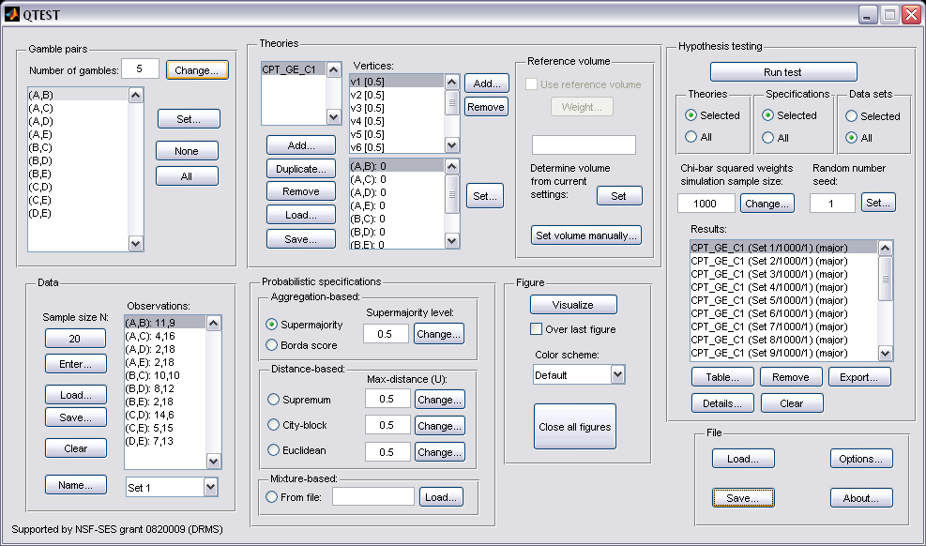

J.6 Cash I, CPT-GE, 0.90-Supermajority
In this section we analyze the Cash I data for CPT-GE with a 0.90-supermajority specification.
Method 1
- Set the “Number of gambles:” under “Gamble pairs” to 5. Then select “All” (also under “Gamble pairs”) so all 10 gamble pairs are now listed.
- Under “Data”, select “Load”. Navigate to “Cash1.txt” in the “DataSets” folder and then select “Open”.
- Under “Theories”, select “Load” and navigate to the folder “TheoriesVertices”. Select the file “Vertices_CPT_GE_Cash1.csv” and then select “Open”. In the “Theory” dialogue box that pops up enter “CPT_GE_C1” and then select “OK”.
- Set the “Probabilistic specification” to “Supermajority” at the “0.9” level.
- Under “Hypothesis testing”, select “All” under “Data sets” and then select “Run test”.
Method 2
- Under “File” of the QTEST interface, select “Load…”. Navigate to the “QTEST_Session_NoResults” folder and open the file “NR_CPT_GE_Cash1_.9SM.mat”.
- Under “Hypothesis testing”, select “All” under “Data sets” and then select “Run test”.
Method 3
- Under “File” of the QTEST interface, select “Load…”. Navigate to the “QTEST_Session_Complete” folder and open the file “Complete_CPT_GE_Cash1_.9SM.mat”.
Results
- The results for this section are in the folder “QTEST_Results” in the file “Results_CPT_GE_Cash1_.9SM.csv”.
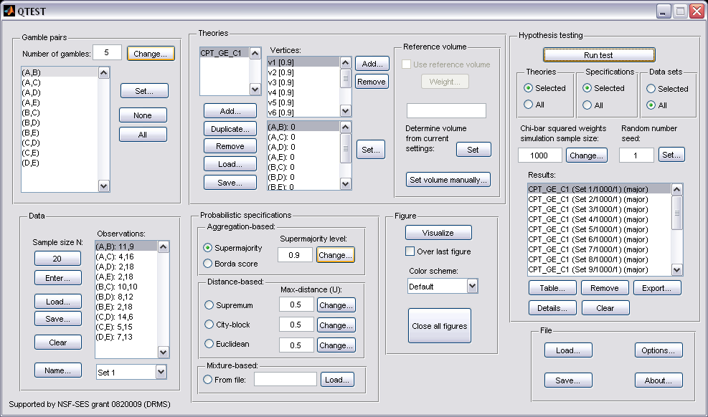

J.7 Cash II, CPT-KT, 0.50-Majority/modal choice
In this section we analyze the Cash II data for CPT-KT with a 0.50-majority/modal choice specification.
Method 1
- Set the “Number of gambles:” under “Gamble pairs” to 5. Then select “All” (also under “Gamble pairs”) so all 10 gamble pairs are now listed.
- Under “Data”, select “Load”. Navigate to “Cash2.txt” in the “DataSets” folder and then select “Open”.
- Under “Theories”, select “Load” and navigate to the folder “TheoriesVertices”. Select the file “Vertices_CPT_KT_Cash2.csv” and then select “Open”. In the “Theory” dialogue box that pops up enter “CPT_KT_C2” and then select “OK”.
- Set the “Probabilistic specification” to “Supermajority” at the “0.5” level.
- Under “Hypothesis testing”, select “All” under “Data sets” and then select “Run test”.
Method 2
- Under “File” of the QTEST interface, select “Load…”. Navigate to the “QTEST_Session_NoResults” folder and open the file “NR_CPT_KT_Cash2_.5M.mat”.
- Under “Hypothesis testing”, select “All” under “Data sets” and then select “Run test”.
Method 3
- Under “File” of the QTEST interface, select “Load…”. Navigate to the “QTEST_Session_Complete” folder and open the file “Complete_CPT_KT_Cash2_.5M.mat”.
Results
- The results for this section are in the folder “QTEST_Results” in the file “Results_CPT_KT_Cash2_.5M.csv”.
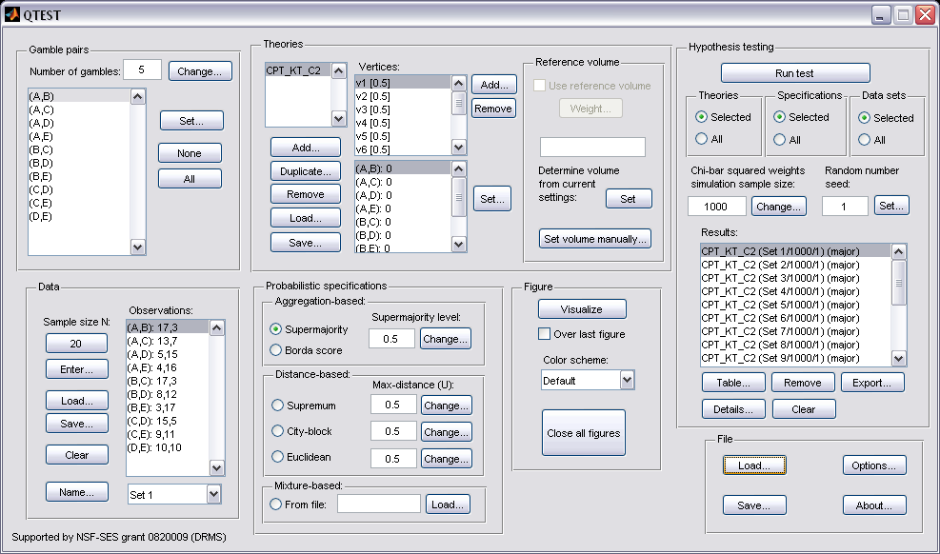

J.8 Cash II, CPT-KT, 0.90-Supermajority
In this section we analyze the Cash II data for CPT-KT with a 0.90-supermajority specification.
Method 1
- Set the “Number of gambles:” under “Gamble pairs” to 5. Then select “All” (also under “Gamble pairs”) so all 10 gamble pairs are now listed.
- Under “Data”, select “Load”. Navigate to “Cash2.txt” in the “DataSets” folder and then select “Open”.
- Under “Theories”, select “Load” and navigate to the folder “TheoriesVertices”. Select the file “Vertices_CPT_KT_Cash2.csv” and then select “Open”. In the “Theory” dialogue box that pops up enter “CPT_KT_C2” and then select “OK”.
- Set the “Probabilistic specification” to “Supermajority” at the “0.9” level.
- Under “Hypothesis testing”, select “All” under “Data sets” and then select “Run test”.
Method 2
- Under “File” of the QTEST interface, select “Load…”. Navigate to the “QTEST_Session_NoResults” folder and open the file “NR_CPT_KT_Cash2_.9SM.mat”.
- Under “Hypothesis testing”, select “All” under “Data sets” and then select “Run test”.
Method 3
- Under “File” of the QTEST interface, select “Load…”. Navigate to the “QTEST_Session_Complete” folder and open the file “Complete_CPT_KT_Cash2_.9SM.mat”.
Results
- The results for this section are in the folder “QTEST_Results” in the file “Results_CPT_KT_Cash2_.9SM.csv”.
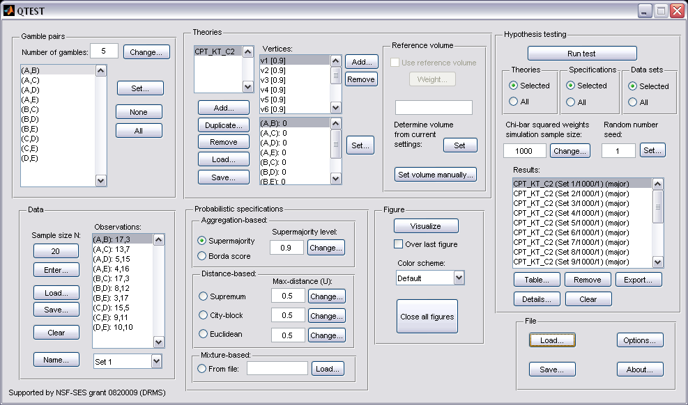

J.9 Cash II, CPT-GE, 0.50-Majority/modal choice
In this section we analyze the Cash I data for CPT-GE with a 0.50-majority/modal choice specification.
Method 1
- Set the “Number of gambles:” under “Gamble pairs” to 5. Then select “All” (also under “Gamble pairs”) so all 10 gamble pairs are now listed.
- Under “Data”, select “Load”. Navigate to “Cash2.txt” in the “DataSets” folder and then select “Open”.
- Under “Theories”, select “Load” and navigate to the folder “TheoriesVertices”. Select the file “Vertices_CPT_GE_Cash2.csv” and then select “Open”. In the “Theory” dialogue box that pops up enter “CPT_GE_C2” and then select “OK”.
- Set the “Probabilistic specification” to “Supermajority” at the “0.5” level.
- Under “Hypothesis testing”, select “All” under “Data sets” and then select “Run test”.
Method 2
- Under “File” of the QTEST interface, select “Load…”. Navigate to the “QTEST_Session_NoResults” folder and open the file “NR_CPT_GE_Cash2_.5M.mat”.
- Under “Hypothesis testing”, select “All” under “Data sets” and then select “Run test”.
Method 3
- Under “File” of the QTEST interface, select “Load…”. Navigate to the “QTEST_Session_Complete” folder and open the file “Complete_CPT_GE_Cash2_.5M.mat”.
Results
- The results for this section are in the folder “QTEST_Results” in the file “Results_CPT_GE_Cash2_.5M.csv”.
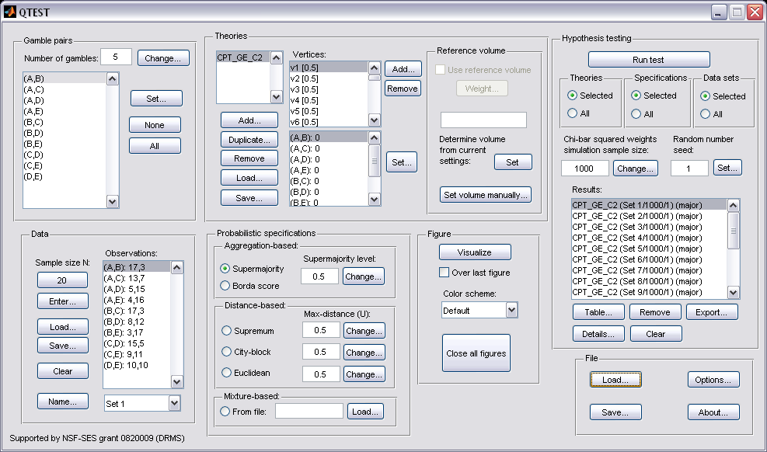

J.10 Cash II, CPT-GE, 0.90-Supermajority
In this section we analyze the Cash I data for CPT-GE with a 0.90-supermajority specification.
Method 1
- Set the “Number of gambles:” under “Gamble pairs” to 5. Then select “All” (also under “Gamble pairs”) so all 10 gamble pairs are now listed.
- Under “Data”, select “Load”. Navigate to “Cash2.txt” in the “DataSets” folder and then select “Open”.
- Under “Theories”, select “Load” and navigate to the folder “TheoriesVertices”. Select the file “Vertices_CPT_GE_Cash2.csv” and then select “Open”. In the “Theory” dialogue box that pops up enter “CPT_GE_C2” and then select “OK”.
- Set the “Probabilistic specification” to “Supermajority” at the “0.9” level.
- Under “Hypothesis testing”, select “All” under “Data sets” and then select “Run test”.
Method 2
- Under “File” of the QTEST interface, select “Load…”. Navigate to the “QTEST_Session_NoResults” folder and open the file “NR_CPT_GE_Cash2_.9SM.mat”.
- Under “Hypothesis testing”, select “All” under “Data sets” and then select “Run test”.
Method 3
- Under “File” of the QTEST interface, select “Load…”. Navigate to the “QTEST_Session_Complete” folder and open the file “Complete_CPT_GE_Cash2_.9SM.mat”.
Results
- The results for this section are in the folder “QTEST_Results” in the file “Results_CPT_GE_Cash2_.9SM.csv”.
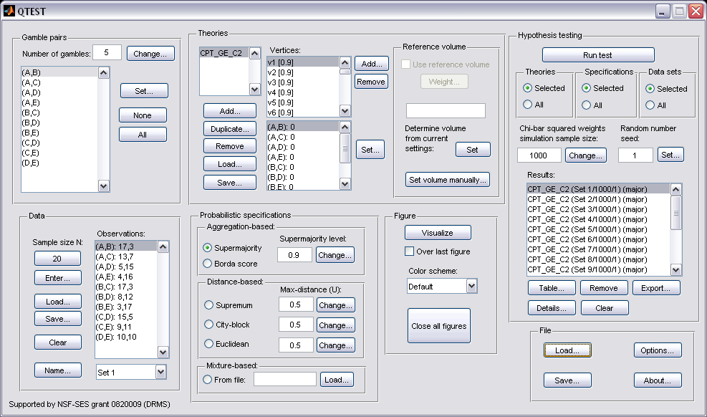

K. Table 6 of the paper
This section of the tutorial allows a use of QTEST to replicate Table 6 of the paper. Once again the 3 different methods for running an analysis are presented.

K.1 Cash I, Random CPT-KT
Method 1
- Set the “Number of gambles:” under “Gamble pairs” to 5. Then select “All” (also under “Gamble pairs”) so all 10 gamble pairs are now listed.
- Under “Data”, select “Load”. Navigate to “Cash1.txt” in the “DataSets” folder and then select “Open”.
- Under “Probabilistic specifications”, under “Mixture-based:” select “Load” and navigate to the folder “TheoriesFDI”. Select the file “FDI_CPT_KT_Cash1.txt” and then select “Open”.
- Under “Hypothesis testing”, select “All” under “Data sets” and then select “Run test”.
Method 2
- Under “File” of the QTEST interface, select “Load…”. Navigate to the “QTEST_Session_NoResults” folder and open the file “NR_CPT_KT_Cash1_Mixture.mat”.
- Under “Hypothesis testing”, select “All” under “Data sets” and then select “Run test”.
Method 3
- Under “File” of the QTEST interface, select “Load…”. Navigate to the “QTEST_Session_Complete” folder and open the file “Complete_CPT_KT_Cash1_Mixture.mat”.
Results
- The results for this section are in the folder “QTEST_Results” in the file “Results_CPT_KT_Cash1_Mixture.csv”.

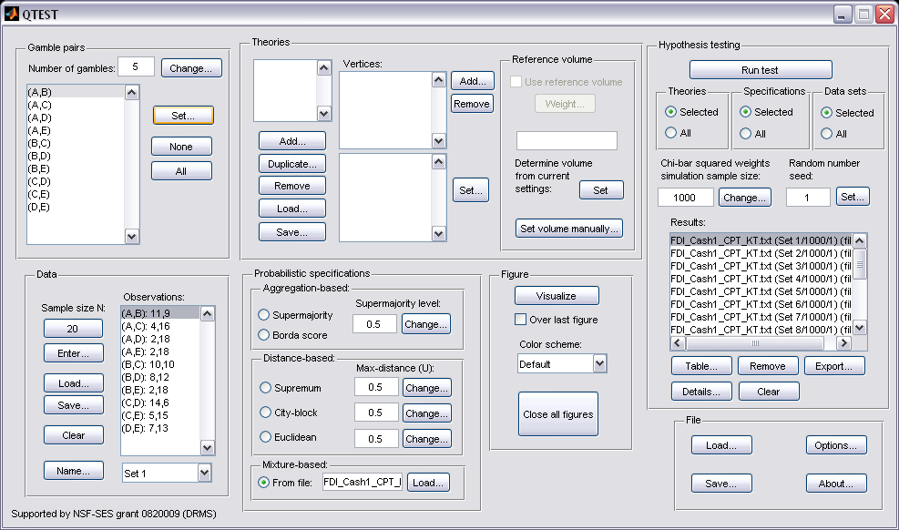

K.2 Cash II, Random CPT-KT
Method 1
- Set the “Number of gambles:” under “Gamble pairs” to 5. Then select “All” (also under “Gamble pairs”) so all 10 gamble pairs are now listed.
- Under “Data”, select “Load”. Navigate to “Cash2.txt” in the “DataSets” folder and then select “Open”.
- Under “Probabilistic specifications”, under “Mixture-based:” select “Load” and navigate to the folder “TheoriesFDI”. Select the file “FDI_CPT_KT_Cash2.txt” and then select “Open”.
- Under “Hypothesis testing”, select “All” under “Data sets” and then select “Run test”.
Method 2
- Under “File” of the QTEST interface, select “Load…”. Navigate to the “QTEST_Session_NoResults” folder and open the file “NR_CPT_KT_Cash2_Mixture.mat”.
- Under “Hypothesis testing”, select “All” under “Data sets” and then select “Run test”.
Method 3
- Under “File” of the QTEST interface, select “Load…”. Navigate to the “QTEST_Session_Complete” folder and open the file “Complete_CPT_KT_Cash2_Mixture.mat”.
Results
- The results for this section are in the folder “QTEST_Results” in the file “Results_CPT_KT_Cash2_Mixture.csv”.
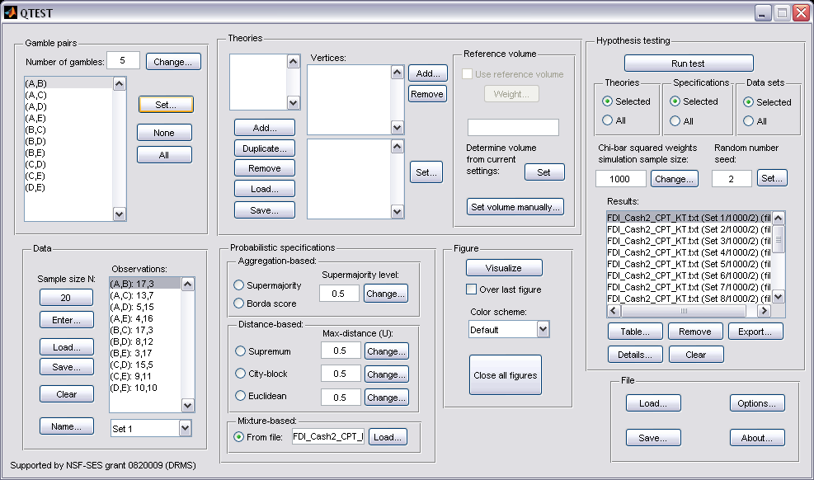

K.3 Cash I, Random CPT-GE
Method 1
- Set the “Number of gambles:” under “Gamble pairs” to 5. Then select “All” (also under “Gamble pairs”) so all 10 gamble pairs are now listed.
- Under “Data”, select “Load”. Navigate to “Cash1.txt” in the “DataSets” folder and then select “Open”.
- Under “Probabilistic specifications”, under “Mixture-based:” select “Load” and navigate to the folder “TheoriesFDI”. Select the file “FDI_CPT_GE_Cash1.txt” and then select “Open”.
- Under “Hypothesis testing”, select “All” under “Data sets” and then select “Run test”.
Method 2
- Under “File” of the QTEST interface, select “Load…”. Navigate to the “QTEST_Session_NoResults” folder and open the file “NR_CPT_GE_Cash1_Mixture.mat”.
- Under “Hypothesis testing”, select “All” under “Data sets” and then select “Run test”.
Method 3
- Under “File” of the QTEST interface, select “Load…”. Navigate to the “QTEST_Session_Complete” folder and open the file “Complete_CPT_GE_Cash1_Mixture.mat”.
Results
- The results for this section are in the folder “QTEST_Results” in the file “Results_CPT_Ge_Cash1_Mixture.csv”.
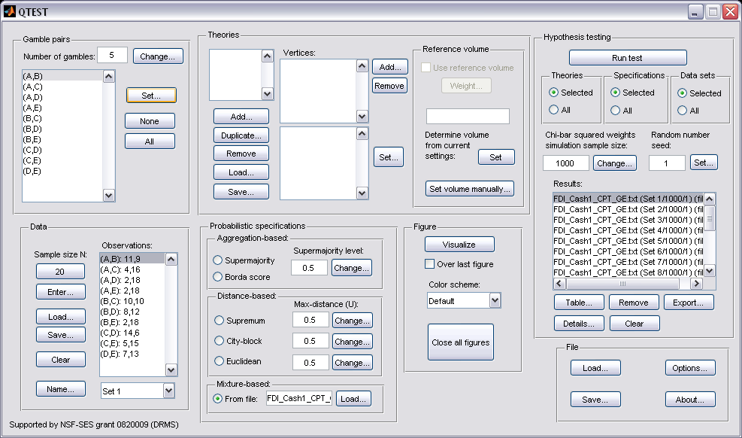

K.4 Cash II, Random CPT-GE
Method 1
- Set the “Number of gambles:” under “Gamble pairs” to 5. Then select “All” (also under “Gamble pairs”) so all 10 gamble pairs are now listed.
- Under “Data”, select “Load”. Navigate to “Cash2.txt” in the “DataSets” folder and then select “Open”.
- Under “Probabilistic specifications”, under “Mixture-based:” select “Load” and navigate to the folder “TheoriesFDI”. Select the file “FDI_CPT_GE_Cash2.txt” and then select “Open”.
- Under “Hypothesis testing”, select “All” under “Data sets” and then select “Run test”.
Method 2
- Under “File” of the QTEST interface, select “Load…”. Navigate to the “QTEST_Session_NoResults” folder and open the file “NR_CPT_GE_Cash2_Mixture.mat”.
- Under “Hypothesis testing”, select “All” under “Data sets” and then select “Run test”.
Method 3
- Under “File” of the QTEST interface, select “Load…”. Navigate to the “QTEST_Session_Complete” folder and open the file “Complete_CPT_GE_Cash2_Mixture.mat”.
Results
- The results for this section are in the folder “QTEST_Results” in the file “Results_CPT_GE_Cash2_Mixture.csv”.
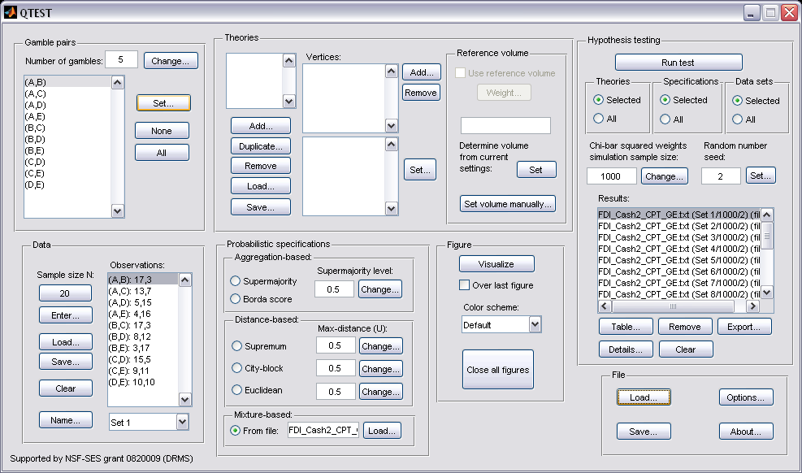

PART IV: Online Supplement
In this part of the tutorial we recreate Figures 2, 3 and 4 of the Online Supplement.

L. Figure 2 of the online supplement
Figure 2 of the online supplement is the mixture model specification for the Linear Ordering Polytope.

L .1 Create the gamble pairs
Make sure the gamble pairs match the following screenshot.

L.2 Create the input file
The linear ordering polytope is based on the following system of facet-defining inequalities in 3-dimensional space. These inequalities are:
θAC - θAD + θAD ≤ 1
-θAC + θAD – θAD ≤ 0

These inequalities, as well as prior literature about them, were also discussed in Regenwetter, Dana, and Davis-Stober (2010, 2011). These inequalities yield the following input file.

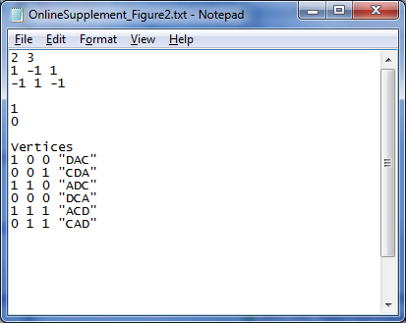

This is all of the information QTEST needs to analyze this mixture model. Save this file as “OnlineSupplement_Figure2.txt”. We now return to the QTEST interface to complete the analysis.

L.3 Mixture model analysis of the Linear Ordering Polytope
In the QTEST interface, under “Probabilistic specifications”, under “Mixture-based”, select the radio button next to “From file:”. Then select “Load…”.

In the “Load Specification” dialogue box that pops up, change the “Files of type:” to “Text files (*.txt)” and then navigate to the location of the “OnlineSupplement_Figure2.txt” file. Then select “Open”. Under “Figure”, select “Visualize”. 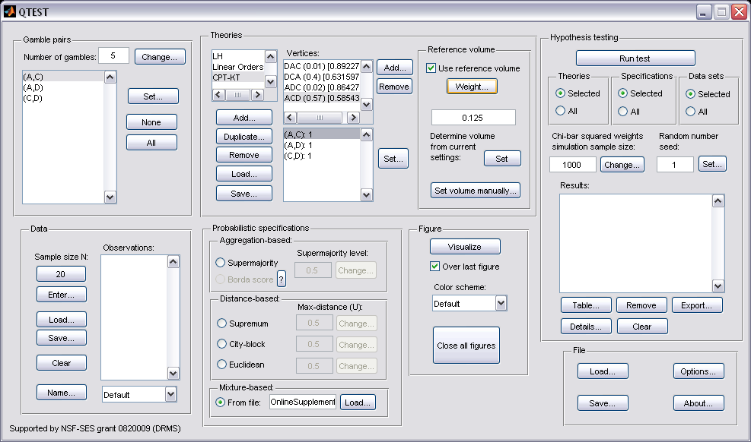

The figure that pops up is a version of Figure 2 of the Online Supplement of the paper.
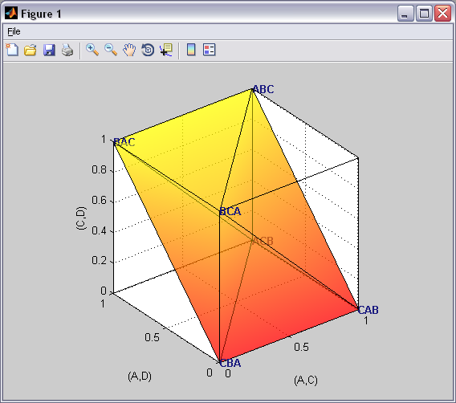

This completes the 3-D example for the mixture model specification of the Linear Ordering Polytope.

M. Figure 3 of the Online Supplement: CPT-KT with constant volumes vs. LH
Figure 3 of the online supplement is similar to Figure 8 of the paper, in that they both compare CPT-KT and LH in the same 3-D space. However, Figure 8 of the paper created a 0.50-majority/modal choice specification (or a 0.90-supermajority specification) of these theories. In generating Figure 3 of the online supplement, we start with a 0.50-majority/modal choice specification of the predictions for CPT-KT and LH. But then weight the volumes of each cube comprising the predictions of CPT-KT so that the total volume of all its cubes equals the volume of the cube for the single prediction of LH. The reason for this weight, as described in the online supplement, is to place the theories on an equal footing geometrically, so that CPT-KT is not favored over LH simply because it has more predictions and occupies a larger volume in the geometric space. Here, volume serves as a measure of model complexity for an order-constrained probability model. After completing this section, we will have created Figure 3 of the Online Supplement

M.1 Create the gamble pairs
Set the gambles so QTEST matches the screenshot below.
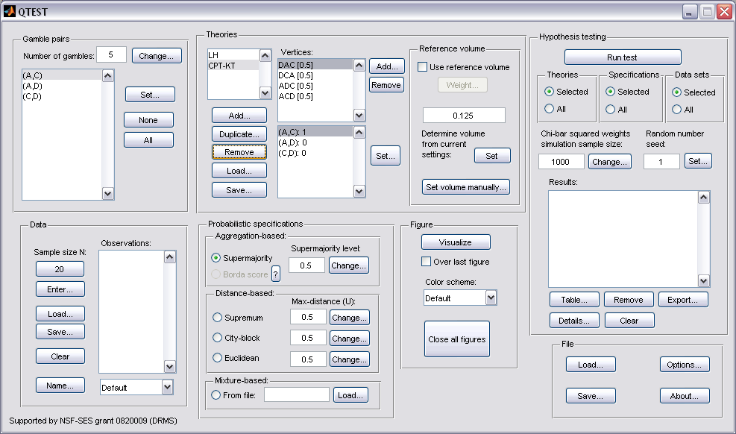

M.2 Define two decision theories, CPT-KT and LH
To create theories “CPT-KT” and “LH”, please see Section E above (or you can load the file ‘OnlineSupplement_Figure3.mat’).

M.3 Specify the predictions of theories LH and CPT-KT
In Section E.3, we specified the predictions for LH and CPT. You may return to Section E.3 or create them as indicated below.
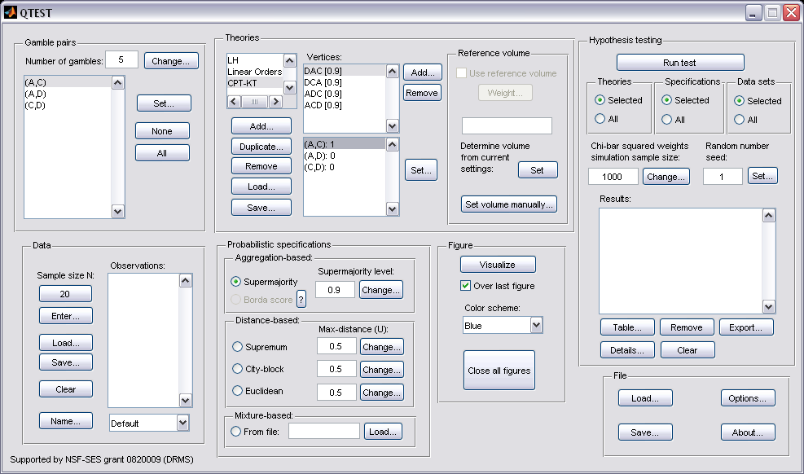

Under “Theories”, under “Vertices:”, verify the predictions “DAC”, “DCA”, “ADC” and “ACD” are listed in any order. The number contained in the square brackets following the prediction represents the probabilistic specification level.

Next, verify that LH has the correct prediction listed. Under “Theories”, select “LH” and verify “LH” is listed under “Vertices:”.
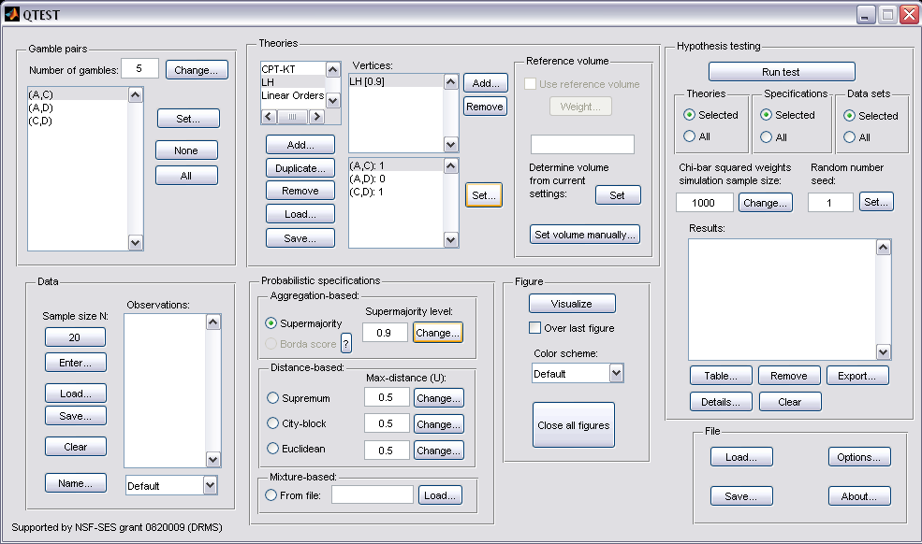

M.4 CPT-KT with constant volumes vs. LH
First verify the “Supermajority level:” is set to “0.5” under “Probabilistic specifications”.
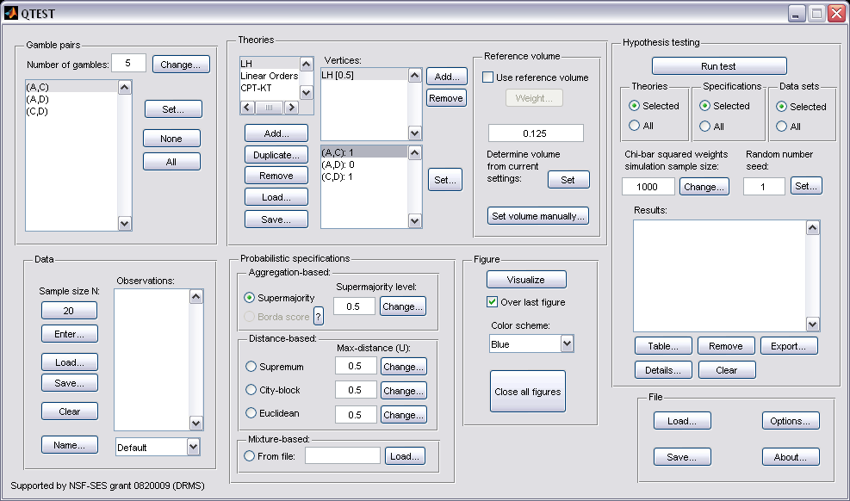

Weighting CPT-KT and LH is a two-step process. First we will use the single prediction of LH as the reference volume. In the QTEST interface, under “Theories”, select “LH” so that it is gray highlighted. 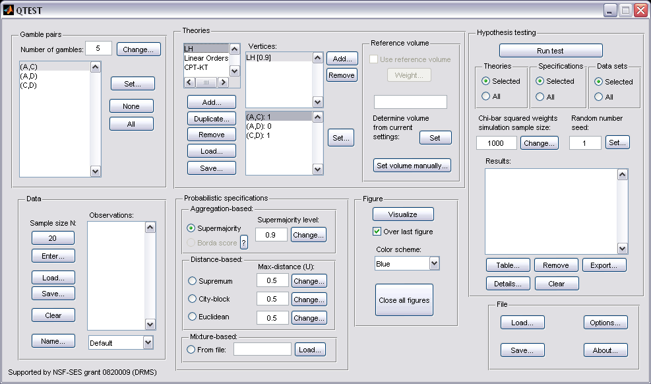

Under “Reference volume”, next to “Determine the volume from current settings:”, select “Set”. Then select the box next to “Use reference volume”.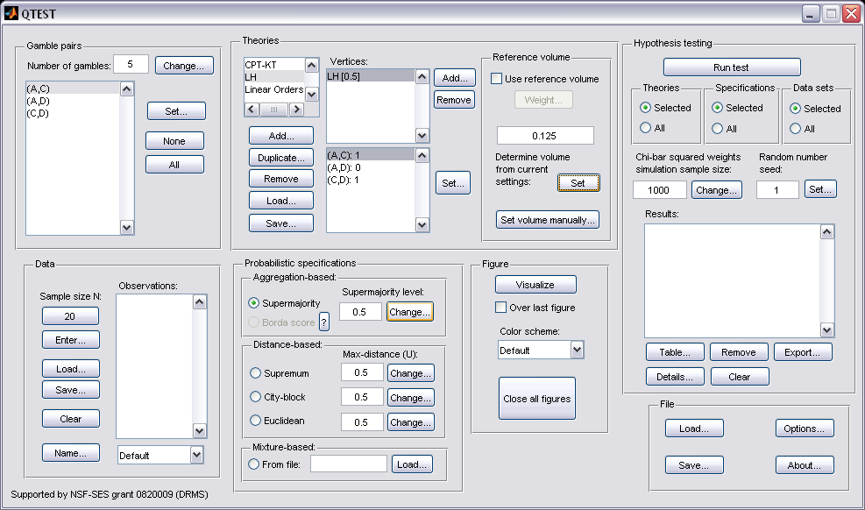

Select “Weight…”, which is now clickable.
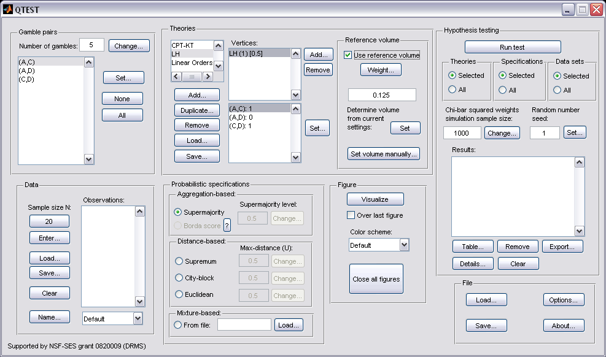

In the “Weight” dialogue box that pops up, enter “1”. Select “OK”.
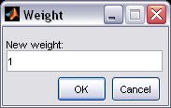

We now generate an intermediate figure. Under “Figure”, change “Color scheme:” to “Blue” from the dropdown menu. (Deselect “Over last figure if it is checked.) Then select “Visualize”.
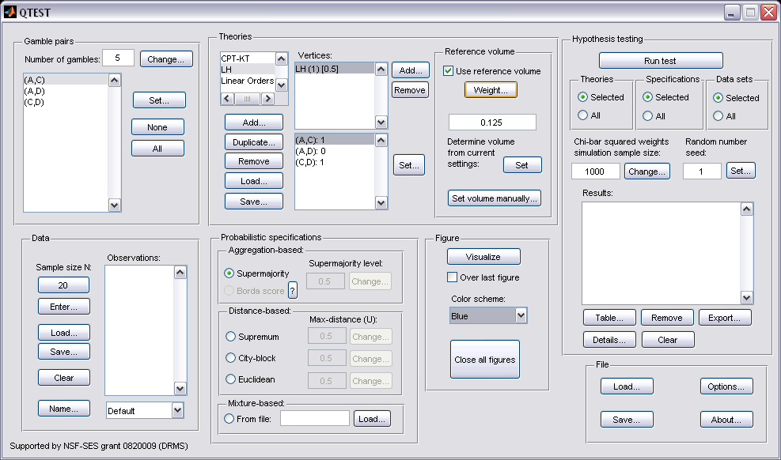

A rotated version of the resulting figure is below. Do not close this figure window. We will visualize the weighted predictions for CPT-KT within this same window.
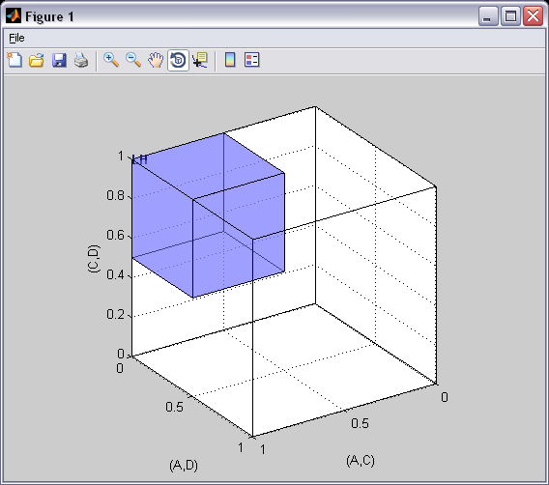

In the second step we weight CPT-KT so its total volume matches LH. Under “Theories” select “CPT-KT” so that it is gray highlighted. By default, under “Vertices:” the weights in parentheses have been set to “(1)”.
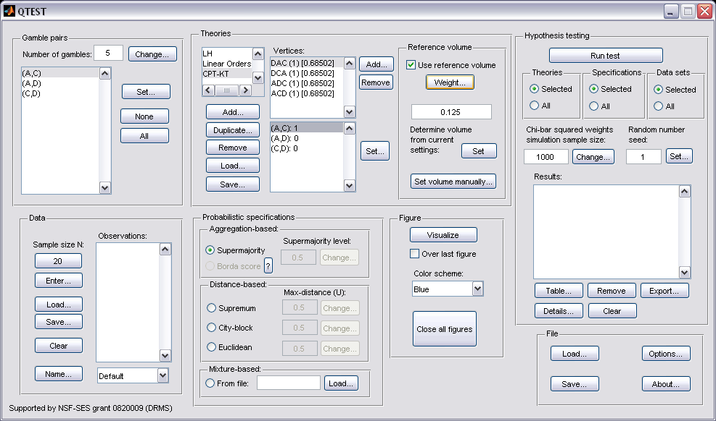

Select “DAC (1) [0.68502]”. Then select “Weight…” under “Reference volume”.
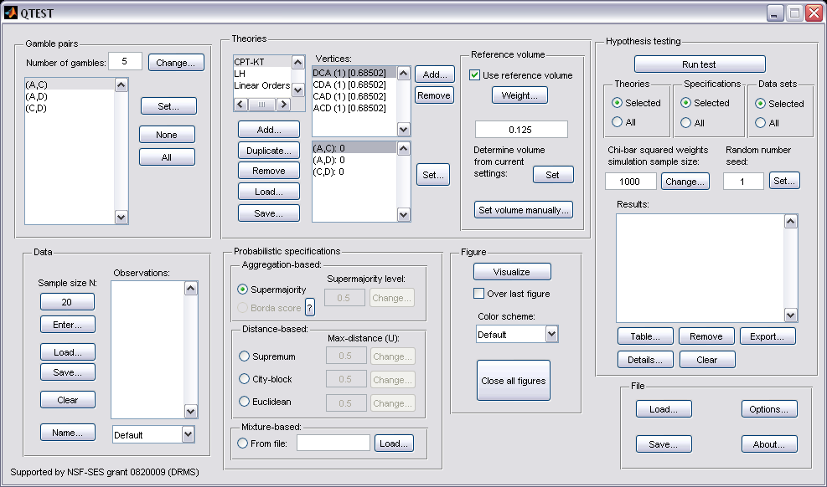

In the “Weight” dialogue box that pops up, enter “.25” and then press “OK”.
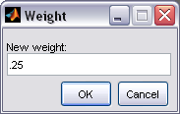

Under “Vertices” notice “DAC” has been updated to “DAC (0.25) [0.78735]”.
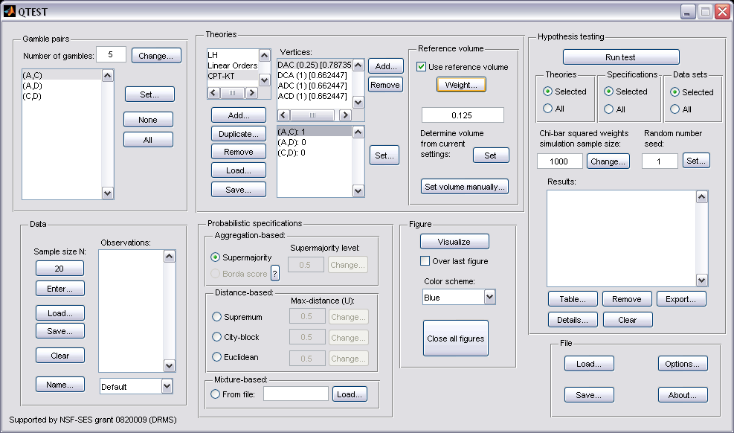

Repeat this procedure for “DCA“, “ADC” and “ACD”. Set all weights to “.25”. Once finished, the QTEST interface will look like the following screenshot.
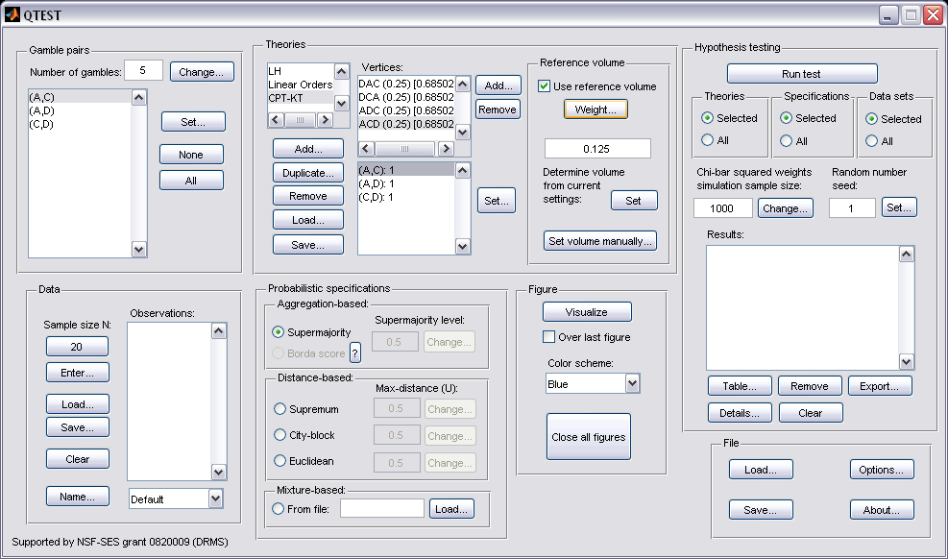

The 4 predictions of CPT-KT sum to the same volume as the 1 prediction of LH with a 0.50-majority/modal choice specification. We can visualize this weighted version of CPT-KT. Under “Figure”, select “Default” from the “Color scheme:” and make sure the box next to “Over last figure” is checked. Then select “Visualize”.
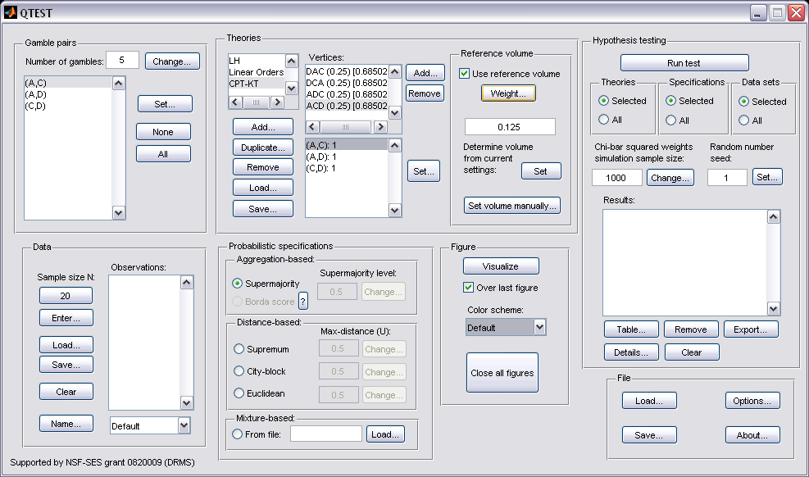

The resulting figure, which is a version of Figure 9 of the paper, is reproduced below. The coloring scheme is a little different in Figure 9 of the paper. But the goal of Section F, to place CPT-KT and LH on an equal footing by giving their predictions equal volumes, is now complete.
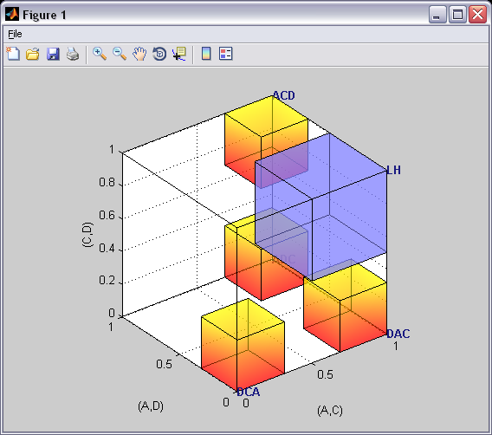

N. Figure 4 of the Online Supplement: CPT-KT with proportional volumes vs. LH
In the previous ection, M, each volume was weighted by .25 and the total volume of the 4 predictions of CPT-KT equaled the volume of the single prediction of LH under a 0.50-majority/modal choice specification. However, it is also possible to differentially weight each prediction. After completing this section, we will have created Figure 4 of the Online Supplement, which gives different weights to each of the predictions of CPT-KT.

N.1 Create the gamble pairs
Verify the gamble pairs match the screenshot below. 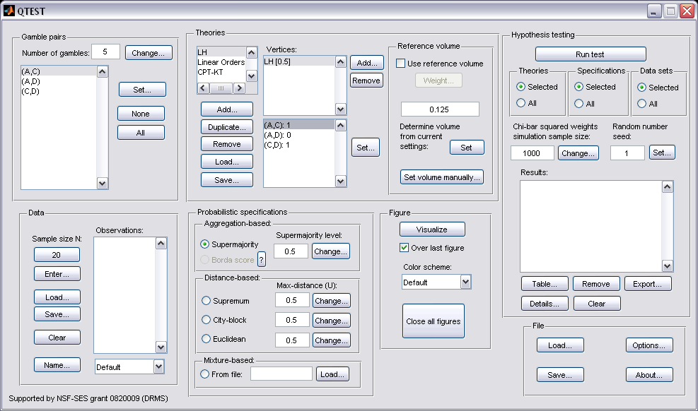

N.2 Define two decision theories, CPT-KT and LH
Under “Theories”, both “CPT-KT” and “LH” should be listed. (If you do not see “CPT-KT” and “LH” listed, return to Section C.2 to define these theories in QTEST, or load a saved session.)
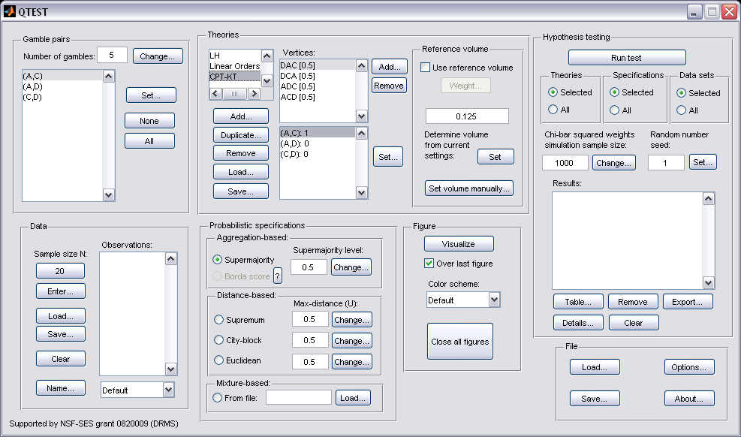

N.3 Specify the predictions of theories LH and CPT-KT
Under “Theories” select “CPT-KT” so it is gray highlighted. Under “Vertices:”, verify that the following 4 predictions are listed in any order: “DCA”, “DAC”, “ADC” and “ACD”. (If you need to specify these predictions, return to Section E.3.)

Next, select “LH” under “Theories”. Under “Vertices:”, verify “LH” is listed.

N.4 Giving CPT-KT proportional volumes (which sum to the total volume ofLH)
In the QTEST interface, under “Theories”, select “LH” and under “Vertices:”, select “LH (1) [0.5]”. These will both be highlighted. Select “Use reference volume” if not already checked.
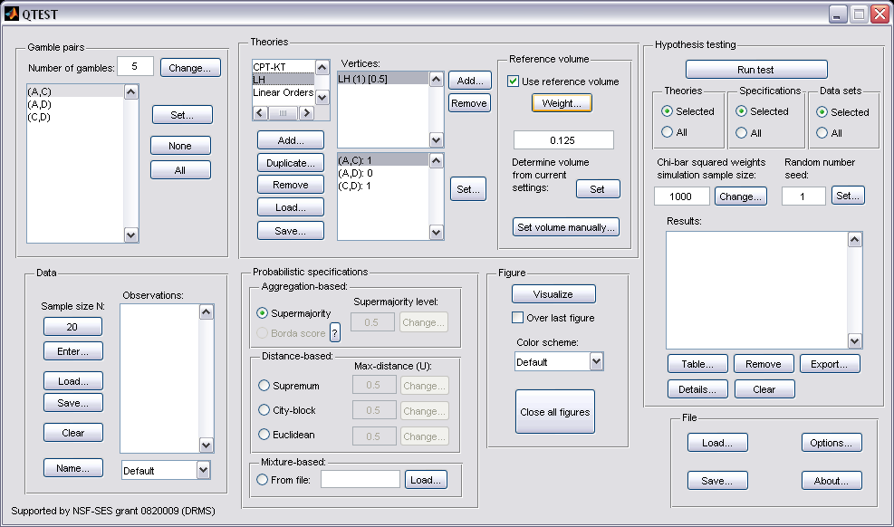

As an intermediate step, we will generate the current figure. Under “Figure”, change “Color scheme:” to “Blue” from the dropdown menu and uncheck “Over last figure” if it is checked. Then select “Visualize”.

A rotated version of the resulting figure is below. Do not close this figure window.

We now weight CPT-KT so its total volume matches that of LH. The weights of each prediction for CPT-KT are different, unlike Section F where the weights for each prediction of CPT-KT were the same. While those weights were constant, these weights are proportional to the portion of the algebraic parameter space associated with each corresponding vertex.

Under “Theories” select “CPT-KT” so that it is gray highlighted. Notice that, under “Vertices” all the weights in parentheses have been set to “(0.25)”. And the value in brackets is set to “[0.68502]”. 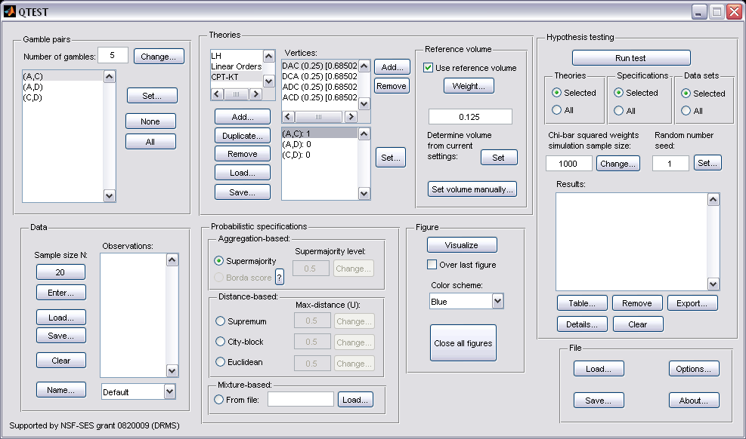

In Figure 10 of the paper, DCA is weighted by .4. So click on “DCA (.25) [0.68502]” so that it is gray highlighted. Then select “Weight…” under “Reference volume”.

In the “Weight” dialogue box that pops up, enter “.4”. Select “OK”.
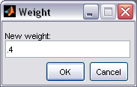

Under “Vertices” notice “DCA” has been updated to “DCA (0.4) [0.648366]”. 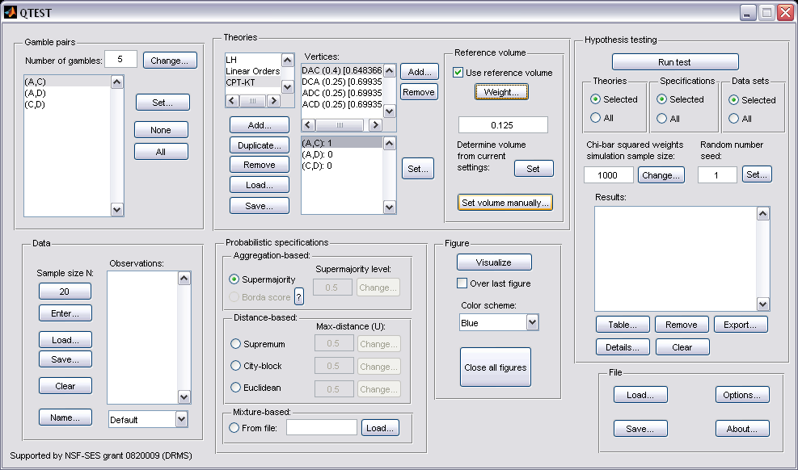

Repeat this procedure for the 3 remaining vertices, using the following weights:

“ADC” with weight “.02”
“DAC” with weight “.01”
“ACD“ with weight “.57”

Once these steps are completed “Vertices:” of the QTEST interface should look like the following screenshot. 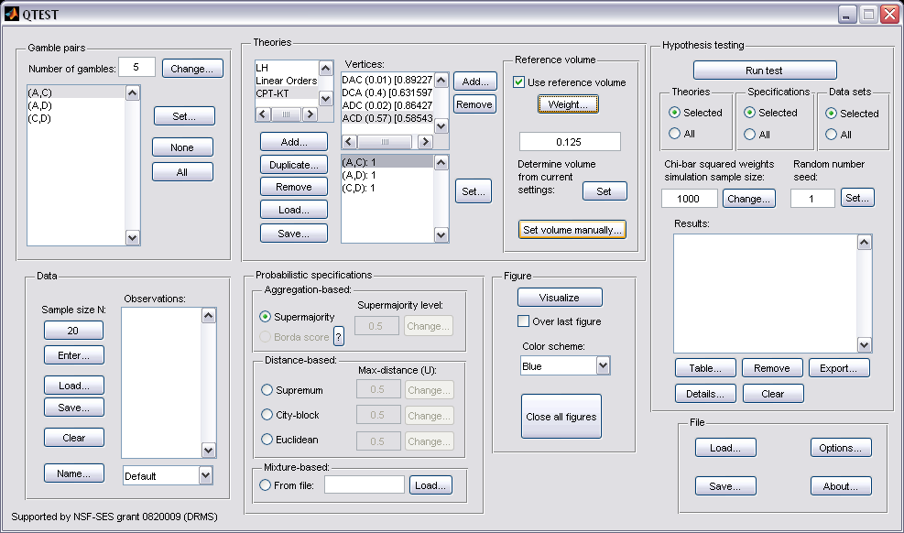
Each of the 4 predictions has a different weight and volume. The weights sum to one. We can visualize this weighted version of CPT-KT and compare it to LH. Under “Figure”, select “Default” from the “Color scheme:” and make sure the box next to “Over last figure” is checked. Then select “Visualize”.
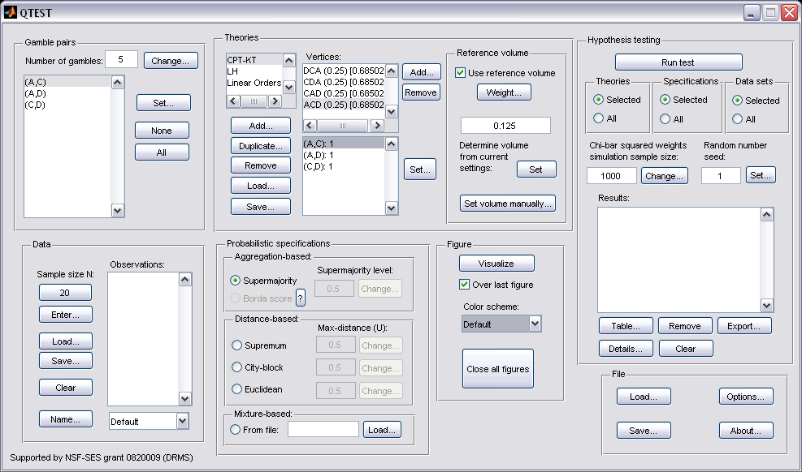

The resulting figure, which is a version of Figure 4 of the Online Supplement, is reproduced below. The goal of placing CPT-KT and LH on an equal footing by giving their predictions equal total volumes while also setting the individual volumes proportional to the portion of the algebraic parameter space generating each prediction, is now complete.

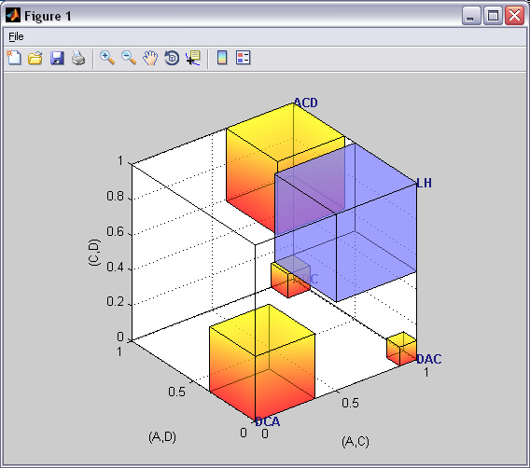

PART V: QTEST Options

O. Warnings, Options and Miscellaneous Items
Section O contains information about QTEST not covered elsewhere in the tutorial. These include warning messages one might encounter, different options and some other details.

O.1 Options
The “Options…” button in the “File” section allows more control of QTEST behavior. Select “Options…”.

The following “Options” window pops up, the details of which are discussed after the screenshot.
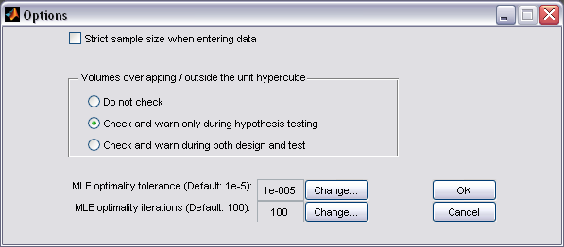

By default, in the “Data” section, QTEST does not restrict the total number of observations for each gamble pair to the stated sample size N. If indeed a fixed sample size per gamble pair is used, then checking “Strict sample size when entering data” can prevent mistakes in entering data.

QTEST can check and warn about overlapping volumes and volumes that fall outside the unit hypercube. However, this check can be computationally costly. Exactly when this check is performed can be set by choosing among the three options.

The last two pieces of the “Options” concern optimality. In running an analysis in QTEST, one might encounter the warning depicted in the following screenshot.
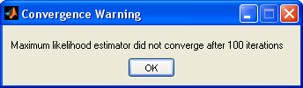

If this warning occurs, first note that the result may still be meaningful. One might want to inspect the data to see if the QTEST results seem reasonable based on where the data lies relative to the model. If one continues to get the same warning message, even after repeating the analysis and suspects the results may not be accurate, one can adjust the optimality parameter settings.

First, one can try to increase, or even decrease, the “MLE optimality tolerance”.

Second, the default number of “MLE optimality iterations” is 100. This is the number of retries before gives up. Another strategy to deal with the “Convergence Warning” is to increase or decrease the number of iterations.

In very rare cases, when a data point is very close to the model, but yields a p-value exactly equal to 0, redo the analysis in QTEST.

O.2 Warning messages
When one is doing an analysis in QTEST and sets the reference volume manually, an error message might appear, indicating that at least two of the polytopes overlap. This does not mean the results are wrong but in these cases one should not interpret the p-values as exactly correct. (One might also get this warning message if the distance-based specification is larger than 0.5.)

Another warning message one might see is the following: “WARNING: non-full rank polyhedral cone!”. This message concerns the facet-defining inequalities near the maximum likelihood (ML) point. And it can be due to too many possible facet-defining inequalities near the ML point. Proceed with caution; but usually such a warning is not problematic, especially if the polytope is full-dimensional.

O.3 Data recommendation
We recommend that at least 20 observations per gamble pair, per person be used in any QTEST analysis. This ensures the assumptions of the asymptotic distributions are reasonably met. Of course, one may use more than 20 observations. But with less than 20 observations the results may be compromised. However, see the Online Supplement to the paper for exceptions (i.e. mixture models) and further details.

O.4 About
Selecting “About”, under “File”, will bring up a window with the following information regarding the release notes of QTEST.

