Measure of Psychological Well-Being
Ed Diener

Using the scale below, please answer each question using a number from 1 to 5.
Place a number next to each item that shows how much you agree with it.

1 Strongly Disagree
2 Disagree
3 Neither Agree nor Disagree
4 Agree
5 Strongly Agree

- _______There are people I can depend on to help me
- _______There are people who give me support and encouragement
- _______There are people who appreciate me as a person
- _______I pitch in to help when my local community needs something done
- _______I invite my neighbors to my home
- _______I look for ways to help my neighbors when they are in need
- _______I can trust people in my society
- _______People in my neighborhood can be trusted
- _______Most people I meet are honest
- _______People respect me
- _______People are polite to me
- _______I am treated with the same amount of respect as others
- _______I feel lonely
- _______I often feel left out
- _______There is no one I feel close to
- _______I feel a sense of belonging in my community
- _______I feel a sense of belonging in my state or province
- _______I feel a sense of belonging in my country

Using the scale below, please answer each question using a number from 1 to 5.
Place a number next to each item that shows how much you agree with it.

1 Strongly Disagree
2 Disagree
3 Neither Agree nor Disagree
4 Agree
5 Strongly Agree

- _______I get fully absorbed in activities I do
- _______In most activities I do, I feel energized
- _______I get excited when I work on something
- _______I use my skills a lot in my everyday life
- _______I frequently use my talents
- _______I get to do what I am good at everyday
- _______I learned something new yesterday
- _______Learning new things is important to me
- _______I always learn something everyday
- _______Other people decide most of my life decisions
- _______The life choices I make are not really mine
- _______Other people decide what I can and cannot do
- _______I am achieving most of my goals.
- _______I am fulfilling my ambitions
- _______I am on track to reach my dreams
- _______I can succeed if I put my mind to it
- _______I am confident that I can deal with unexpected events
- _______I believe that I am capable in most things
- _______What I do in life is valuable and worthwhile
- _______The things I do contribute to society
- _______The work I do is important for other people

Using the scale below, please answer each question using a number from 1 to 5.
Place a number next to each item that shows how much you agree with it.

1 Strongly Disagree
2 Disagree
3 Neither Agree nor Disagree
4 Agree
5 Strongly Agree

- _______My life has a clear sense of purpose
- _______I have found a satisfactory meaning in life
- _______I know what gives meaning to my life

- _______I am optimistic about my future
- _______I have a positive outlook on life
- _______I expect more good things in my life than bad

- _______In most ways my life is close to my ideal
- _______I am satisfied with my life
- _______My life is going well

- _______I feel positive most of the time
- _______I feel happy most of the time
- _______I feel good most of the time

- _______I feel negative most of the time
- _______I experience unhappy feelings most of the time
- _______I feel bad most of the time

Below are 8 statements with which you may agree or disagree. Using the 1–7 scale below, indicate your agreement with each item by indicating that response for each statement.

• 1 - Strongly disagree
• 2 - Disagree
• 3 - Slightly disagree
• 4 - Neither agree nor disagree
• 5 - Slightly agree
• 6 - Agree
• 7 - Strongly agree

- _______I lead a purposeful and meaningful life
- _______My social relationships are supportive and rewarding
- _______I am engaged and interested in my daily activities
- _______I actively contribute to the happiness and well-being of others
- _______I am competent and capable in the activities that are important to me
- _______I am a good person and live a good life
- _______I am optimistic about my future
- _______People respect me

- _______In most ways my life is close to my ideal.
- _______The conditions of my life are excellent.
- _______I am satisfied with my life.
- _______So far I have gotten the important things I want in life.
- _______If I could live my life over, I would change almost nothing.

Please think about what you have been doing and experiencing during the past four weeks. Then report how much you experienced each of the following feelings, using the scale below. For each item, select a number from 1 to 5, and indicate that number on your response sheet.

1 - Very Rarely or Never
2 - Rarely
3 - Sometimes
4 - Often
5 - Very Often or Always

- _______Positive
- _______Negative
- _______Good
- _______Bad
- _______Pleasant
- _______Unpleasant
- _______Happy
- _______Sad
- _______Afraid
- _______Joyful
- _______Angry
- _______Contented

- If you imagine your own life, where do you stand on the ladder, from the Worst possible to Best possible life you can imagine? On what step of the ladder is your life?
(Place a number here to indicate the step): ________
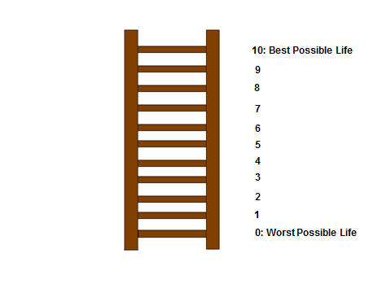

Hadley Cantril’s Self-Anchoring Striving Scale (1965)

